Finance & Performance Panel briefing note: 7 Dec 2022
The Panel requested that a briefing note be supplied by the Head of Financial Services and the Head of Corporate Strategy to the next Panel presenting information on the savings achieved by implementing renewable energy sources at leisure sites and the potential savings that could be achieved.
Leisure centre renewable energy investment benefits – existing/potential
Leisure Centres account for over 40% of the CO2 emissions arising from Council buildings where it pays the energy bills and therefore make up a significant contribution to the core Council carbon footprint as outlined in the Net Zero Carbon Council by 2030 carbon management plan.

Emissions source | tCO2e | %
Car parks | 139 | 2.6%
Community Centres | 235 | 4.4%
Corporate Property | 103 | 1.9%
High-rise housing blocks | 82 | 1.5%
Leisure Centres | 2366 | 44.2%
Low-rise Housing blocks | 225 | 4.2%
Main Offices & Depots | 721 | 13.5%
Parks and cemeteries | 31 | 0.6%
Public space lighting | 16 | 0.3%
Public toilets | 87 | 1.6%
Sheltered Housing blocks | 665 | 12.4%
Sports Pavilions | 153 | 2.9%
Temporary Accommodation | 479 | 9.0%
Misc other | 44 | 0.8%
Total – sites/buildings | 5348 | 100%

Table 1: Breakdown of core council carbon emissions (tCO2e) by buildings (where the council pays the energy bills) – 2019/20 data

Since the Council commenced delivering carbon reduction plans, Leisure centres have been the target of a number of energy efficiency/carbon reduction projects including the investment in installation of a significant amount of renewable energy installations at the leisure sites.
This constitutes the following Solar PV installations:
- Barton Leisure Centre – 48kWp Solar PV installation (roof mounted) – installed March 2012
- Ferry Leisure Centre – 33kWp Solar PV installation (roof mounted)– installed March 2012
- Leys Pools and Leisure Centre – 122.5kWp Solar PV installation (roof mounted) installed Dec 2014
- Leys Pools and Leisure Centre – 100kWp Solar PV installation (Solar canopy over car park) – installed Dec 2020

These sites generate an annual electricity yield of around 264,000kWh per year – predominantly supplying directly into the buildings for use on site with limited export of electricity to the grid.
This not only reduces the use of grid supplied electricity and their associated carbon emissions but also avoids the payment of electricity (at increasingly rising cost) from the grid.
At current projected electricity unit rates (ca 30p/kWh from 1 Oct 22) this delivers an approximate avoided energy spend of around £79k per year.

Public Sector Decarbonisation Scheme funded projects
The council was successful in winning ca £11m in Public Sector Decarbonisation Scheme (PSDS) grant funding to decarbonise the heating systems in the leisure centres.
Although not strictly renewable energy technologies – they are lower carbon in that they shift heating plant to predominantly electricity based (on a zero carbon trajectory by 2035) – and is significantly more efficient than gas heated systems.
This will change consumption profiles in the leisure buildings funded (all sites apart from the Ice Rink) to predominantly being heated via electricity - though gas consumption will still occur to cover peak loads at certain times of the year (eg winter).
In headline terms, if the plant operates fully to the designed and modelled consumption patterns at projected utility rates from Oct 22 (est 30p/kWh electricity and 8.5p/kWh gas)– the leisure centre energy costs will reduce by between ca£100k to £200k/year compared to if the decarbonisation works and building upgrades had not been carried out.
Ongoing monitoring of building performance will be tracked over the next year to 18 months to establish the new energy consumption profiles/costs for the buildings.
An associated investment in a Solar Farm was carried out as part of this grant funded scheme to benefit from a transfer of Renewable Energy Guarantees of Origin (REGOs) which can be used in council CO2 reporting.

Potential for additional renewable energy investment on or around council buildings
Further to the detailed design works during the Public Sector Decarbonisation Scheme (PSDS) – additional Solar PV was found to be technically viable at Barton and Ferry Leisure centres but not pursued at the time due to rising programme delivery costs and limited programme time available. Additional PV arrays would provide significant additional electricity into the buildings – avoiding expensive imported electricity from the grid.
It is assessed that an additional 84kW of PV generation is viable at Ferry and a further 33kW at Barton to add to the existing large arrays there (subject to detailed structural/electrical surveys). The additional panels would generate an estimated additional 100,000kWh of electricity per annum that could be used directly in the buildings at an estimated installation cost of £163k. At price projected grid electricity unit rates – these installations could payback in under 6 years. If electricity prices outturn higher than this, then the payback periods shorten. The installations would also reduce carbon emissions in the buildings by a total of around 30tCO2/year.
See below: proposed locations of additional solar at Barton Leisure centre – see red circled panels – approx. 33kW generation.
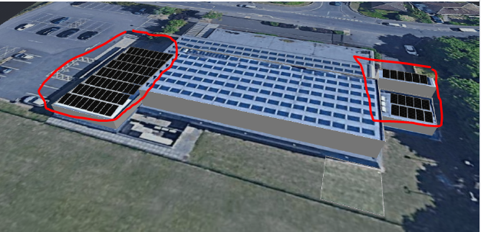

See below: proposed locations of additional Solar PV at Ferry Leisure centre – approx. 84kW generation.

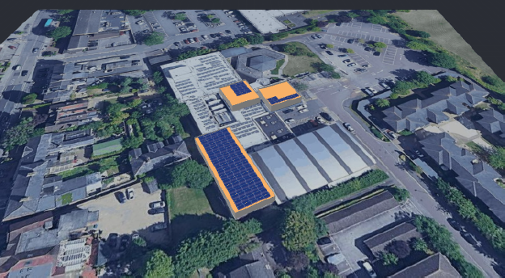

Hinksey Lake PV generation: Floating Solar PV installation on Hinksey Lake – potential for up to 400kW generation.
This was first suggested as part of the PSDS programme but not progressed due to local member objections, and the extremely tight timeframes associated with the government funding. It would present a significant injection of solar electricity to the site during summer when the pool is at its highest usage – thereby reducing energy costs for the pool and also driving closer towards net zero. Options to sell surplus electricity to local off-takers such as the hotel across the road from Hinksey Park or community centre could also be explored. The estimated cost established during the PSDS works is estimated to be ca £500k to generate around 372,000kWh per year, saving c£90k per year on electricity bills and reduce carbon emissions by around 110tCO2/year if all of the electricity can be used on site and/or surplus provided to other local off-takers.

See below: schematic of PV array in Hinksey Lake.
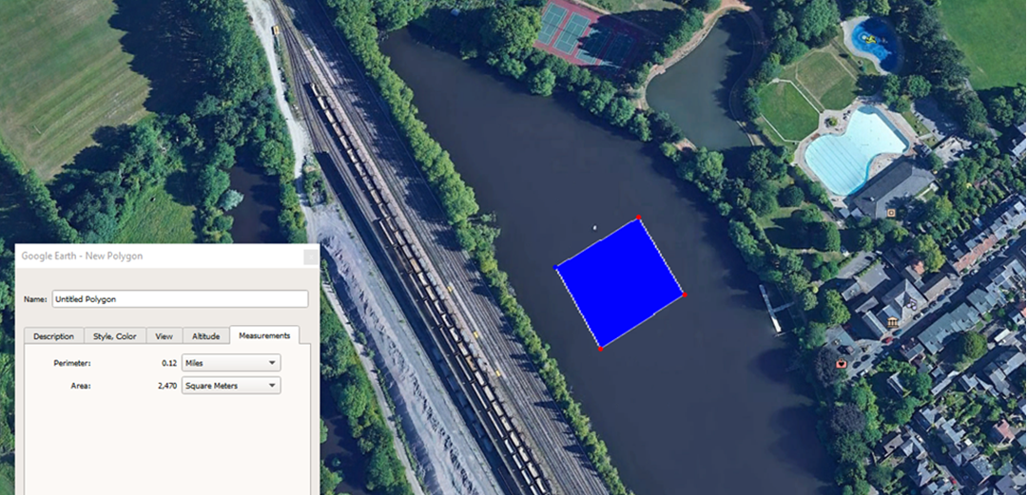

https://www.oxford.gov.uk/download/downloads/id/7518/zero_carbon_plan_2030.pdf

