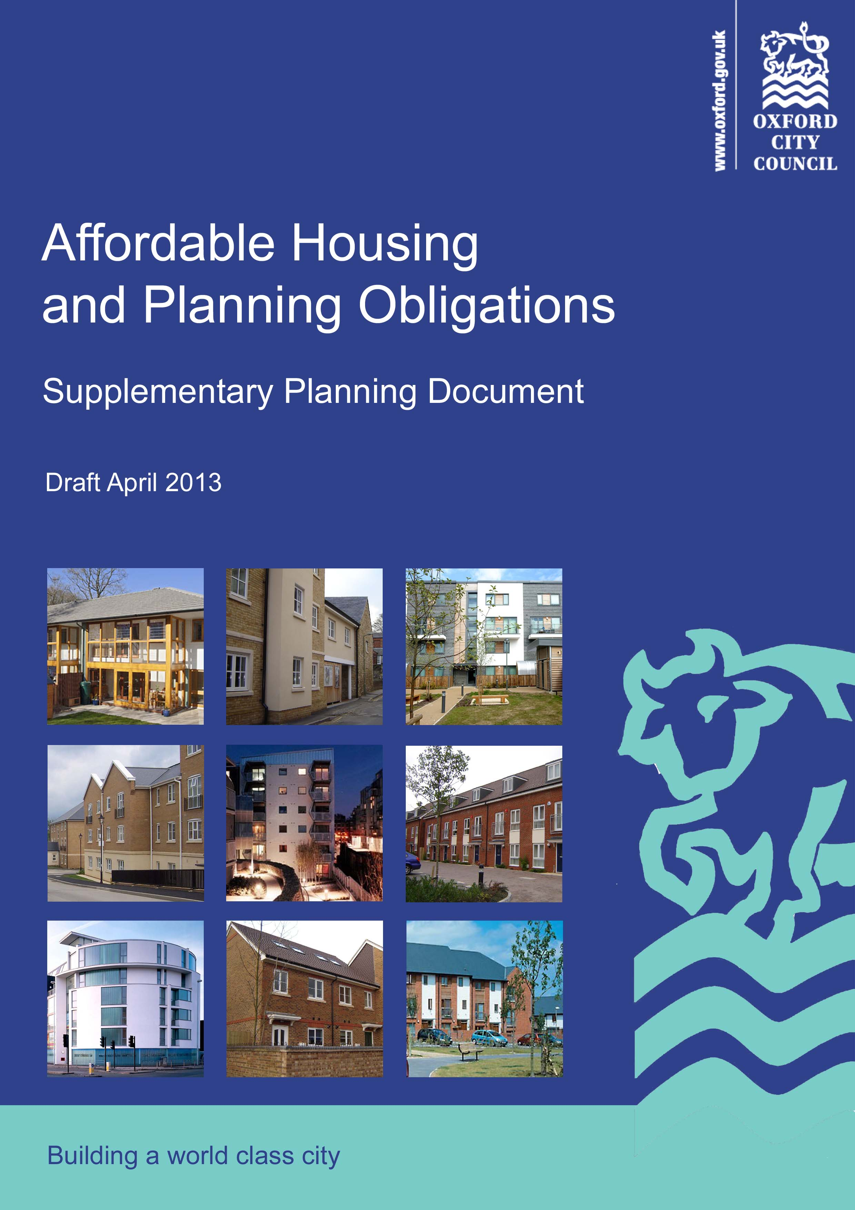
Supplementary Planning Document
Affordable Housing and Planning Obligations SPD

This Supplementary Planning Document supersedes the Affordable Housing SPD (November 2006) and the Planning Obligations SPD (November 2007).

CONTENTS
- Overview | 3
- Affordable Housing | 5
- Other Planning Obligations | 11
- Processes for delivery | 16
Appendix 1: Extracts from Oxford Core Strategy 2026 and Sites and Housing Plan | 19
Appendix 2: Dwelling and student accommodation floorspaces | 27
Appendix 3: Viability appraisal | 28
Appendix 4: Contribution towards affordable housing from non-residential developments | 33
Appendix 5: Standard Legal Agreement | 36
Appendix 6: Standard Unilateral Undertaking | 47
1. OVERVIEW

Background

- The provision of new homes, economic development and other forms of development are essential to ensure the prosperity of Oxford and to meet the needs of residents, workers and visitors. The City Council has established a planning policy framework that seeks to achieve well-planned and sustainable development, and to ensure that development in Oxford comes with the necessary supporting infrastructure.

- Oxford is one of the least affordable cities in the UK and the provision of new affordable housing is a key priority for the City Council. The adopted planning policies in Oxford seek to meet the pressing need for new affordable housing as far as is possible within a city that has many environmental constraints, and to deliver a wide choice of high-quality homes to create sustainable, mixed and balanced communities.

- In order to help fund the provision of the infrastructure necessary to support new development across Oxford, the City Council is introducing a Community Infrastructure Levy (CIL). CIL is a tariff in the form of a standard charge on new development to help the funding of infrastructure. As a consequence of the introduction of CIL, the use of Section 106 planning obligations for most types of infrastructure, other than affordable housing, will be much more limited than in the past.

Purpose of this SPD
- Section 2 of the Supplementary Planning Document (SPD) provides further guidance to support the implementation of the affordable housing policies of the Core Strategy and the Sites and Housing Plan, specifically:
- Core Strategy Policy CS24 (Affordable Housing). This policy relates to both residential and commercial development;
- Sites and Housing Policy HP3 (Affordable Homes from Large Housing Sites);
- Sites and Housing Policy HP4 (Affordable Homes from Small Housing Sites); and
- Sites and Housing Policy HP6 (Affordable Housing from Student Accommodation)
- It provides further detail on the mechanisms for delivering affordable housing, the mix of dwelling sizes and the tenures expected.

- Section 3 of the SPD supplements in particular Core Strategy Policy CS17 (Infrastructure and Developer Contributions), but it also supports a number of topic based policies in the Core Strategy and the Local Plan. The SPD clarifies the difference between CIL and Section 106 planning obligations and sets out the City Council’s approach to all forms of planning obligations when considering planning applications for development. The SPD explains the basis on which planning obligations will be sought and the process by which they will be negotiated and calculated where appropriate.

- Section 4 provides details on the processes used to ensure the delivery of affordable housing, contributions and other planning obligations. This includes further information on negotiating contributions in the case of non-viability, the drafting and enforcement of legal agreements and administrative costs.

- This SPD will assist in securing both local and national objectives in respect of the provision of sustainable development across Oxford. It will help to ensure both the delivery of affordable housing and the provision of the necessary measures required to mitigate the impact of development of all types, resulting in a high quality urban environment and socially inclusive communities.

- Proposals for development that may require the provision of planning obligations should be made in accordance with the relevant policies of Oxford’s Local Plan. This SPD constitutes an important material consideration in the decision‐making process.

Planning policy context
- The National Planning Policy Framework (NPPF) indicates that “Local Plans are the key to delivering sustainable development” (paragraph 150) and highlights the importance of planning positively for the development and infrastructure required to meet the objectives of the NPPF (paragraph 157). The NPPF advises that SPDs “should be used where they can help applicants make successful planning applications or aid infrastructure delivery and should not be used to add unnecessarily to the financial burdens on development" (paragraph 153).

- This SPD replaces the City Council’s adopted SPDs on Affordable Housing (November 2006) and Planning Obligations (April 2007) and their supporting documents. In so doing it not only updates, but also streamlines and consolidates the City Council’s existing guidance on these matters.

- The guidance in this SPD is consistent and in conformity with the adopted planning policies set
Figure 1: Oxford’s Local Plan
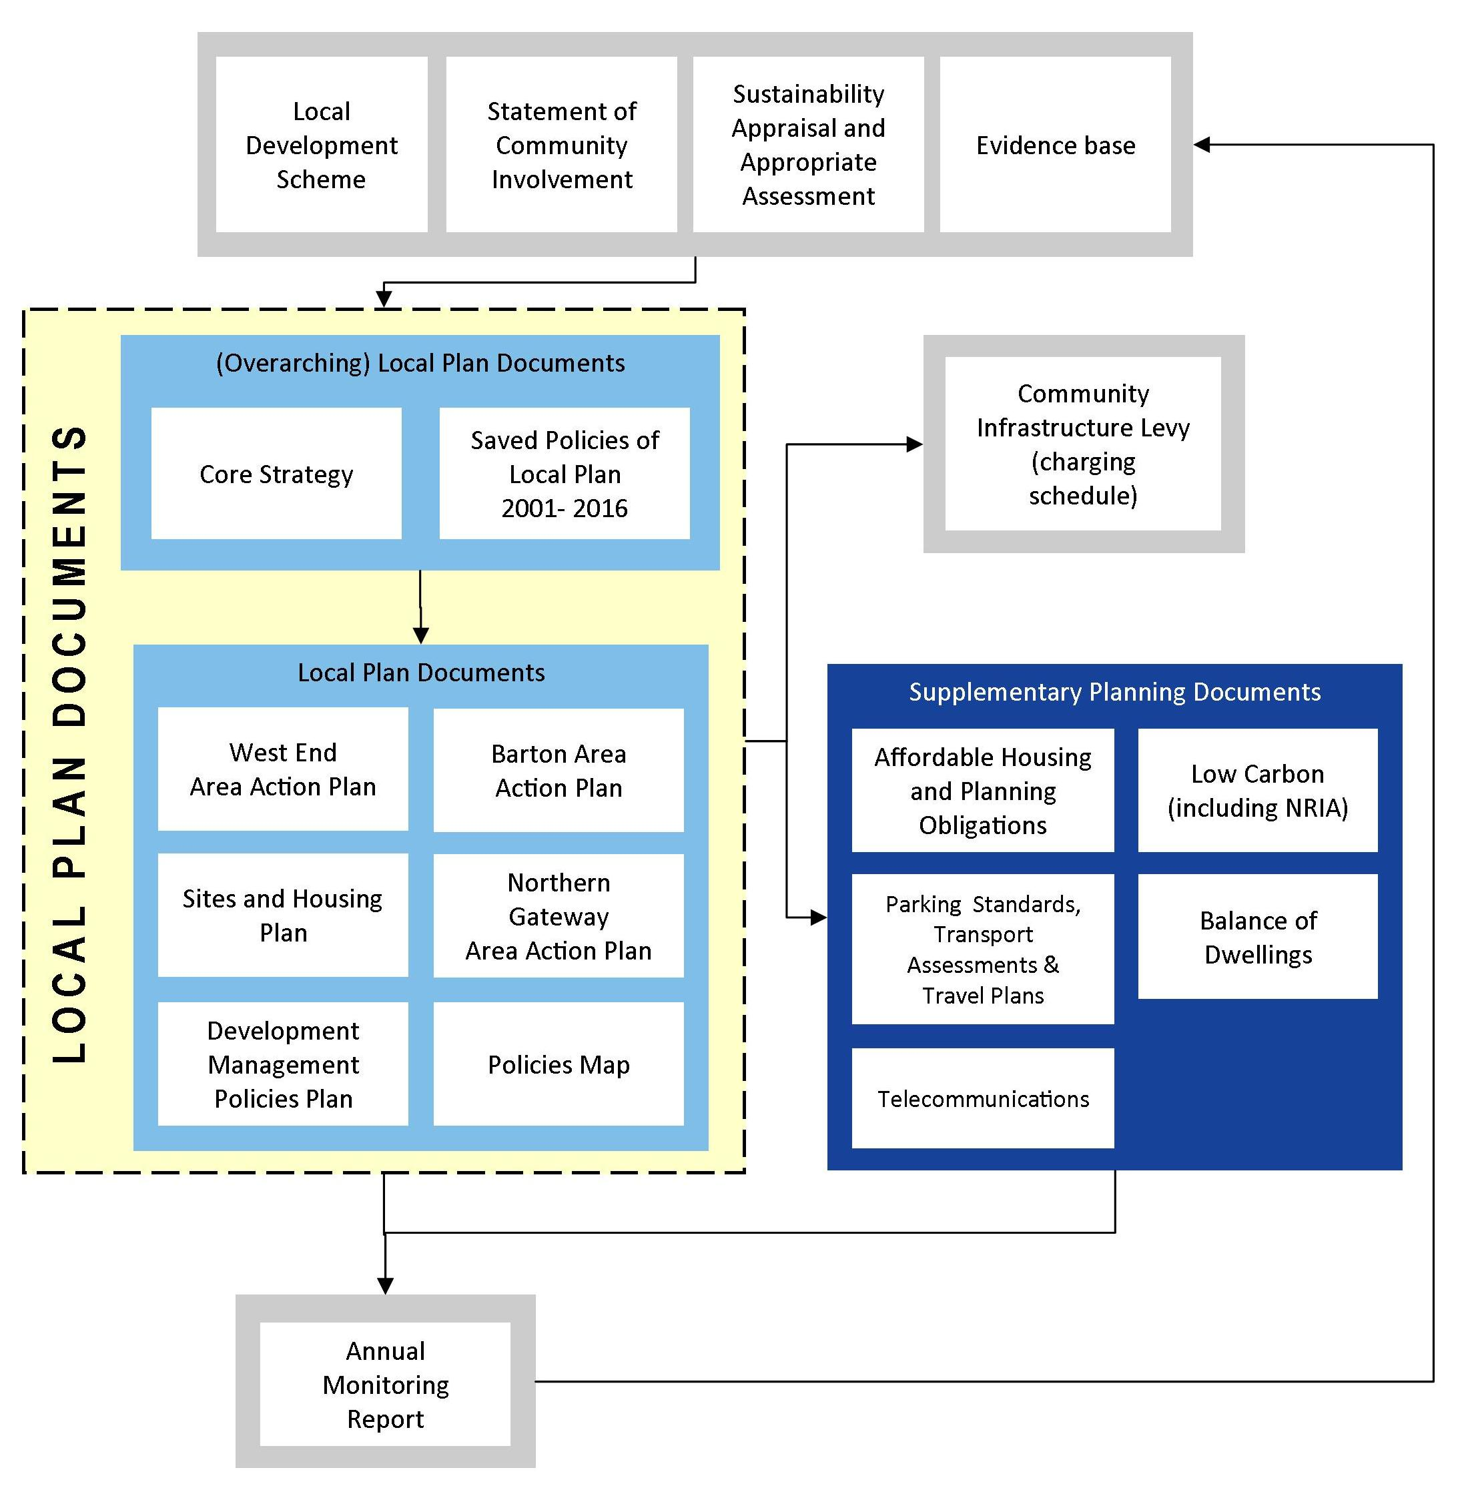
out in Oxford’s Local Plan. The term ‘Local Plan’ includes a number of policy documents that have been prepared and adopted separately. Oxford’s Local Plan currently comprises ‘saved’ policies from the Oxford Local Plan 2001-2016 (adopted November 2005), the Oxford Core Strategy 2026 (adopted March 2011); the Sites and Housing Plan (adopted February 2013); the West End Area Action Plan (adopted June 2008); and the Barton Area Action Plan (adopted December 2012).

2. AFFORDABLE HOUSING

- The Sites and Housing Plan sets out the way in which housing and student accommodation development must contribute to affordable housing, in line with Policies HP3, and HP4 and HP6 of the Sites and Housing Plan. Further guidance on applying these policies is found in the following sections.

When will Policies HP3 and HP4 apply?
- Policies HP3 and HP4 will be applied to all self-contained dwellings (except for developments under the trigger threshold), i.e. all uses that fall within Use Class C3. A dwelling under Use Class C3 is described as a building that ordinarily affords the facilities required for day to day domestic existence, i.e. all the rooms (including kitchen, bathroom and toilet) in a household’s accommodation are behind a single door which only that household can use. This includes, but is not necessarily limited to:
- Self-contained accommodation which is intended to be occupied by students(either as a single person or single household occupation)
- Extra Care Housing
- Sheltered housing
- Retirement homes (In these cases it may be more appropriate for the provision to be affordable retirement, sheltered or Extra Care housing.)

- Care homes and nursing homes that are not self-contained are not required to provide for affordable housing. Similarly, specialist or supported housing schemes provided and managed by a local authority or partner Registered Provider that are not self-contained (e.g. accommodation for homeless or vulnerable people) need not provide for additional affordable housing.

- The policies apply to the gross development within the red line indicated on the planning application. The City Council considers that a site will include all existing elements of built development that are being materially modified (e.g. extended, reconfigured or converted). As such, any existing dwelling or building on a plot proposed for development will only be excluded if there is no material alteration to that building proposed. If there are changes to the access, garden or parking to an existing dwelling or building that is necessary for the wider development to go ahead, the City Council is likely to conclude that the land and building in question form part of the same development site. The Council will be mindful of Policies HP3, HP4 and HP6 which state that developers may not circumvent the policy by artificially subdividing sites.

- The City Council will consider carefully whether the number of homes proposed is an efficient use of the site, taking into account genuine site constraints. Provided the City Council agrees that the land is to be used efficiently, Policies HP3 and HP4 will apply to the gross number of dwellings proposed on the site. If the developer proposes a scheme that does not make optimum use of the land (for example, where unusually large dwellings are proposed), and the policy threshold is not reached, the City Council will seek to apply Policy HP3 or HP4 based on the site capacity rather than based on the number of dwellings. Appendix 2 sets out guideline dwelling sizes. These are for guidance only: site context will be critical in judging the site’s residential capacity.

- The thresholds that trigger affordable housing requirements are set out in detail below but where homes, student accommodation or commercial development are proposed as part of a mixed-use scheme, account will be taken of the overall floorspace of all development on the site. The relevant method for calculating the contribution will be used in respect of each qualifying use, in a pro rata approach to the uses on site. As a rule of thumb, the total gross development floorspace (for all uses) For example, if the principal use is housing, and the total gross development floorspace of all uses combined is equal to or exceeds the floorspace of a 4 dwelling development appropriate to that site, financial contributions will may be sought for affordable housing.

- If Similarly, if the principal use is housing, and the total gross development floorspace total gross development floorspace (for all uses) is equal to or exceeds the floorspace of a 10 dwelling development appropriate to that site, the City Council will is likely to seek on-site provision of at least 50% of the C3 dwellings as affordable housing in line with Policy HP3. An exception may be made wWhere the housing element is deemed by the City Council as ancillary to the main use (in which case a financial contribution will may be sought as outlined in the preceding paragraph).

- The Council will not accept proposals where a non-qualifying commercial element or student accommodation uses is are proposed in order to avoid making a contribution toward affordable housing provision that is related in scale to for the qualifying uses proposed. This would be viewed as artificial subdivision.

Use of financial contributions
- Policies HP3, HP4 and HP6 include financial contributions toward affordable housing as a mechanism for providing affordable housing. This is additional to the Community Infrastructure Levy, which does not cover contributions towards affordable housing. Financial contributions will be used to support the delivery of affordable housing elsewhere, in line with Oxford’s Housing Strategy. Possible uses of financial contributions are:
- Increase the number of affordable homes that are being delivered using the City Council’s own land;
- Provide additional resources for affordable housing schemes proposed by Registered Providers to provide more affordable units, or a greater proportion of social rented units;
- Extend or remodel existing affordable homes where this will help reduce priority housing needs in a cost-effective way (e.g. create family homes from small dwellings).

Small housing sites (capacity for up to 9 homes)
- Where a site has capacity for 4 – 9 homes, Policy HP4 of the Sites and Housing Plan will apply. The policy and supporting text are at Appendix 1. Appendix 2 in the Sites and Housing Plan sets out the method of calculation and payment. Calculating the amount based on 15% of the sale value allows the payment to reflect current market conditions: during less buoyant periods, the amount payable will be less, thereby improving the viability of the scheme. The timing of payment, at the point when 50% of units are sold or occupied, improves the cashflow by allowing capital from the sold units to support the additional cost of the affordable housing contribution. Appendix 2 of the Sites and Housing Plan allows for a reduced contribution if it can be robustly demonstrated that the development would otherwise be unviable.

- It is expected that the sales prices at which the new units are marketed will provide a basis for estimating the contribution payable. The actual contribution will be based either on this information, where available and reliable, or alternatively can be based on one of the following:
  - Documentary evidence of sale transactions, to be provided at the time when payment of the affordable housing contribution is triggered, plus a valuation of the unsold units based on the average valuation of three RICS qualified surveyors, or
  - When completed units are privately rented by the developer, a valuation of all units based on the average valuation of three RICS qualified surveyors.

- A template legal agreement for securing the affordable housing contribution is set out in Appendix 5. Any draft agreement that is different to this should be discussed at the pre-application stage with the case officer.

Large housing sites (capacity for 10+ homes)
- Where a site has capacity for 10 dwellings or more, Policy HP3 of the Sites and Housing Plan will apply,. Policy HP3 requires on site provision of affordable housing, unless it can be robustly demonstrated that the site is unviable even at the second stage of the cascade approach. Applications are to be determined in accordance with the development plan unless material considerations indicate otherwise. Exceptionally there may be proper planning reasons, other than viability, justifying a departure from HP3 on the basis those planning reasons constitute material considerations indicating otherwise that constitute material considerations which outweigh Policy HP3 and necessitate off-site provision. In those circumstances the Council will ensure that there is no net reduction in affordable housing provided – i.e. provision on an alternative site is in addition to any affordable housing ordinarily required on that site the contribution towards affordable housing is sufficient to provide at least an equivalent number of affordable homes, of the required tenure mix, as market homes proposed. It is however to be stressed that d Determination of an application in such a manner would be a departure from HP3.

- When applying Policy HP3 to the tenure split, including the cascade approach where triggered, the applicant will be expected to round up the number of affordable units overall, and social rented units, to the nearest whole number.

Tenure mix
- To ensure mixed and balanced communities, and respond appropriately to housing need, at least 80% of affordable homes should be social rented. Social rented housing is owned by a Registered Provider (RP) or the City Council and is rented to a household on the housing register at an affordable cost based on a specific formula, i.e. affordable by those in greatest need. If applicable, service charges should also be at an affordable cost and should not include any inappropriate or non-essential charges. Social rented affordable housing should be available, in perpetuity, to those in housing need. Developers will need to satisfy the City Council that secure arrangements are in place to ensure the housing will meet this need on a permanent basis. The City Council’s Affordable Housing Team can advise on rent levels consistent with this guidance.

- Policy HP3 allows for up to 20% of homes to be intermediate tenure. This can include shared ownership, intermediate rental, affordable rented, and in some cases low cost market housing.

- Shared ownership housing (the City Council’s preferred intermediate housing type) refers to housing which is partly sold to the occupiers and partly rented to them by an RP. It is tailored towards a specific income group that is correctly targeted to address specific local housing needs. Because of the high cost of housing in Oxford, shared ownership housing should offer buyers a maximum initial share of 25% of the open market value of the dwelling. Higher proportions can be offered provided the cost would be less than 30% of net household income. RPs will be expected to demonstrate that the shared ownership dwellings would meet this requirement. The rental charges on the unsold equity (share) should be no more than 2.75% of this share. Shared ownership affordable housing should be available, in perpetuity, to those in housing need (with the exception that occupants may staircase their equity share to outright ownership).

- ‘Low cost market housing’ refers to dwellings sold below the market value or at the lower end of the property market. These are not generally considered to be truly affordable housing in Oxford, as the cost of buying such housing would still be beyond reach for most people in housing need. However, the City Council will consider low-cost market housing, and other alternatives to shared ownership or affordable/intermediate rent, if it can be convincingly shown that it will be genuinely affordable to those in housing need.

- Intermediate rent housing refers to self-contained rented homes with rent levels higher than social rents, but lower than market rents. A rule of thumb is whether the cost of rent would be less than 30% of average net household income in Oxford.

- ‘Affordable rent’ housing can be provided by RPs such that the rent is capped at no more than 80% of the gross market rent, and offered on a minimum 5-year fixed-term tenancy. It is viewed by the City Council as a form of intermediate rental housing, and may therefore form up to 20% of all affordable units, provided the remaining 80% are provided as social rented. Affordable rented housing cannot be substituted for social rented housing.

- Definitions for affordable housing, social rented housing, shared ownership housing, low cost market housing, intermediate rent and affordable rent are contained in the Glossary to the Sites and Housing Plan.

Cascade mechanism
- Policy HP3 includes a mechanism to allow a variation in affordable tenures, and possible reduction from 50% affordable housing, where it is agreed that the scheme would otherwise be unviable. Appendix 3 gives more detail on assessing viability. Policy HP3 is clear that the cascade approach should be used provided that the overall proportion of affordable housing is not reduced below 40% and that the intermediate tenure does not exceed 8% of the total number of dwellings. The box below illustrates how this would work in practice, using a worked example of 20 homes.

The City Council has agreed with a developer that their proposal for 20 dwellings would not be viable with 50% affordable housing, of which 80% social rented (SR) and 20% Intermediate tenure (IT). The cascade mechanism is therefore triggered:

Stage 1: Normal requirement of 10 affordable dwellings (50% of total) and 8SR/2IT is unviable: Move to Stage 2

Stage 2: Reduce to 9 affordable dwellings (45% of total) of which 8SR/1IT: If still unviable, move to Stage 3

Stage 3: Reduce to 8 affordable dwellings (40% of total) of which 8SR/0IT: If still unviable, move to stage 4

Stage 4: Maintain 40% affordable dwellings but substitute 1 social rented unit for intermediate (7SR/1IT): If still unviable, move to stage 5

Stage 5: Maintain 40% affordable dwellings but substitute 1 further social rented for intermediate, (6SR/2IT)

- No further cascade is allowable under Policy HP3 because after Stage 5, the overall proportion of affordable housing is reduced to the minimum of 40% and intermediate tenure has reached its maximum of 8% of the total number of dwellings. If after Stage 5 the development was still unviable, the Council would accept no affordable units on-site, and instead seek a financial contribution for off-site affordable housing, using the formula set out in the Sites and Housing Plan (Appendix 2). Appendix 2 allows for a reduced contribution if it can be robustly demonstrated that the development would otherwise be unviable.

- The Council expects the viability appraisal to show the workings through each of the cascade stages. For example, if an applicant proposes that the affordable housing provision was viable at Stage 5 but not at Stages 1-4, the workings for Stages 1-4 must be shown in order for the Council to be convinced that Stage 5 is the first stage at which the proposal becomes viable.

Strategic mix and size of units
- In assessing the mix of affordable dwelling types and sizes proposed, the City Council will refer to the most recent information it has published about the groups in priority need of affordable housing. The Council will also have regard to location and characteristics of the site: City centre and District centre locations are more suitable for a greater proportion of 1 and 2 bedroom dwellings than in other areas. Overall, the strategic mix of affordable housing for Oxford will reflect and prioritise a greater need for family size dwellings with 2 or 3 bedrooms than for any other size.

- Table 1 and Table 2 indicate the Council’s preferred mix of dwelling sizes for social rented and intermediate housing. These ranges provide flexibility, but must be used in conjunction with the City Council’s policy on the Mix of Housing (see Core Strategy Policy CS23 and associated SPD). The affordable housing mix will therefore impact on the mix of market dwellings, to ensure a good overall balance. The City Council considers that the mix of housing and careful design should determine the number of units on a site; however as a rule of thumb there should be a minimum of 40 dwellings per hectare. On sites of 20 or more homes, the City Council will expect affordable homes to be provided in small clusters throughout the development. Further information is available from the City Council’s Affordable Housing team.

Table 1: Strategic mix of housing for sites In the City and District centres
Bedrooms (people) | % Social Rented | % Intermediate
1 bed (2 person) | 0–10 % | 5–15%
2 bed (4 person) | 35–45% | 5–15%
3 bed (5 person) | 20–30% | 0–5%
4 bed + (min 7 person) | 5–15% | 0%
Total | 80% | 20%

Table 2: Strategic mix of housing for sites outside the City and District centres
Bedrooms (people) | % Social Rented | % Intermediate
1 bed (2 person) | 0–10 % | 0–10%
2 bed (4 person) | 15–25 % | 5–15%
3 bed (5 person) | 35–45% | 0–10%
4 bed + (min 7 person) | 10–20 % | 0%
Total | 80% | 20%

- There is a particular need for fully wheelchair adaptable homes on some sites. There is also a need for some very large social rented dwellings of 5 or 6 bedrooms. The City Council may allow flexibility in meeting the overall 40% target for on-site social rented housing if the City Council and the applicant agree this is more appropriate. Within the ranges in Table 1 and Table 2, the City Council will favour larger dwellings over 1-bedroom flats.

- All affordable homes must comply with the minimum standards set out in Sites and Housing Policies HP12 and HP13. All affordable units with 2 or more bedrooms must provide enough space within at least two bedrooms for at least two people to comfortably share. Affordable units of 4 or more bedrooms must provide enough space within at least 3 bedrooms for at least 2 people to share. Social rented units of 2 or more bedrooms should comply with the definition of ‘family home’, and should ideally be houses rather than flats. Table 3 indicates absolute minimum floorspaces for different types of affordable dwelling. (Note that 1 person units will only be permitted for specialist housing schemes, such as supported or sheltered housing.)

Table 3: Minimum floorspaces for affordable homes
Bedrooms/people | Minimum floorspace
1 bed (2 person) | 39 m²
2 bed flat (4 person) | 67 m²
2 bed house (4 person) | 75 m²
3 bed flat (5 person) | 75 m²
3 bed house (5 person) | 82 m²
4 bed (7 person) | 108 m²
5 bed (8 person) | 118 m²
More than 8 people | Add 10 m² per additional bedspace

Phasing
- Developers should ensure that the affordable housing is built in the same phases as market housing or earlier. This will be ensured through the legal agreement.

Student accommodation
- The Core Strategy and the Sites and Housing Plan define student accommodation as non-self contained accommodation for students. Policy HP6 of the Sites and Housing Plan requires a contribution towards affordable housing from non- self contained student accommodation development of 20 or more student rooms. Appendix 4 of the Sites and Housing Plan states that a reduced contribution may be negotiated if the City Council agrees that evidence of non-viability has been carried out robustly and fairly.

- Where self-contained accommodation is proposed for occupation by students, it will be considered as a dwelling under Use Class C3 and as such, will be subject to the requirements of Policies HP3 and HP4 of the Sites and Housing Plan. This is explained in paragraph 2.2 above.

- Part (d) of Policy HP6 states that an exception will be made for proposals for student accommodation necessary for either the University of Oxford, or Oxford Brookes University, to achieve or maintain its 3,000 student numbers threshold (i.e. the ‘cap’ on students living in Oxford but not in bespoke student accommodation). The City Council’s latest available information will be used to consider this exception. The exception will only be applied where student accommodation is proposed specifically by or for Oxford Brookes University or the University of Oxford. The City Council will expect submission of a signed long lease or long-term nominations agreement where the proposal is being made by anyone other than Oxford Brookes University, the University of Oxford, or a University of Oxford college. The City Council will expect a legal agreement to be signed alongside planning permission, to ensure continued occupancy by one of the Universities. Appendix 5 provides a standard legal agreement. The City Council will require evidence to be submitted regularly to be satisfied that the legal requirement is being adhered to.

- Part (e) of Policy HP6 states that an exception will be made on sites that the City Council agrees are not suitable, nor capable of being made suitable, for general purpose housing. A site may be unsuitable for general purpose housing where the physical constraints of the site would make it impossible for C3 dwellings to be built whist providing acceptable living standards and functionality for long-term residents. For example, such a site may have no scope for useable private outdoor space.

- Where student accommodation forms part of a mixed use development with housing and/or commercial development, a pro-rata approach will be used to determine whether a contribution is triggered, and the amount. See section below on Mixed Use Development for further guidance.

- Appendix 5 provides a template legal agreement that should be used as a basis for securing a financial contribution towards affordable housing from student accommodation. Early negotiation, resolution and drafting of the legal agreement is strongly encouraged.

Commercial development
- Core Strategy Policy CS24 states that planning permission will only be granted for commercial development that provides affordable housing to meet additional demand created. This could mean building affordable homes on the site, or making a financial contribution that reflects the cost of providing the number, types and sizes of dwelling required. Retail developments are exempted from this requirement.

- Policy CS24 contains no size threshold at which a contribution will be sought; however an indicative threshold of 2,000m² net additional floorspace, including changes of use, will be used to indicate that a contribution will be expected, as this size of development would be considered to generate a significant further need for affordable housing. While this indicative threshold exists, smaller commercial developments can generate a significant need for affordable housing. These will be considered on a case-by-case basis.

- The examples of commercial development below demonstrate the City Council’s approach to applying Policy CP24:
  - New commercial development, or extensions to commercial buildings, of around 2,000m² or greater (including the change of use of a building to a commercial use or from one commercial use to another) will be expected to contribute towards meeting the need for affordable housing that would be created by the development, unless it can be clearly shown that a change of use would result in no net increase in employees working on that site;
  - A company relocating from one site in Oxford to another would be expected to contribute towards meeting the need it created for affordable housing. While the relocation might not create a significant new need in itself, its relocation would free up commercial space into which a company could potentially move. A contribution would not be required if, at the time of the application for the new commercial development, the previous floorspace was redeveloped for a land use not required to contribute towards affordable housing provision;
  - A mixed-use development where the residential and commercial elements fall below their respective thresholds, but where their comparable total is considered to exceed either threshold, will be expected to contribute towards the provision of affordable housing.

- The standard method of contribution from commercial development would be financial. The contribution will be equivalent to the cost of building the required number of affordable dwellings of the size and type set out in the City Council’s strategic mix, plus the open-market value of the land needed to build them on, minus the amount equivalent to what would be payable by an RP. The formula for calculating the financial contribution, and sources of data, are set out in Appendix 7 4.

- The high level of housing need, with the limited amount of land available for development, means that the entire housing need created by new commercial development could never be met. On the other hand, commercial floorspace commands a much lower value than residential or student accommodation and our requirements should reflect this. The City Council considers that the financial contribution should be equivalent to providing affordable housing for at least 1% of the estimated number of employees of the commercial development.

- Where the new occupier and their number of employees are known, this information will be used in the calculation. The City Council will be attentive to information on employee numbers which suggest under-occupancy. Otherwise, the number of employees estimated to occupy the proposed development will be calculated using the employee/floorspace ratios in Appendix 4.

- Some types of commercial development such as hotels and residential institutions may provide accommodation for their staff on site. Developers may be able to reduce any financial contribution required if they provide suitable self-contained units as staff accommodation on site. The occupancy of these units would be secured to staff by a legal agreement.
3. Other planning obligations

What are planning obligations?
- Planning obligations are formal commitments given by an owner of land enforceable by a local authority against that owner and subsequent owners. They are a means of securing measures to make a development acceptable in planning terms and to accord with national or local planning policies. Planning obligations can be used to mitigate the impact of a development; to compensate for loss or damage created by a development; or to prescribe the nature of a development.

- The legislative framework for planning obligations is set out in Section 106 of the Town & Country Planning Act 1990, as substituted by Section 12 of the 1991 Planning and Compensation Act. Further legislation is set out in Regulations 122 and 123 of the Community Infrastructure Levy (CIL) Regulations 2010, and the CIL (Amendment) Regulations. Government policy on planning obligations is set out in Paragraphs 203 to 205 of the National Planning Policy Framework (NPPF).

- Planning obligations can be carried out in two main ways: either the developer provides the physical measures or makes a financial contribution towards any works to be carried out by the local authority or its partners. Planning obligations run with the land and are enforceable against the original covenanter and anyone subsequently acquiring an interest in the land.

What is the Community Infrastructure Levy?
- The Community Infrastructure Levy is a tariff in the form of a standard charge on new development, which in Oxford will be set by the City Council to help the funding of infrastructure. It is intended to supplement, or top up, other sources of funding to widen infrastructure delivery.

- Most development has some impact on infrastructure and should contribute to the cost of providing or improving infrastructure. The principle behind CIL is for those who benefit financially from a planning permission to pay towards the cost of funding the infrastructure needed to support development.

- CIL applies to new buildings or extensions that create 100 m² or more of new build floorspace, or that involve the creation of one or more dwellings, even when that is below 100 m².

- CIL differs fundamentally from planning obligations in that the funds collected are not tied to a specific development or the provision of specific infrastructure.

How will planning obligations operate alongside the Community Infrastructure Levy?
- Paragraph 204 of the NPPF advises that planning obligations should only be sought if they are:
- necessary to make the development acceptable in planning terms;
- directly related to the development; and
- fairly and reasonably related in scale and kind to the development.

- The CIL Regulations limit the pooling of Section 106 contributions, so that no more than five developments may contribute to the same infrastructure project. This restriction comes into effect when CIL is implemented or from 6th April 2014, whichever is the sooner, and applies to planning obligations entered into on or after 6th April 2010.

- As a result of these changes, planning obligations will be scaled back to cover the provision of affordable housing and site specific measures required to mitigate the impact of development. In circumstances where a development proposal directly results in the loss of an existing community facility that is used by the public, or an important site feature such as a habitat of high biodiversity value, the City Council may require the replacement of that facility or site feature either directly by the developer or through a financial contribution that would be set out in a planning obligation. This is in line with Core Strategy policies CS20 and CS21.

- CIL will be the mechanism by which contributions are pooled to help pay for items of infrastructure that are needed to support growth. CIL will therefore replace planning obligations as the means of funding off-site infrastructure, such as additional school places, transport improvements or improved leisure facilities, which are required in connection with new development and consequent population or economic growth.

- The City Council will publish a list under CIL Regulation 123 to set out what projects or types of infrastructure it intends to fund wholly or partly through CIL, and to avoid ‘double charging’ it will not seek contributions from Section 106 planning obligations for those items. The Regulation 123 list will be kept under regular review and will be updated whenever necessary to take account of changes in circumstances. The Regulation 123 list will be published on the City Council’s website. In relation to Core Strategy strategic sites that are likely to include significant on-site infrastructure provision, the City Council will be careful to ensure that the combination of CIL and S106 obligations does not threaten delivery of the sites.

- From the date that CIL comes into effect in Oxford, the City Council will no longer require the payment of Streamlined Contributions towards infrastructure in the West End of the City centre. Policy WE29 of the West End Area Action Plan will therefore no longer be applied.

Maintenance Contributions
- Where a development results in a need for new infrastructure or a new facility, that item of infrastructure or facility may in some cases be transferred into the City Council’s ownership. Examples of items that may be passed to the City Council’s ownership are public open space, children’s play areas and public art. In such cases, the City Council will require a maintenance contribution, generally as a one-off payment. The maintenance contribution to cover the physical upkeep of the facility will usually be equivalent to 10 years’ maintenance cost and reflects the time lag between providing the new facility (with additional establishment costs such as replacing dead shrubs and trees) and including it in the public sector funding stream. The level of the contribution required will be calculated on a case-by-case basis.

- Where developers choose to retain responsibility for the facility, they will need to be bound by a planning condition or obligation to ensure proper maintenance. (an obligation will apply on sites involving biodiversity issues).

Types of infrastructure
- Table 4 summarises types of infrastructure and their mechanism for delivery when required as part of a planning permission. Table 5 sets out planning obligations for purposes other than delivering infrastructure.

Table 4: The mechanisms for delivery of various types of infrastructure
Type | Infrastructure and other items to be delivered through S106 Agreements; S38 or S278 of the Highways Act; or through Planning Conditions | Infrastructure to be funded or part funded through CIL | Relevant planning policies
Affordable Housing | On-site provision and financial contributions towards affordable housing. Section 2 of this SPD sets out the arrangements that will apply in respect of the delivery of affordable housing through planning obligations. | CIL will not be used to pay for affordable housing | CS24, HP.3, HP.4, HP.6
Biodiversity | On-site habitat creation or enhancement ; relocation of protected species to a suitable alternative site; some minor off-site mitigation, for instance where measures are required to mitigate identified impacts upon a nearby area of high biodiversity interest (such as the measures identified in some site specific policies in the Sites and Housing Plan) | Any Significant off-site measures (other than those specified in the previous column) e.g large areas of compensation land resulting from loss of habitat to development | CS12, NE.6, NE.21, NE.23
Community Facilities | Only where there is a specific requirement for the facility to be located on that site. In exceptional circumstances, where granting planning permission leads to the loss of community facilities, the City Council will secure alternative provision of equivalent or improved benefit to the community in terms of size, utility and access. This may be through contributions towards replacement/improvement of facilities or direct provision on an alternative site. | Most community buildings/facilities | SR.16, CS20
Day-care provision for adults | Not provided under S106 | All day-care provision
Education | Only where there is a specific requirement for the facility to be located on that site. | Most provision of new schools or expansion of existing schools including early years, primary and secondary (covering ages 3 – 19) | CS16
Environmental Improvements | Only where there is a specific requirement for environmental improvements to be undertaken on that site. | Off site provision or enhancement, including public realm improvements | RC.10, RC.11, TA.3
Flood Defence | On-site measures which an FRA identifies as a requirement | Flood defence works | CS11
Indoor sports facilities | Only where there is a specific requirement for facilities to be provided on that site. In exceptional circumstances, where granting planning permission leads to the loss of indoor sports facilities, the City Council will secure alternative provision of equivalent or improved benefit to the community in terms of size, utility and access. This may be through contributions towards replacement/improvement of facilities or direct provision on an alternative site. | Most indoor sports provision including swimming pools, gyms and indoor sports halls | CS21
Libraries | Not provided under S106 | All library provision
Maintenance | Infrastructure provided under S106 agreements and transferred to the local authority will require a contribution towards future maintenance
Outdoor sports facilities, public open space/children’s play areas, allotments | Only where there is a specific requirement for facilities to be provided on that site. In exceptional circumstances, where granting planning permission leads to the loss of outdoor sports facilities, public open space, play areas or allotments in active use, the City Council will secure alternative provision of equivalent or improved benefit to the community in terms of size, utility and access. This may be through contributions towards replacement/improvement of facilities or direct provision on an alternative site | Most outdoor sport and play provision, including outdoor sports pitches, courts and greens, recreational open space, allotments | CS21, SR.2, SR.7, SR.8, HP.9
Public art | Where on-site public art is required, it should preferably be considered as part of the design process and incorporated into the submitted planning application. The public art would then be secured by condition.  An applicant may need to pay a contribution if they require assistance to manage the project or for future maintenance if the work of art is to be transferred to the City Council’s ownership. | Off-site provision | CP.14
SUDS | SUDS provision will normally be on-site and may require a maintenance payment |  | CS11
Transfer of land |  | In-kind payments under CIL regulations
Transport | Provision of works required to secure safe access and egress from the development site to the adjoining highway network, provision of internal roads, on-site pedestrian/cycle facilities and on-site public transport facilities. Off-site transport improvements are expected to be funded under CIL, via updates to the Regulation 123 List where necessary,  Travel Plans are likely to be secured through planning conditions on most sites, but may require a planning obligation on some larger or more complex development proposals. | Transport improvements to support growth, including measures to promote walking, cycling and public transport (including Park and Ride), and highways improvements such as bus priority measures, traffic-calming, and capacity improvements where appropriate | CS13, CS14, CS30, TR.2, TR.4-TR.10, TR.13, SR.10, SR.11
Waste recycling centre | Not provided under S106 | All provision of waste recycling/waste management facilities
Youth services | Not provided under S106 | All aspects of the Youth Service

Table 5: Planning obligations for purposes other than delivering infrastructure
Type | Purpose of planning obligation | Relevant planning policies
Student developments | The City Council will seek to restrict students from bringing cars to Oxford. Appropriate management controls will be secured either through a legal agreement or a planning condition.  The City Council may enter into agreements with private colleges or similar academic institutions offering student services to limit the number of students attending their premises and to supply data on student numbers annually so that this can be monitored.  The City Council will require the occupancy of new student accommodation to be restricted to students in full-time education on courses of an academic year or more. This will be secured either through a planning condition or a legal agreement. | CS25  ED.10
Joint User Agreement | The City Council will also seek public access to private and institutional facilities through sharing schemes and joint user agreements. The details of these agreements will be negotiated on a case by case basis and set out in the appropriate legal agreement. | CS16, CS20, CS21

4. PROCESSES FOR DELIVERY

Viability
- The City Council recognise that it will need to be flexible in its requirements for affordable housing and other planning obligations where viability is proven to be an issue. Where it is not possible for the development to support the full provision of affordable housing, or the full financial contribution, robust evidence must be submitted to support the reduced offer. Further details on what the City Council expects in relation to viability is set out in Appendix 3.

- The evidence will be open to public scrutiny and, where necessary, will be audited by external experts. When applicants submit evidence of non-viability, the City Council will expect to see the calculations for the important factors set out in enough detail for viability to be properly assessed and tested. Any ‘assumptions’ must be clearly explained and justified. This evidence will be assessed on whether the figures prove that the scheme would be unviable if it were to meet all affordable housing and other planning obligation requirements, in addition to any relevant CIL payments.

- The City Council expects developers to have considered the financial implications of CIL, affordable housing and any other planning obligation policies when buying land for development or taking an option to buy the land. The City Council is aware that landowners will seek to maximise the value of their land. However, the planning system is clear that legitimate planning obligations and affordable housing will have an impact on land values and landowner expectations. The costs of buying land will not be accepted as a reason for non-viability.

- In cases where the City Council agree that site specific planning obligations sought make a development unviable, the need for affordable housing will be balanced against the need for any site-specific infrastructure measure.

Administration Costs
- Applicants must meet the costs of preparing and producing a planning obligation legal agreement, which will be charged at an hourly rate. Applicants will be required to provide a solicitor’s undertaking or cash deposit to meet the City Council’s legal costs whether or not the matter proceeds to completion.

- Once the planning obligation is signed, administrative costs are incurred on tasks such as checking legal agreements, receiving financial contributions and spending contributions in accordance with the terms of the obligation. This requires compliance checks, monitoring, project management and implementation by the City Council. Standard charges will apply to recoup these costs. For large-scale developments, phased payments may be agreed by negotiation, although this will incur an additional administrative charge. The default position for administration charge will be 5% of the total contribution(s). The City Council will consider reasonable requests to reduce the administrative charge in certain circumstances, mainly where the infrastructure works are to be provided wholly on-site by the developer with a consequent reduction in the City Council’s administrative workload.

- The basic fee structure in relation to affordable housing is that on-site measures will be charged at £2,000 per clause. For other on-site infrastructure, a charge of £700 will be made.

- Where an applicant does not propose the full requirement of affordable housing or other policy requirements as part of a development, citing non-viability, additional administrative costs are likely to be incurred by the City Council. This is due to the need for an expert independent audit of evidence submitted to demonstrate lack of viability. The Council’s approach to this is set out in Appendix 3.

Indexing
- Any financial contributions required by way of planning obligations must be index-linked to maintain the real value of the payments, so that the infrastructure can be provided in good time. The Royal Institute of Chartered Surveyors (RICS) Building Cost Information Service ‘All-in Tender Price Index’ will be used for this purpose. The Halifax Price Index for the South East will be used for affordable housing contributions. All obligations will include interest clauses for late payments.

- Where the precise level of development in an outline permission requires subsequent approval, the obligation will include clauses allowing for a proportionate decrease/increase in the scale of contributions. For example, where outline permission is granted (and the indicative layout on which the contributions are based is for 20 units of housing), if the reserved matters application increases this to 25 units, the obligation will include formulae requiring a proportionate increase in the contributions payable.

- Any information requested by a third party regarding section 106 agreements e.g. clause’s discharged, complied with, completed etc. will be charged a fee prior to the information being supplied.

Legal Agreements
- Unilateral undertakings cannot be used to impose obligations on the City Council. Legal agreements are required when securing funding currently above £15k or infrastructure that the City Council is responsible for. It is likely that most infrastructure provided by the City or County Council would be funded via CIL in the future. Contributions under planning obligation agreements are normally payable when development starts.

- Appendix 6 5 sets out a standard agreement with standard clauses. These broadly follow the standard agreement in the Planning Obligations Practice Guidance. The standard agreement in Appendix 5 relates to agreements between the City Council as the local planning authority and the applicant. In so far as additional requirements may be required, and for these to be undertaken by other authorities, the City Council will deal with these on a case-by-case basis. The City Council may request these other authorities or statutory undertakers to be parties to, and signatories of, the relevant Section 106 agreement as and when required.

- Developers will be encouraged to use unilateral undertakings in the standard form in Appendix 7 6 should they need to make contributions towards infrastructure for City Council functions that are currently under £15k. Applicants may also offer unilateral undertakings to the County Council. Such payments are made in full on completion of the unilateral undertaking. They do not require the local authority to establish title to land and should require less time to complete. Any other unilateral undertaking offered by an applicant would need to be assessed by the appropriate legal teams and may not benefit from the streamlined process of the standard unilateral undertaking. Non-standard unilateral undertakings may need to prove title and confirm other legal elements. Unilateral undertakings may also be offered under the planning appeal process.

- Where on site affordable housing is part of a planning approval, development on a site should not commence until an agreement has been reached between the developer and a Registered Provider. Agreeing this at an early stage ensures that the affordable housing element can be completed, which permits the lawful completion of the whole development.

Section 278 Agreements
- Oxfordshire County Council, as the Local Highway Authority, can also use Section 278 of the Highways Act 1980 to secure funding for works to the local highway network that are necessary to serve the proposed development. Section 278 Agreements are generally more likely to be required where highway works are proposed as part of a planning condition or a unilateral undertaking rather than being specified in a jointly signed Section 106 Agreement. Section 278 highways schemes are not subject to the CIL regulations, and therefore the limitations on pooling planning obligations do not apply to Section 278 Agreements. While at the current time CIL and S278 may legally be combined to pay for highways infrastructure, it is important that there should be no double charging whereby developers are charged for the same works under these two different regimes.

Planning Conditions
- Planning conditions may be applied to the grant of planning permission to limit and control the way in which the planning permission may be implemented. They cannot be used to secure financial contributions but can be used to ensure certain elements related to the development proposal which may benefit the wider community are carried out. Conditions can include a range of factors such as time limits on development; controls regarding environmental and noise issues; limits on the size and external appearance of a new development; limits on student numbers; and restriction of cars.

- Imposing planning conditions rather than planning obligations is generally preferred as they are a simpler and more cost effective mechanism. There is a right to apply to vary or discharge planning conditions.

Pre-application discussions
- Pre-application discussions are greatly encouraged. Early negotiation, resolution and drafting of the legal agreement is encouraged. Discussions before applying may highlight the likely impact of the development, and suggest ways to mitigate it. Officers can also advise on what infrastructure will be provided through CIL and what through planning obligations. While planning officers will offer advice, any advice given cannot influence or pre-judge the formal consideration of an application.

- Where a planning obligation will be required, the City Council will tell applicants how it will secure the infrastructure needed (by unilateral undertaking or agreement) and who will be party to the agreement. Normally all those with an interest in the land will be required to enter into the deed creating the planning obligation. Applicants should complete and return a legal questionnaire so that a draft obligation can be promptly prepared. It may be possible to speed up the process if applicants discuss and agree draft heads of terms at the pre-application stage if possible, so that the obligation can be drafted when they submit the application.

- The City Council expects that major applications involving a legal agreement will normally be determined within 13 weeks of the submission date. If completion of the agreement has been unduly delayed by the applicant, officers will be granted delegated powers by committee to refuse the application.

Planning process
- Where planning permission is sought for a proposal that requires the provision of affordable housing or other planning obligations, officers will prepare a report which states how the affordable housing is to be secured and the key aspects of any planning obligations that are material to the planning application when the application is considered. In normal cases involving affordable housing, this will mean specifying a Registered Provider and the broad terms of the transfer of the units. The City Council’s Affordable Housing team can provide information on the terms under which Registered Providers can operate to ensure that the Council’s definitions of affordable housing are met, and can also provide contact details for our preferred RPs.
Appendix 1: Extracts from Oxford Core Strategy 2026 and Sites and Housing Plan

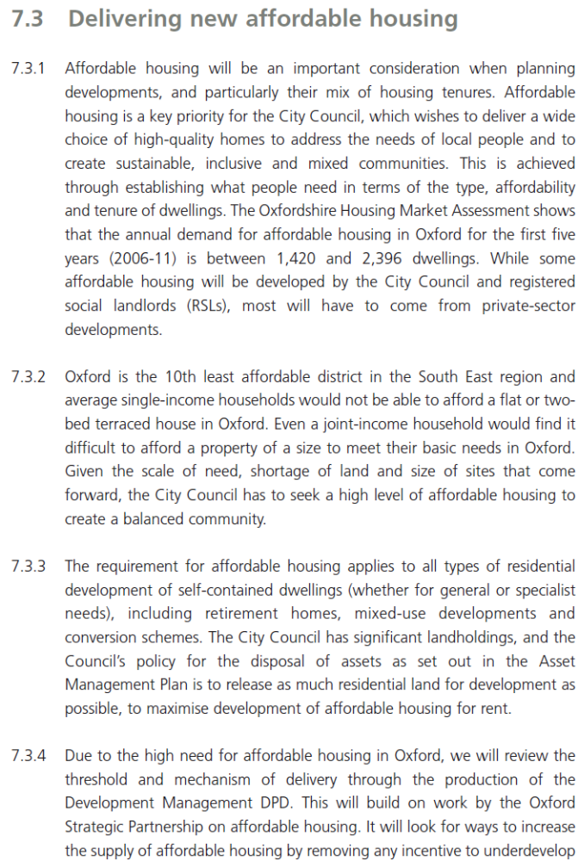

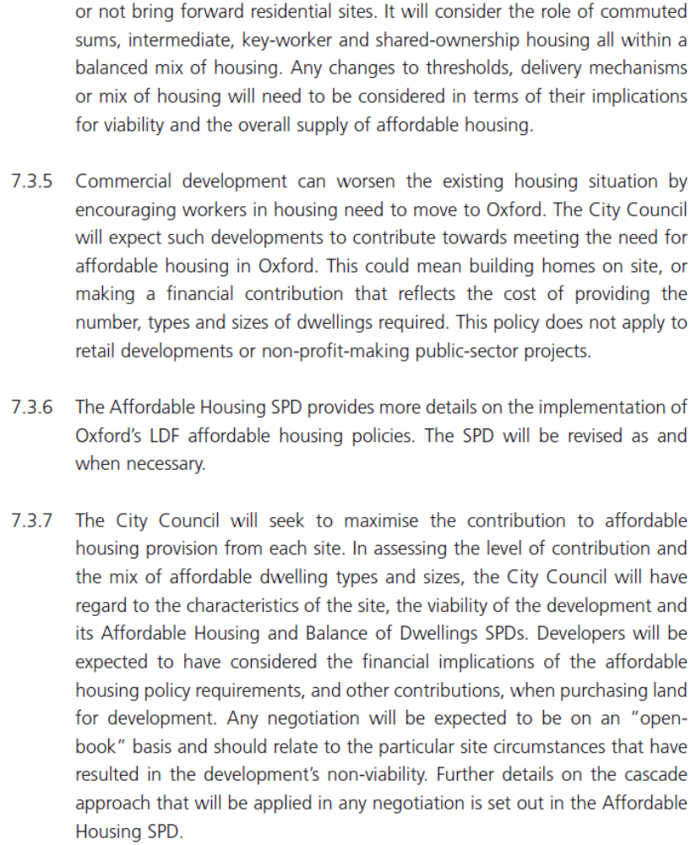
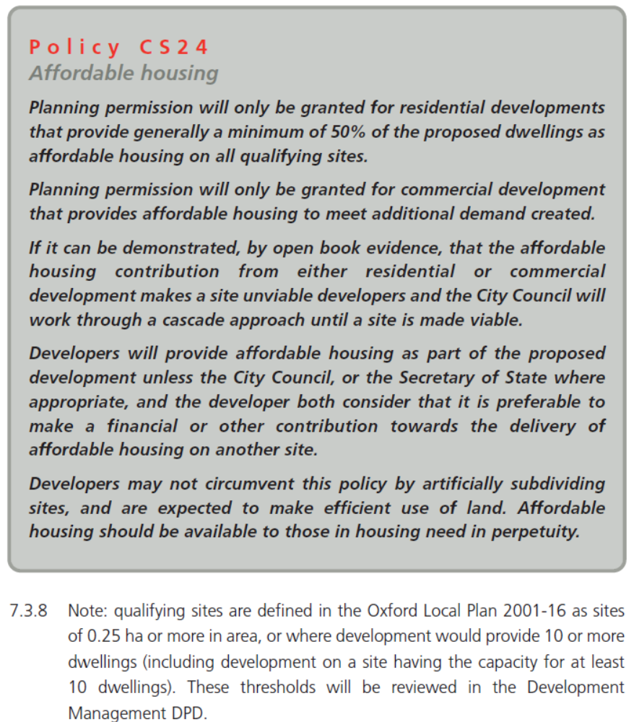
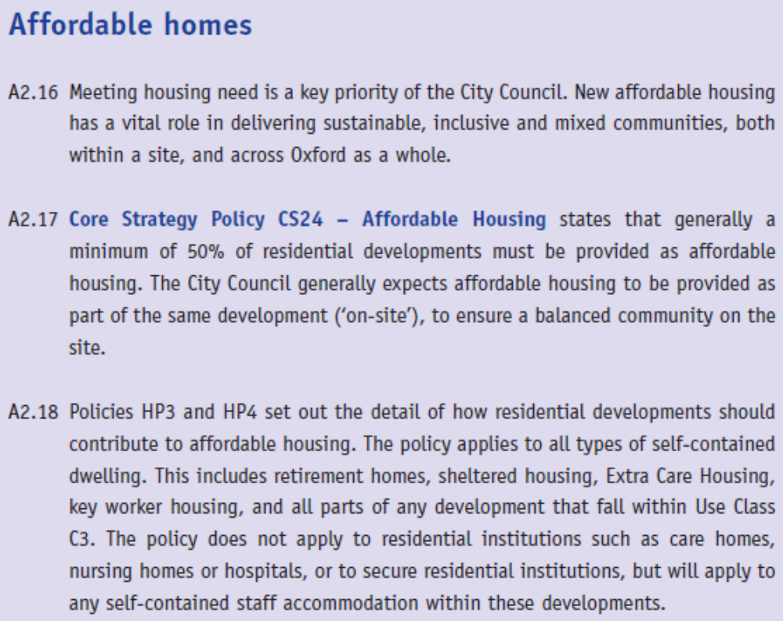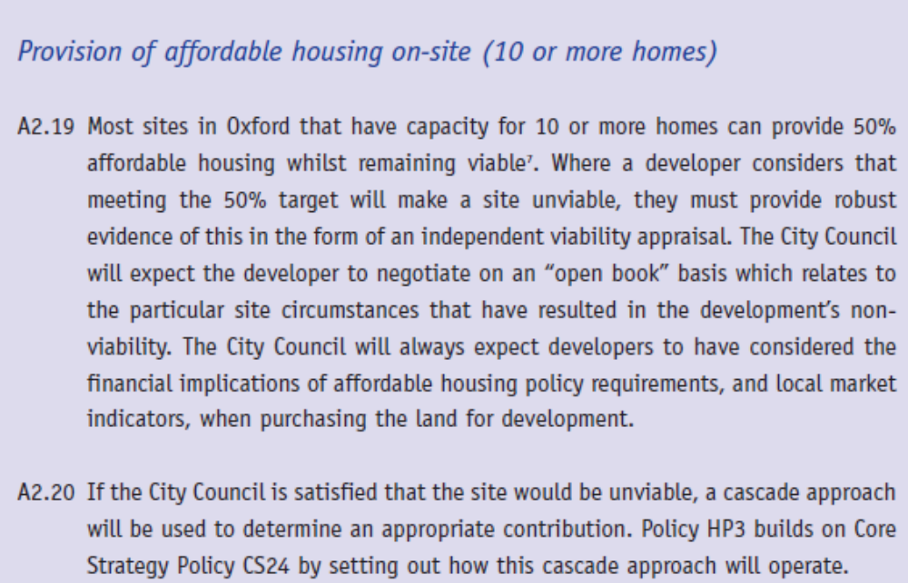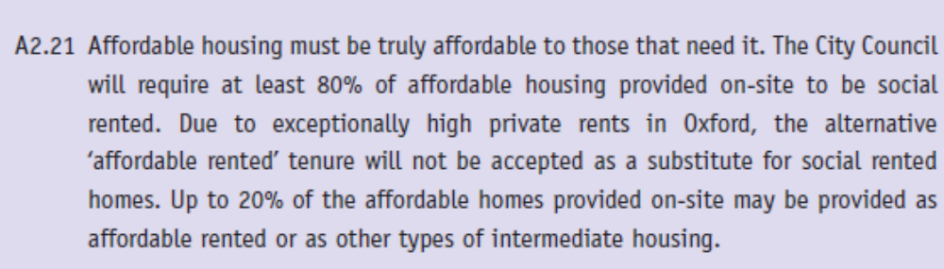

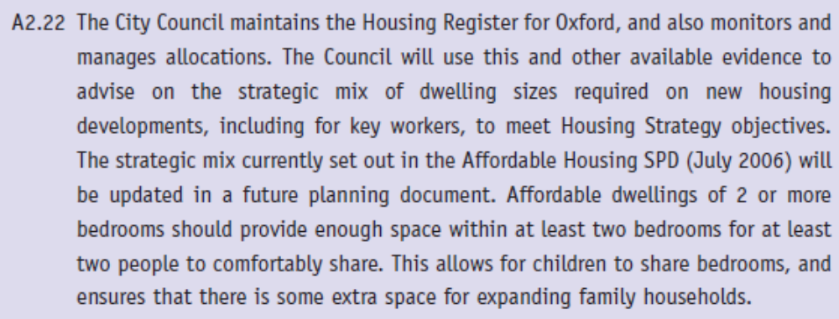
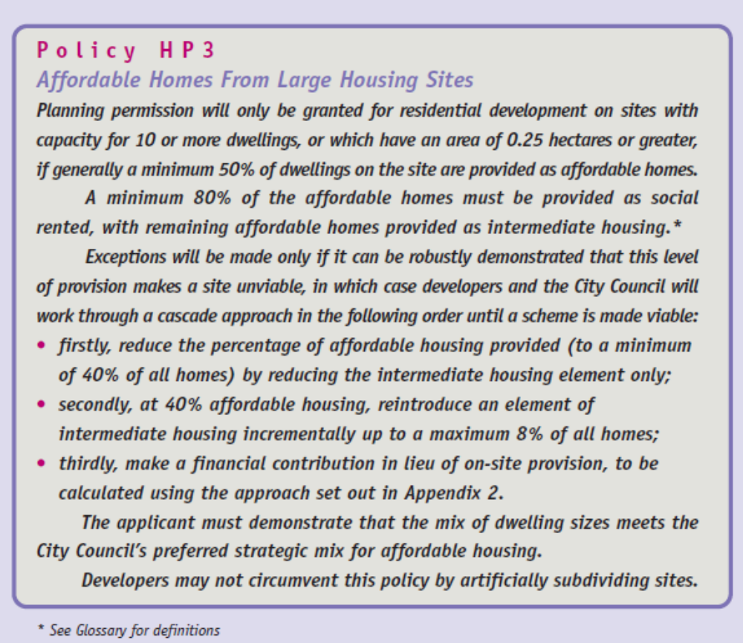
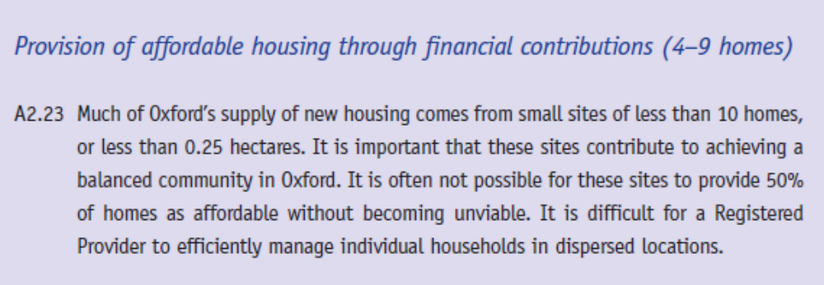
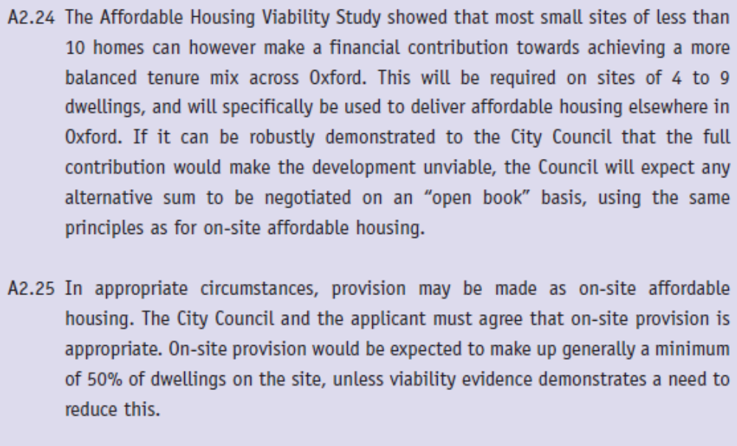
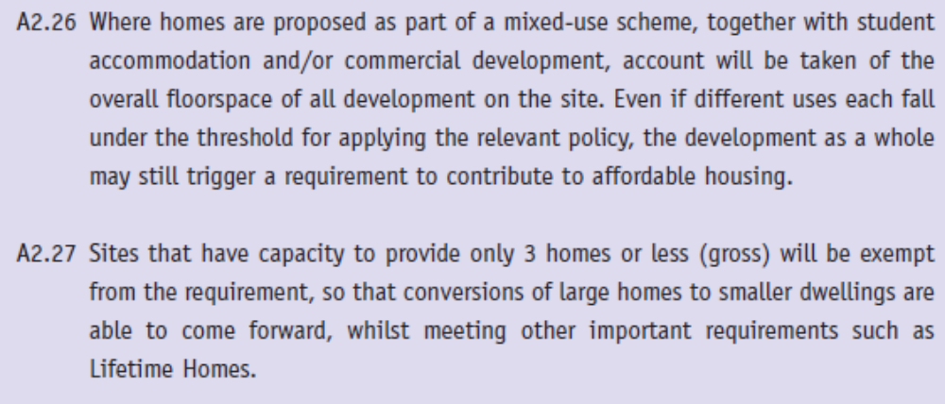
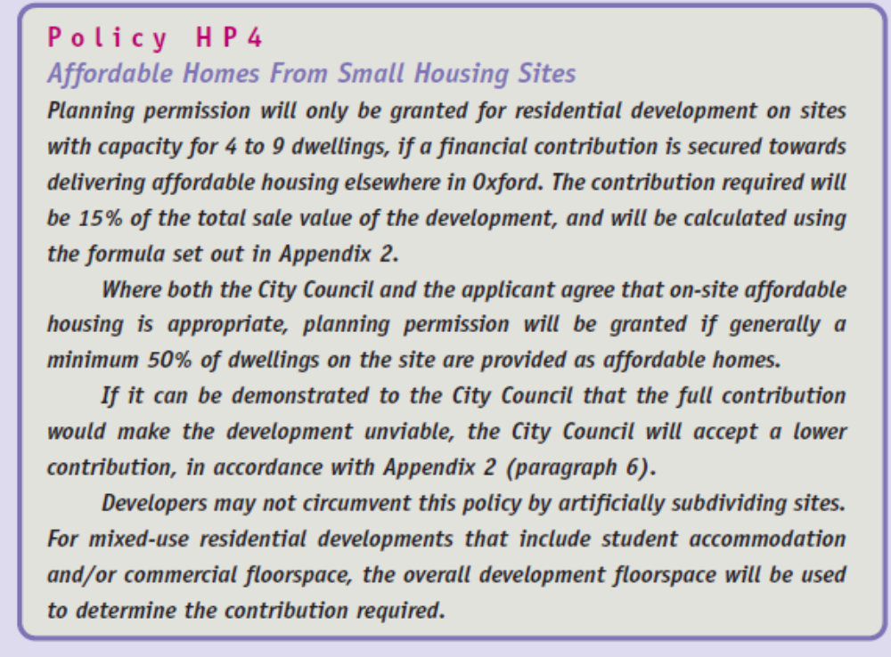
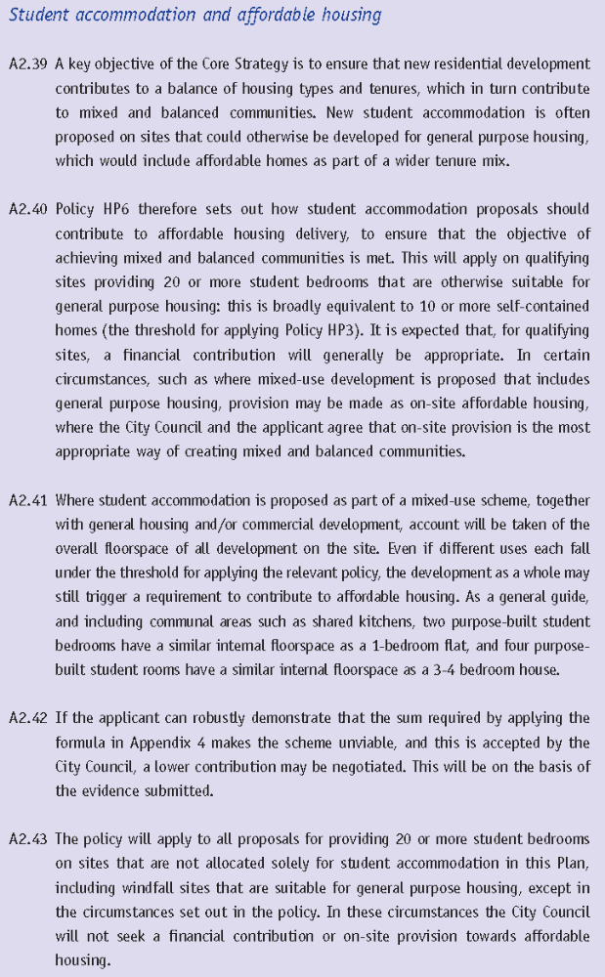
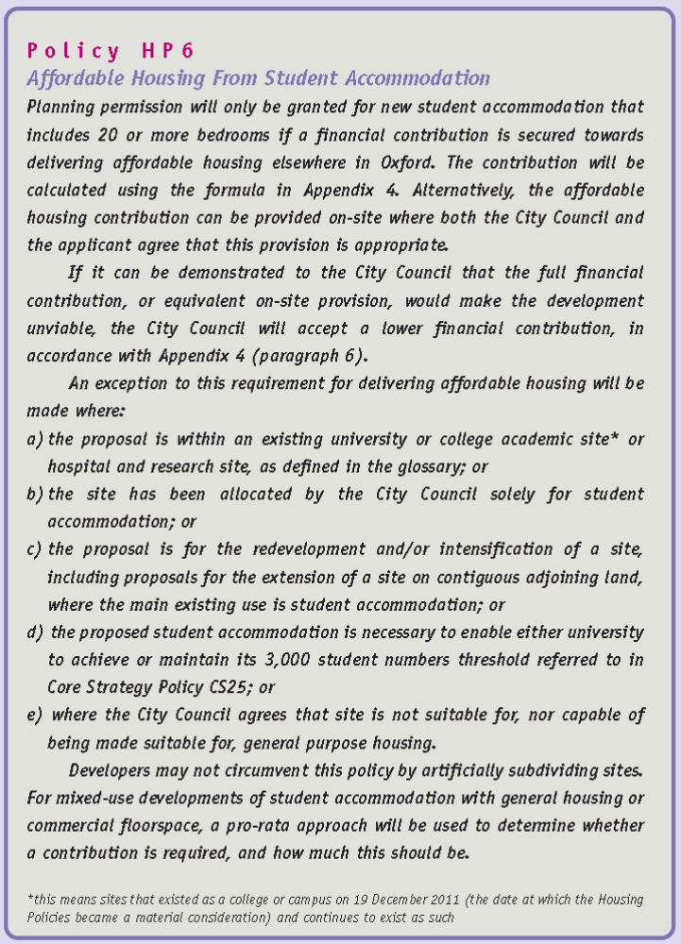
Appendix 2: Dwelling and student accommodation floorspaces

The table below shows typical floorspaces for different types of dwelling (gross internal area).

1 bedroom flat | 50m²
2 bedroom flat | 67m²
2 bedroom house | 75m²
3 bedroom house | 95m²
4 bedroom house | 100m²
5 bedroom house | 105m²
Source: Oxford Affordable Housing Viability Study (June 2011) (Appendix 7)

Student accommodation – single study bedroom | 25m² *
* includes an allowance for communal areas

Source: Oxford Affordable Housing Viability Study – Student Accommodation (Dec 2011)
Appendix 3: Viability appraisal

What is a viability appraisal?

- A viability appraisal is an assessment of whether the development of a site would create sufficient value such that both the landowner brings the site to the market, and the developer has sufficient profit to undertake the development.

- The Viability Appraisal Checklist provides details of what costs should be included in a viability appraisal, and how these should be used to assess viability.

When should one be submitted?

- In Oxford, a site viability appraisal is required where an applicant considers that policy requirements will make a site unviable, and should therefore be negotiated down.

- The appraisal should be submitted at the pre-application stage. If the City Council is content that it is robust, the outcome of the appraisal will be used as a basis for negotiating a reduced contribution for affordable housing. If, however, the City Council does not consider it robust, we will ask the applicant to review the assumptions and/or methodology, before the formal planning application is submitted.

- If an applicant decides to submit a viability appraisal with the planning application without first agreeing it with the City Council, we will undertake an initial audit to determine whether the appraisal is robust. If there is doubt regarding its robustness, this may lead to the application being refused.

How will the City Council consider viability appraisals?

- The City Council will, under normal circumstances, require the full contribution to be made in line with the Sites and Housing Plan policies HP3, HP4 and HP6. If the developer has evidence that the full level of on-site provision or financial contribution will make the site unviable, this evidence should be submitted as a full viability appraisal well before the formal application stage. This should have regard to the Viability Appraisal Checklist set out below.

- The City Council will assess the viability appraisal, using the Viability Appraisal Checklist. If the City Council considers there are significant shortcomings in the level or quality of information provided, or in the overall approach, we will ask the applicant to address these concerns and submit a revised viability appraisal.

- The Council must be in receipt of a draft viability appraisal that has enough information, and justification of assumptions, to allow a more detailed assessment. As any reduced affordable housing contribution is a departure from policy, the Council will wish to be fully satisfied that the reduced contribution offered is justified by a lack of viability. Depending on the robustness of the appraisal, the City Council may ask an independent RICS qualified consultant to provide an expert audit of the findings of the viability assessment.

- If either the Council or the independent consultant has found flaws in the viability appraisal, the applicant will be expected to either increase provision for affordable housing, or further refine the viability appraisal, to take account of the Council’s concerns. If the applicant is not willing to do this, it is likely the Council will recommend refusal (subject to formal consideration of the planning application).

- If the viability appraisal is accepted, the applicant may, in the context of the site, be asked to consider changing the density, dwelling mix and other scheme details as an alternative to reducing affordable housing contributions. This reflects the Council’s priority to increase the supply of affordable housing in Oxford.

Large (Major) and complex applications

- Where the viability appraisal involves a large site and/or complex inputs, officers may suggest a collaborative approach to assessing viability. This will take longer and be more expensive initially, but if done in good faith should lead to a much swifter resolution and potentially avoid the need for an appeal.

- Such an approach is likely to involve:

- Establishing a working group, to include Council officers, the applicant, the consultant commissioned to assess viability on behalf of the applicant, and the Council’s appointed consultant who will act as independent auditor;

- Agreeing as many aspects of the viability appraisal as possible in advance of the main assessment, e.g. an appropriate tool/model, existing use value, likely GDV, cost of build, etc.

- Reviewing the outcome, and agreeing between parties any further changes to the appraisal inputs and assumptions to ensure a robust outcome (i.e. ‘sensitivity testing’).

  - Due to the additional expense to the Council of such an approach (in terms of both officer time and consultancy fees), the Council will seek a contribution from the developer towards its additional expenses.

Viability Appraisal Checklist

Introduction

- The City Council has produced this Viability Appraisal Checklist to provide advice to applicants on the information the City Council would expect to be submitted if an applicant wishes to pursue a case of non-viability. This information is expected from the applicant if a development is proposed which does not provide the amount or type of affordable housing and/or financial contributions expected through Oxford’s Development Plan policies.

Open book approach

- The information provided as part of this checklist will be subject to scrutiny by the Council. This information will be used to inform the decision taken when determining a planning application, this information will therefore be publicly available.

- Providing full, clearly presented and fully justified details on development viability, on an open book basis, will streamline the planning application process and potentially allow a collaborative approach. Viability appraisals provided at the pre-application stage are encouraged to further speed up decision making.

- All costs must be justified, with clear references to supporting evidence, and will be critically scrutinised by the Council to ensure each element is robust. All valuations should have 3 independent valuations undertaken by qualified RICS surveyors.

Residual Land Value

- Whilst there are different ways that a viability appraisal can be undertaken, the City Council prefers the Residual Land Value method. This is the most commonly used approach, that takes account of the fact that development land value uplift viability will depend both on the market value of a redeveloped site (i.e. the future use), and also on all the costs that are borne by the developer, including planning and infrastructure costs, and the value of the site based on its current use and condition (i.e. the existing use value). Other methodologies, such as adopting a Threshold or Benchmark Land Value based on (sometimes limited) local market evidence, may not take full account of the impact that planning policies will have on land value, thus an artificially high ‘hope’ value for the site may skew the results.

- The Residual Land Value is the amount that a developer is able to pay for a site, whilst still being able to deliver the project. This is worked out by using the following formula:

EQUALS
LESS
LESS
LESS
LESS
Gross Development Value
Total Construction Cost
Community Infrastructure Levy + Section 106 (Planning Obligations)
Finance costs (interest on loans)
Developer’s profit
Residual land value

- In some circumstances, an existing landowner will be looking to dispose of a site, or the existing use may have ceased. In this scenario, if the Residual Land Value is equal to or greater than the Existing Use Value (EUV), then the development is viable.

- In other circumstances, a landowner may not need to sell a site. In this scenario the landowner will expect an incentive to sell, so a degree of uplift in the value of their land to make it worthwhile selling. In this scenario, an appropriate level of uplift in the Existing Use Value can be factored into the viability appraisal. The level of uplift on EUV will need to be fully justified based upon the circumstances of the site.

Calculating the Residual Land Value

- The following information will need to be set out in the viability appraisal:

1. Gross Development Value

- The Gross Development Value (GDV) is the value to be achieved if all units within the development were sold, either on the open market or, in the case of affordable units, to a Registered Provider (RP).

- If some or all of the development is to be retained in the ownership of the developer, the completed development will still have an open market value. The City Council would expect 3 independent valuations each undertaken by a different RICS qualified surveyor on the basis of capitalised rental income.

- The Gross Internal Area should be provided for each part of the development.

- The elements that might make up the total development value are:

- Market housing units: Total expected to arise from open market sales. The values arrived at must take account of real current market values for the type and location of development. The source of this information must be clearly justified. The value of the units should be evidenced by reference to other sales figures in the area, reflect the new build premium, and the expected market value at the time the units would come to the market, considering the time it would take to build the units.
- Social rented units: The value of units to be sold to an RP, on the basis of social rented tenure. Calculated by capitalising target social rents, allowing for deductions for repairs, voids/bad debts, management, maintenance and service charge.
- Shared ownership units: The value of units to be sold to an RP, on the basis of shared ownership with the maximum of 25% of each unit to be sold at open market value, and rent on the unsold equity of 2.75%. The sale element will be added to the capitalised rental income (allowing for deductions for repairs, voids/bad debts, management, maintenance and service charge) to arrive at an overall value that an RP can afford to pay for the unit.
- Intermediate rented / Affordable rented units: The value of units to be sold to an RP, on the basis of intermediate or affordable rent. Calculated by capitalising a rental income agreed (or likely to be agreed) with a partner RP, allowing for deductions for repairs, voids/bad debts, management, maintenance and service charge. Affordable rent should be assumed to be 80% of the equivalent market rent, unless there is solid evidence that the ratio will be lower.
- Student accommodation: The value of a student accommodation development will be calculated by capitalising the rental income of the completed development, allowing for deductions for repairs, voids/bad debts, management and maintenance. This income may vary over the course of a year, given that many such developments are let out to conference delegates out of term time. Future rental income may also depend on whether it is to be run or leased by a major institution, or privately let directly to students. It will be borne in mind that student accommodation developed by a public or charitable institution may be sold to a private provider in the future.

2. Construction costs

- The following elements may make up the total cost of construction:

- Basic build cost: This should normally align with current BCIS build costs. These will be different for different types of dwelling (e.g. flats compared with housing; conversion compared with new-build). If BCIS is not used, there must be robust and detailed justification as to why a different assumption has been applied.
- Demolition works: Relating to structures to be demolished to make way for new build development.
- Site servicing and infrastructure costs: A reasonable estimate of the cost of providing services to the site, and infrastructure within the site, based on BCIS data, or other robust costings specific to the site. Infrastructure covered by the Section 106 Agreement must not be double counted.
- Renewable energy: Such costs must relate to features that are over and above the cost of meeting current building regulations (Part L – conservation of fuel and power).
- Accessibility design features: Modest and justified additional costs may be assumed relating to meeting Lifetime Homes standards or to make a proportion of dwellings readily adaptable to Wheelchair Accessible Standard. Note that the requirements of Sites and Housing Policy HP2 generally relate to space and internal design, rather than to specialist features that go beyond building regulations (Part M). Applying BCIS build costs on a per m² basis would automatically take account of such costs.
- Specialist flood protection/mitigation: These may apply where the City Council or Environment Agency has advised that there is a requirement. These elements need to be fully costed and justified.
- Build contingency: A contingency margin is appropriate where justified, to take account of reasonable uncertainties and unknowns relating to the site.

3. Affordable Housing, Section 106 and CIL

- The level of the Section 106 Planning Obligation should be provided by the City Council in its role as Planning Authority. This includes contributions which are for County Council functions, such as education.

- In October 2013, the City Council expects to adopt its Community Infrastructure Levy Charging Schedule (CIL). CIL will replace most of the financial planning obligations which are currently required under S106. CIL is charge on the basis of a fixed rate per m² of different use class.

- In respect of other planning obligations, please see the Planning Obligations SPD (April 2007), or from adoption of the Community Infrastructure Levy Charging Schedule, see the Affordable Housing & Planning Obligations SPD (draft publication April 2013).

- Financial contributions towards the off-site provision of affordable housing are required from sites of 4-9 homes (gross) in line with the Sites and Housing Plan Policy HP4. Financial contributions are also required in line with Policy HP6 from student accommodation developments of 20 or more units (gross). Further detail will be set out in the Affordable Housing & Planning Obligations SPD (draft publication April 2013). The costings of these financial contributions needs to be clearly set out, and agreed with the City Council.

4. Finance and professional costs

- The following elements may make up the finance costs of a scheme:

- Finance: Details of project finance, related to phasing of construction and sales, should be clearly set out. The proportion of the overall cost to be met by securing bank loans, and the rate of interest applicable to these, should be included in the open book assessment.
- Professional fees: These may include fees for planning application, land acquisition, architect, planning agent, quantity surveyor, building control and stamp duty. The phasing of these costs should be appropriately timed (e.g. building control should not be applied until later build phase).
- Marketing and legal fees: These may include the reasonable costs of sales (e.g. marketing agent commission) and legal input for the sale or transfer of units. These costs must be benchmarked in line with current industry standards. The phasing of these costs should be appropriately timed; they will normally only apply to the later phases of development.

5. Developer profit

- Developer profit can be calculated as either profit on cost or profit on Gross Development Value (GDV). The City Council will expect the applicant to work on the basis of profit on cost. This is more transparent, and will therefore allow more effective discussion on viability issues.

- The level of developer profit will reflect the degree of risk to the developer. The required profit margin should by fully justified.

- The viability appraisal should assume that on-site affordable housing units do not require a developer’s profit. This is on the basis that the developer is not taking any risk with the delivery of affordable housing, for which there is a guaranteed buyer and price i.e. the Registered Provider to whom the affordable housing will be transferred on an agreed date.

6. Existing Use Value

- The EUV is what the site is worth in its current use and condition. The City Council would expect three EUV valuations, each of which must be undertaken by a different qualified RICS surveyor.

- The EUV is not necessarily the same as the actual land purchase price. Developers when purchasing a site should take account of adopted and emerging planning policies in agreeing a price. The Council will not accept overpayment for site purchase as a justification for non-viability.

Appendix 4: Contribution towards affordable housing from non-residential developments (Core Strategy Policy CS24)

Formula for calculating affordable housing contribution from non-residential developments

- The formula below will be used to calculate the required contribution towards affordable housing from qualifying non-residential developments:

EQUALS
MULTIPLIED BY
MULTIPLIED BY
Estimated number of employees in the new development

0.01
(i.e. 1% of employees)
Build cost of the required sizes and types of dwelling (one per employee)
+
Land cost
–
The amount equivalent to what would be payable by a Registered Provider of Social Housing

The sum payable

Employment densities

- The figures in Table A7 are expressed either as Net Internal Area (NIA), Gross Internal Floorspace (GIF), or Gross External Area (GEA). Information on a planning application form relates to Gross Internal Floorspace (GIF). The following conversion rates will be applied:

NIA = 85% x GIF
GEA = 105% x GIF (applicable to B8 uses)

Table A7 Table A4 Commercial developments by use class and whether of not a contribution towards affordable housing is sought
Use class |  | Contribution required? | Comment | Typical floor space per employee (sq m)
A1 | Shops | No | Contribution not required from retail development | n/a
A2 | Financial and professional services | No | Contribution not required from retail development | n/a
A3 | Restaurants and cafes | No | Contribution not required from retail development | n/a
A4 | Drinking establishments | No | Contribution not required from retail development | n/a
A5 | Hot food takeaway | No | Contribution not required from retail development | n/a
B1(a) | Offices | Yes | - | 12 (NIA)
B1(b) | Research and development | Yes | If no reliable information has been submitted by the applicant, a ratio equivalent to B1(a) will be assumed. | Information required from applicant.
B1(c) | Light industry | Yes | - | 47 (NIA)
B2 | General industrial | Yes | - | 36 (GIF)
B8 | Storage or distribution | Yes | Large scale and high bay warehousing may have a ratio of around 80 sq m | 70 (GEA)
C1 | Hotels | Yes | (1) Hotels may provide self-contained accommodation for their staff on site, which would reduce the level of contribution  (2) Budget hotels may have reduced staff of 1 employee per 3 bedrooms plus casual staff. 4/5 Star hotels may have additional staff of 1 employee per 1.25 bedrooms. | 1 employee per 2 bedrooms
C2 | Residential institutions | Yes | Residential institutions may provide self-contained accommodation for their staff on site, which would reduce the level of contribution | Information required from applicant
D1 | Non-residential institutions | Yes | - | Depends on specific use - information required from applicant
D2 | Cinemas | Yes | - | 90 (GIF)
D2 | Amusement & entertainment centres (including music and concert halls, bingo and dance halls) | Yes | - | 70 (GIF)
D2 | Sports centres and private clubs (including swimming baths, skating rinks, gymnasiums or areas for indoor or outdoor sports and recreations) | Yes | - | 65 (GIF)
 | Sui generis | Seek advice from the planning department

Build costs

- The build cost should be estimated on the basis of up-to-date BCIS data. The mix of units assumed should be equivalent to the strategic mix set out in Table 2 of this SPD, i.e. for housing sites outside the City and District centres. The typical dwelling size measurements set out in Appendix 2 of this SPD should be used to calculate the total cost per dwelling.

Land cost

- The land cost should be based on evidence from the Valuation Office Agency or Land Registry of the typical cost of residential development land in Oxford. The City Council currently uses a figure of £4million per hectare, this may be reviewed in light of updated evidence. The density of development should be assumed as 55 dwellings per hectare, which is considered a typical density for sites in Oxford.

Value of residential development

- To estimate the selling prices to a Registered Provider (RP), the City Council will use figures contained in the Affordable Housing Viability Study, or any update to these figures either published or expressly endorsed by the City Council. Values have been calculated on a zero grant basis. Selling prices for both social rented and shared ownership affordable housing vary with location within Oxford, therefore the specific site values used should correspond as closely as possible to the location of the development from which the contribution is sought.

- In calculating the amount that would be payable by an RP, developers should assume an 80/20 social rented/shared ownership mix and should base the mix of dwellings on the Strategic Mix as set out in Table 2 of the main SPD, i.e. assume that off-site affordable housing will be on a site outside the City centre.
Appendix 5: Standard Legal Agreement

STANDARD AGREEMENT

DATED 20

(NAME OF APPLICANT/DEVELOPER/OWNER)

- and -

THE OXFORD CITY COUNCIL

__________________________________________________________________

A G R E E M E N T

under Section 106 of the Town and Country Planning Act 1990
relating to (INSERT NAME OF SITE) and
planning application no. (INSERT REF)
___________________________________________________________________

Date:

File Ref :

This ‘skeleton’ agreement is in indicative model form for routine planning obligations. It is not intended to be definitive. Variations may be necessary to address site specific issues or to take account of further developments in law or practice.
THIS AGREEMENT by way of Deed is made on 20XX
B E T W E E N:
1 (Insert names and addresses of all those with interests (not chargees/mortgagees) in the land to be bound (registered office and registration numbers for companies)) “the Owner”)

2 THE OXFORD CITY COUNCIL of The Town Hall Blue Boar Street Oxford OX1 4EY ("the City Council")

3 (Insert names and addresses of all chargees/mortgagees in the land to be bound (registered office and registration numbers for companies)) “the Chargee”)

WHEREAS
1.1 The Owner is interested in land at [describe land (by reference to registered title is applicable)] (“the Land”) in the manner and to the extent set out in Schedule One hereto

1.2 The City Council is a local planning authority and the district planning authority for the administrative area of the City of Oxford for the purposes of the Town and Country Planning Act 1990 (“the Act”)

1.3 Application bearing reference [planning application number] (“the Application”) has been made to the City Council pursuant to Part III of the Act for planning permission to develop the Land by [description of development from planning application] (“the Development”)

1.4 The parties hereto have entered into this Agreement with the intent that its provisions be material to the determination of the Application

NOW THIS DEED WITNESSTH AS FOLLOWS

1 Interpretation

1.1 Save where contrary intention is shown the provisions of the Interpretation Act 1978 shall apply to the provisions hereof as if this Deed was an Act of Parliament

1.2 Save where contrary intention is shown the following expressions shall bear the following meanings herein

“Commencement of Development” means the date on which the Development permitted by the Permission is initiated within the meaning of section 56 of the Act and “commence” “commencement” and similar expressions shall be construed accordingly

“Index” means
in relation to any sum referred to in Schedule Two the Halifax Price Index for the South East

in relation to any other sum herein the BCIS All-In Tender Price Index published in the Quarterly Review of Building Prices by the Royal Institution of Chartered Surveyors

“Permission” means planning permission granted in determination of the Application

2 Statutory Authority

2.1 All obligations hereunder on the part of the Owner [and the Chargee] (howsoever expressed) are planning obligations for the purposes of section 106 of the Act entered into in respect of its interest in the land as particularised in Schedule One hereto enforceable against the Owner and his successors in title the obligations being enforceable by the City Council

2.2 All and any obligations hereunder on the part of the City Council are contractual obligations personal to the Owner (and not to any successor in title to the Land or assignable to any other person) entered into pursuant to section 111 of the Local Government Act 1972

3 Obligations

3.1 The Owner covenants with the City Council to observe and perform the requirements contained in the Schedules hereof

4 Miscellaneous

4.1 All sums payable hereunder shall be exclusive of any value added tax properly payable

4.2 The Contracts (Right of Third Parties) Act 1999 shall not apply to any of the provisions of this Agreement

4.3 All sums payable hereunder shall be paid subject to indexation which shall mean that should the value of the Index as at the date of payment (“the Payment Date Value”) exceed the value of the Index as at the date of this Agreement (“the Base Date Value”) the sum to be paid shall be the sum specified hereunder multiplied by the Payment Date Value and divided by the Base Date Value

4.4 In the event of the Chargee exercising powers under or by virtue of his charge upon the Land as particularised in Schedule One hereof the Chargee and his successors in title shall become liable hereunder as if he were the Owner PROVIDED ALWAYS that he shall not otherwise be liable hereunder

4.5 If any sum payable to the City Council hereunder is not paid in full (including any increase in consequence of clause 4.3 above) on or before the due date interest shall be due and payable to the payee at the rate of 4% per annum above the base lending rate of Lloyds TSB Bank PLC compounded monthly for the period from the due date until payment of the full amount due as at the date of payment

4.6 No alteration in the terms of this Agreement nor any forbearance or forgiveness on the part of the City Council in or in the extent or nature of any matter or thing concerning this Agreement shall in any way release the Owner from any liability hereunder

4.7 Nothing in this Agreement shall prejudice or affect the rights powers duties and obligations or the City Council in the exercise of its functions in any capacity

4.8 Where more than one person is liable under any provision hereof the liability shall be joint and several

4.9 All notifications approvals permissions consents or similar hereunder shall be in writing

4.10 The Owner shall permit the City Council full access to the land (save for buildings in residential or commercial occupation to which access shall be permitted on not less than 24 hours written notice) for any purpose in connection with this Agreement

In Witness whereof the parties have executed this Agreement as a deed on the day and year first before written

Schedule One

[Set out land ownership details (freehold and leasehold if relevant) including charges

If there are multiple parcels of land with differing ownerships deal with each separately by reference to the plan]

Schedule Two
[Affordable Housing – on site provision]

1 The Owner shall not cause or permit the Commencement ofr continuance of the Development prior to obtaining the written agreement of the City Council to a scheme for the provision of at least 50% of the total number of dwellings within the Development as Affordable Housing (“the Affordable Housing Scheme”) such scheme to provide

1.1 the locations of dwellings to be available at a rent or price that can be afforded by people who are in housing need and would otherwise not be able to compete in the general housing market and complying with the definition of Affordable Housing in the glossary to the Sites and Housing Local Plan (February 2013) (“Affordable Housing”) ensuring that the Affordable Housing is integrated into the Development as a whole

1.2 the details of the type and tenure of the Affordable Housing ensuring that at least 80% of the dwellings comprising the Affordable Housing is social rented housing complying with the definition in the glossary to the Sites and Housing Local Plan (February 2013) (“Social Rented Housing”) providing that
no less than [x%] and no more than [y%] of the Affordable Housing shall be 1 bedroom (2 person) Social Rented Housing with a minimum floorspace of 39 square metres
no less than [x%] and no more than [y%] of the Affordable Housing shall be 2 bedroom (4 person) Social Rented Housing with a minimum floorspace of 67 square metres
no less than [x%] and no more than [y%] of the Affordable Housing shall be 3 bedroom (5 person) Social Rented Housing with a minimum floorspace of 75 square metres
no less than [x%] and no more than [y%] of the Affordable Housing shall be 4 bed (minimum 7 person) Social Rented Housing with a minimum floorspace of 108 square metres (118 square metres if a 5 bedroom (8 person) unit increasing by 10 square metres per additional bedroom above 8 for units for more than 8 people)
no less than [x%] and no more than [y%] of the Affordable Housing shall be 1 bedroom (2 person) Intermediate Housing (which expression bear the meaning provided in the glossary to the Sites and Housing Local Plan (February 2013)) with a minimum floorspace of 39 square metres
no less than [x%] and no more than [y%] of the Affordable Housing shall be 2 bedroom (4 person) Intermediate Housing with a minimum floorspace of 67 square metres
no less than [x%] and no more than [y%] of the Affordable Housing shall be 3 bedroom (5 person) Intermediate Housing with a minimum floorspace of 75 square metres
[FOR PERCENTAGES PLEASE REFER TO TABLES 2 AND 3 OF THE SPD]

and showing that at least 5% of the dwellings comprising the Affordable Housing (where these will exceed three in number) will be fully wheelchair accessible, or of a design that allows future adaptation to become fully wheelchair accessible.

1.3 the contractual arrangements with a registered provider of social housing within the meaning of the Housing and Regeneration Act 2008 (including for the avoidance of doubt the City Council) (“Registered Provider”) for the delivery (both construction and transfer (or lease of not less than 125 years in the case of flats) of the Affordable Housing including a copy of such completed contract certified as a true copy by a solicitor

1.4 the servicing of the Affordable Housing and the allocation of responsibility for such servicing and the cost of such servicing

2 In the event that the Registered Provider is not the City Council the Owner shall not cause or permit the Commencement of continuance of the Development prior to that Registered Proprietor having entered into a framework agreement applicable to the Affordable Housing to be provided hereunder with the City Council for partnership working in relation to the operation of a shared register of people in need of Affordable Housing in the administrative area of the City Council and the allocation of Social Rented Housing

3 The Owner shall not cause of permit the occupation of more than 25% of the dwellings (excluding those specified as Affordable Housing) authorised by the Permission until

3.1 50% of the dwellings comprising the Affordable Housing have been fully constructed and are finished ready for immediate residential occupation in accordance with the Affordable Housing Scheme and

3.2 (as regards that 50%) the leasehold interest of those dwellings comprised within the Affordable Housing which are flats and/or the freehold interest of those dwellings comprised with the Affordable Housing which are not flats have been transferred to the Registered Provider such grant and/or transfer to be prepared by solicitors instructed by the Owner and at the cost of the Owner in substantially the form attached and marked “AH Grant of Lease” and “AH Transfer” respectively

4 The Owner shall not cause of permit the occupation of more than 50% of the dwellings (excluding those specified as Affordable Housing) authorised by the Permission until

4.1 75% of the dwellings comprising the Affordable Housing have been fully constructed and are finished ready for immediate residential occupation in accordance with the Affordable Housing Scheme and

4.2 (as regards that 75%) the leasehold interest of those dwellings comprised within the Affordable Housing which are flats and/or the freehold interest of those dwellings comprised with the Affordable Housing which are not flats have been transferred to the Registered Provider such grant and/or transfer to be prepared by solicitors instructed by the Owner and at the cost of the Owner in substantially the form attached and marked “AH Grant of Lease” and “AH Transfer” respectively

5 The Owner shall not cause of permit the occupation of more than 75% of the dwellings (excluding those specified as Affordable Housing) authorised by the Permission until

5.1 all of the dwellings comprising the Affordable Housing have been fully constructed and are finished ready for immediate residential occupation in accordance with the Affordable Housing Scheme and

5.2 the leasehold interest of those dwellings comprised within the Affordable Housing which are flats and/or the freehold interest of those dwellings comprised with the Affordable Housing which are not flats have been transferred to the Registered Provider such grant and/or transfer to be prepared by solicitors instructed by the Owner and at the cost of the Owner in substantially the form attached and marked “AH Grant of Lease” and “AH Transfer” respectively

6 The Owner will procure that all dwellings comprised within the Affordable Housing shall
6.1 meet all requirements of Homes and Community Agency Design Quality Standards and Housing Quality Indicators that (were that Agency funding their provision) would be applicable to them
6.2 comply with Lifetime Homes standards then applicable
6.3 show compliance with Secure By Design standards then applicable

7 The Owner shall not cause permit or allow occupation of any dwelling comprised within the Affordable Housing other than as Affordable Housing in accordance with the Affordable Housing Scheme

8 The Owner shall not cause permit or allow all or any dwelling comprised within the Affordable Housing to be disposed of for a consideration (howsoever constructed) in excess of [x%] of the value that would otherwise be achievable on the open market in the event that the provisions of this Schedule Two were not applicable thereto

9 The Owner shall not cause permit or allow all or any dwelling comprised within the Affordable Housing to be occupied at a weekly/monthly cost to the occupier in respect of the right to so occupy (including for the avoidance of doubt any service charges) in excess of [x%] of the sum that would otherwise be achievable on the open market in the event that the provisions of this Schedule Two were not applicable thereto

[Affordable Housing – contributions]

[HP3/HP4]
10 The Owner shall not cause or permit more than 50% of the dwellings comprised within the Development to be residentially occupied prior to paying to the City Council the sum of 15% of the combined sales value of all dwellings that may be occupied lawfully for planning purposes pursuant to the Permission the sales value in respect of each such dwelling being the then last available price at which such dwelling was legitimately advertised for sale OR such sum representing the actual sale price as the Owner may evidence to the satisfaction of the City Council OR a sales value which is the average (mean) value arising from at least two three professionally conducted valuations submitted in writing by two three separate and independent Chartered Surveyors each of whom shall be full members of the Royal Institute of Chartered Surveyors

[HP6]
11 The Owner shall not cause or permit the Development to be occupied as student accommodation prior to paying to the City Council the sum of £140 multiplied by the gross internal floor area permitted by the Permission for student accommodation the internal floor area to be calculated in accordance with the RICS “Red Book” then in effect

12 [if student accommodation of the Universities within HP6(d)] The Owner shall not cause or permit the Development to be residentially occupied other than for student accommodation for either Oxford University or Oxford Brookes University without first paying to the City Council the sum of £140 multiplied by the gross internal floor area permitted by the Permission for student accommodation the internal floor area to be calculated in accordance with the RICS “Red Book” then in effect

[CS24]
13 The Owner shall not cause or permit the Development to be occupied as [IDENTIFY RELEVANT COMMERCIAL USE] prior to paying to the City Council the sum of £[x]

Schedule Three
[Matters other than Affordable Housing]

1 The costs of the City Council

1.1 The Owner shall pay to the City Council on completion of this Agreement the legal costs of the City Council in connection with the preparation and completion of this Agreement

1.2 The Owner shall pay to the City Council on completion of this Agreement the sum of [XXXXX] being a contribution towards the costs of the City Council in connection with the administration and management of this Agreement (including the payments further to this Agreement) [ Calculated as per SPD]

2 Bond

2.1 The Owner shall not cause or permit the commencement or continuance of the Development at any time that there are outstanding obligations hereunder that he has not procured that the City Council is in possession of an extant bond with at least 3 months remaining prior to its date of expiry in a form with a bondsman and to a value acceptable to the City Council (having regard to the then outstanding obligations) providing that in the event of default hereunder the bondsman shall be liable to the extent of that default

3 Notifications

3.1 The Owner shall not cause or permit the commencement or continuance of the Development unless the Owner has given notice of commencement of the Development to the City Council such notice specifying the intended date for commencement

3.2 The Owner shall give notice to the City Council of any disposal of his interest in the Land (or part thereof) or any other event giving rise to a successor in title (other than disposals of individual dwellings) providing the name and address of that successor the date of disposal and a plan identifying the land affected such notice to be provided within 14 days of the disposal or other event giving rise to a successor in title

3.3 On each anniversary of Commencement of Development until completion of the Development the Owner shall give notice to the City Council identifying the extent to which the Development has been executed

3.4 [if student accommodation (CS25 / ED10)] The Owner shall on each anniversary of the Commencement of Development notify the City Council particularising how many occupiers of the Development are in full time education on a course of not less than one academic year in length

3.5 [if student accommodation of the Universities within HP6(d)] The Owner shall on each anniversary of the Commencement of Development notify the City Council particularising how many occupiers of the Development are in full time education on a course provided by the University of Oxford / Oxford Brookes University and how many occupiers of the Development there are in total.

4 Public Art

4.1 The Owner shall not cause or permit the Commencement or continuance of the Development unless the written approval of the City Council has been obtained for a scheme for the provision of public art such scheme to provide for consultation and approval of the item or items comprising the public art (including design appearance materials and location) commissioning execution of all required works for the item or items comprising the public art and subsequent maintenance including a timetable for each stage by reference to time from Commencement of Development and/or prior to the commencement/completion/occupation of specified elements of the Development

4.2 The Owner shall ensure that the approved scheme referred to in paragraph 4.1 above is executed in its entirety and shall notify the Council of the completion of each distinct element

4.3 In the event that there is an extant breach of the approved scheme referred to in paragraph 4.1 above the Owner shall not cause or permit any further works for the execution of the Development or the occupation of any part of the Development not previously occupied

4.4 In the event that the City Council notifies the Owner of a desire to acquire any element of the approved scheme referred to in paragraph 4.1 above no later than 12 months after receiving notification in respect of that element that the same is complete then in respect of that element
4.4.1 the Owner shall continue to maintain that element for a further 12 months at which date it will execute and deliver a transfer to the City Council in a form approved by the City Council
4.4.2 the Owner shall (no later than the date on which it complies with paragraph 4.4.1 above) pay to the City Council the sum certified by the City Council as its anticipated costs of maintenance for a ten tear period

4.5 upon compliance with paragraphs 4.4.1 and 4.4.2 above the obligations upon the Owner to further maintain that element shall cease

5 Public Open Space / Amenity Areas / Play Areas

5.1 The Owner shall not cause or permit the Commencement or continuance of the Development prior to obtaining the written approval of the City Council to a public open space scheme such scheme to provide
5.1.1 the locations and details of each area of amenity and/or recreational open space (providing specifications of equipment where equipment is proposed) proposed within the Land as part of the Development sufficient to ensure that the needs of all those likely to use the Development will be met
5.1.2 a timetable for the provision of each and every element by reference to such element being available for functional public use either prior to a defined part of the Development being commenced or occupied for the purpose permitted by the Permission
5.2 The Owner shall comply fully with all aspects of the approved scheme referred to in paragraph 5.1 above and shall notify the City Council of each and every element of the approved scheme referred to in paragraph 5.1 above first being made available for public use
5.3 The Owner shall in respect of each and every element of the approved scheme referred to in paragraph 5.1 above from the date on which it is first made available for public use
5.3.1 keep it available for free public use at all times restricting public access only as may be required by law
5.3.2 maintain it such that it does not materially deteriorate
5.4 The Owner shall not cause or permit the commencement or carrying on of any works for the provision of any element of the approved scheme referred to in paragraph 5.1 above prior to obtaining the written approval of the City Council to a mechanism to ensure future compliance with the obligations of the Owner pursuant to paragraphs 5.3.1 and 5.3.2 above.
5.5 In the event that the City Council notifies the Owner of a desire to acquire any element of the approved scheme referred to in paragraph 5.1 above within 12 months of receiving notification in respect of that element as referred to in paragraph 5.2 above then in respect of that element
5.5.1 the Owner shall continue to maintain that element for a further 12 months at which date it will execute and deliver a transfer to the City Council to the City Council in a form approved by the City Council
5.5.2 the Owner shall (no later than the date on which it complies with paragraph 5.5.1 above) pay to the City Council the sum certified by the City Council as its anticipated costs of maintenance for a ten year period
5.5.3 upon compliance with paragraphs 5.5.1 and 5.5.2 above the obligations upon the Owner pursuant to paragraphs 5.3.1 and 5.3.2 above in respect of that element shall cease
6 Species relocation

6.1 The Owner shall not cause or permit the Commencement or continuance of the Development prior to obtaining the written approval of the City Council to a scheme for the relocation of [IDENTIFY SPECIES] (“the Species Relocation Scheme”) such scheme to provide
6.1.1 the locations and details of each area proposed for the species to be relocated to together with a schedule of the works proposed to firstly render those areas suitable for the relocated species and secondly to effect the relocation of that species
6.1.2 a timetable for the provision of each and every element by reference to such element being effected either prior to a defined part of the Development being commenced or occupied for the purpose permitted by the Permission and in any event at such time as to ensure that the Development does not adversely impact upon the species to be relocated in its original location
6.1.3 post relocation maintenance and protection arrangements

6.2 The Owner shall comply fully with all aspects of the Species Relocation Scheme referred to in paragraph 6.1 above and shall notify the City Council of each and every element of the approved scheme referred to in paragraph 6.1 above being completed

6.3 In the event that the City Council notifies the Owner of a desire to acquire any area of the Species Relocation scheme referred to in paragraph 6.1 above within 12 months of receiving notification in respect of that area as referred to in paragraph 6.2 above that all works of preparation and relocation have been completed then in respect of that area
6.5.1 the Owner shall continue to maintain that area for a further 12 months at which date it will execute and deliver a transfer to the City Council in a form approved by the City Council
6.5.2 the Owner shall (no later than the date on which it complies with paragraph 6.5.1 above) pay to the City Council the sum certified by the City Council as its anticipated costs of maintenance for a ten year period
6.5.3 upon compliance with paragraphs 6.5.1 and 6.5.2 above any ongoing maintenance and protection obligations upon the Owner pursuant to paragraph 6.2 above in respect of that area shall cease

7 On site Habitats / Biodiversity Creation / Protection

7.1 The Owner shall not cause or permit the Commencement or continuance of the Development prior to obtaining the written approval of the City Council to a scheme for the creation of a habitat suitable for [xxxxx] (“the Habitat Creation Scheme”) such scheme to provide
7.1.1 the locations and details of each area proposed for the habitat together with a schedule of the works proposed to firstly render those areas suitable for its purpose and secondly to effect the establishment of the intended flora and/or fauna
7.1.2 a timetable for the provision of each and every element by reference to such element being effected either prior to a defined part of the Development being commenced or occupied for the purpose permitted by the Permission
7.1.3 post provision maintenance and protection arrangements

7.2 The Owner shall comply fully with all aspects of the Habitat Creation Scheme referred to in paragraph 7.1 above and shall notify the City Council of each and every element of the approved scheme referred to in paragraph 7.1 above being completed

8 Travel Planning

8.1 The Owner shall not cause or permit the Commencement or continuance of the Development prior to obtaining the written approval of the City Council to a plan for the facilitation of transportation to and from the Development in a manner minimising the overall need to travel; minimising the need to rely upon the private motor vehicle; and maximising opportunities to travel by more sustainable modes (“Travel Plan”) such scheme to provide
8.1.1 for the establishment of targets for the total number of journeys to and from the Development by specified modes of travel
8.1.2 for the implementation of initial steps designed to achieve the targets referred to in paragraph 8.1.1
8.1.3 for the monitoring of the total number of journeys to and from the Development by specified modes of travel at least [twice each year/annually – delete as appropriate]

8.2 The Owner shall not cause or permit the Commencement or continuance of the Development prior to appointing for a period starting immediately and expiring ten years from the first [residential/B1/insert appropriate use] occupation of the Development an individual agreed in writing by the City Council to act in connection with the Travel Plan (“the Travel Coordinator”)

8.3 The Owner shall make available to the Travel Coordinator the sum of [£x] upon his/her appointment for expenditure upon the steps referred to in paragraph 8.1.2 above

8.4 On the first nine anniversaries of the first [residential/B1/insert appropriate use] occupation of the Development the Owner shall make available to the Travel Coordinator the sum of [£x] for expenditure on such further measures as the Travel Coordinator considers necessary for the advancement of the objectives of the Travel Plan

8.5 The Owner shall procure that each and every sum made available to the Travel Coordinator under this paragraph 8 is fully expended for the purposes of the Travel Plan within 12 months of receipt

8.6 The Owner shall procure that a full written report of the monitoring referred to in paragraph 8.1.3 above is provided to the City Council within 30 days of each instance of such monitoring being completed

9 Cycle / Pedestrian routes

9.1 The Owner shall not cause or permit the Commencement or continuance of the Development prior to obtaining the written approval of the City Council to a route specification of works and timetable for those works for the provision of [identify number, type and approx location / terminal points] of permissive routes through the Land (“Cycle / Pedestrian Route Scheme”)

9.2 The Owner shall fully execute the Cycle / Pedestrian Route Scheme in accordance with its terms and thereafter maintain the routes provided such that they do not materially deteriorate

9.3 The Owner shall permit passage and repassage on foot by the public at large at all times without obstruction or interruption over all routes provided as permissive footpaths pursuant to the Cycle / Pedestrian Route Scheme

9.4 The Owner shall permit passage and repassage on foot and by cycles by the public at large at all times without obstruction or interruption over all routes provided as permissive cyclepaths pursuant to the Cycle / Pedestrian Route Scheme

10 Joint Use

[CASE BY CASE NEGOTIATION]

[The obligations will prohibit the use of the premises other than in accordance with a joint use agreement the details of which will either be set out in full or will require to be agreed prior to first occupation.

The obligations will identify the facilities (there may be different provisions applicable to different facilities) to be subject to joint use providing that local groups and/or local residents shall be permitted to use all or specified parts of the facilities during specified times (which may be varied from time to time by agreement) on terms and conditions (including charges) for booking and usage of those facilities. Those terms and conditions may be by reference to comparable City Council facilities, the basis upon which the facilities are made available to those the facilities are primarily provided for or some bespoke basis.]

Appendix 6: Standard Unilateral Undertaking

STANDARD UNILATERAL UNDERTAKING

DATED______________________20___

[NAME OF APPLICANT/DEVELOPER/OWNER]

-and-

OXFORD CITY COUNCIL

PLANNING OBLIGATION (by Unilateral Undertaking)
Relating to development at

[insert name and address of the site]

THIS UNILATERAL UNDERTAKING is given on [insert date] 20

BY [INSERT NAME OF APPLICANT/DEVELOPER/OWNER]
whose registered office is at [insert address of applicant/developer/owner] [‘the Applicant’]

TO THE OXFORD CITY COUNCIL whose principal office is at The Town Hall Blue Boar Street Oxford OX1 4EY (‘the Council’)

1. Interpretation

In this Deed

1.1 ‘the 1990 Act’ means the Town and Country Planning Act 1990 (as amended)
1.2 ‘the Infrastructure’ means [insert description of infrastructure provision]
1.3 ‘the Contribution’ means the sum of £x
1.4 ‘the Planning Application’ means [insert details of application]
1.5 ‘the Site’ means [insert application address and refer to site plan]

2. Preliminary

  - The Applicant is the [freehold] owner [of a lease] of the Site
  - The City Council is the local planning authority for the City of Oxford for the purposes of the Town and Country Planning Act 1990.
  - The Applicant has submitted the Planning Application to Oxford City Council and Oxford City Council is minded to grant planning permission for the Development subject to the completion of this Deed
  - This Deed is made under Section 106 of the 1990 Act and is a planning obligation for the purposes of Section 106 of the 1990 Act entered into by the Applicant in respect of the Site and enforceable by the Council

3. Covenants

3.1 The Applicant covenants to pay the Contribution to the Council on the date of this undertaking to be applied towards the cost of the Infrastructure

3.2 The Applicant covenants to pay £100 on the date of this undertaking towards the costs of administering and managing this Deed

4 Acknowledgements

The Applicant acknowledges that nothing contained or implied in this Deed shall prejudice or affect the rights discretion powers and duties and obligations of the Council in the exercise of their functions

5. Third Party Rights

This Deed is enforceable by the Council but otherwise it confers no rights under the Contract (Rights of Third Parties) Act 1999

EXECUTED AS A DEED by )

[insert name of Applicant/Developer/Owner] )
Director

Director/Secretary

Definition taken from Definitions of General Housing Terms (DCLG, 2012) (www.gov.uk)
References to RPs also apply to the City Council as affordable housing provider
See Sites and Housing Plan Glossary for full definition of Social Rented Housing
The City Council may, in future, review Tables 1 and 2 in light of updated evidence.
Figures sourced from HCA Housing Quality Indicators (Updated April 2008) except for 1 bedroom (2 person) unit which is consistent with Sites and Housing Policy HP12
Source: Employment Densities Guide 2nd Edition (Homes and Communities Agency, 2010)
Oxford Affordable Housing Viability Study (King Sturge, 2011) Appendix 7

