Oxford City Council Corporate Plan 2012–2016

Contents

1. Foreword from the Leader of the Council and the Chief Executive

2. Our City

3. Your Council: who we are and what we do

4. Your Council: political structure (to be inserted)

5. Management structure (to be inserted)

6. Corporate Priorities

- A vibrant and sustainable economy
- Meeting housing need
- Strong and active communities
- Cleaner greener Oxford
- An efficient and effective council.

7. Working with others

8. Spending plans 2012-16 (to be inserted after agreement of the budget in February 2012)

9. Conclusion.

Foreword from the Leader of the Council and the Chief Executive

Welcome to Oxford City Council’s Corporate Plan for 2012–2016

The Corporate Plan is the City Council’s key strategic document. This plan updates and takes forward the main themes of the plan that was agreed by the Council last year. It sets out the Council’s strategic direction over the next five years. It also highlights key areas of new investment.

The Corporate Plan 2012-16 reaffirms the Council’s ambition – developed with our partners, including local business, community organisations, the health and education sectors and the County Council – to make Oxford a world-class city for all its citizens. Our plans to work with those partners to improve educational attainment and youth provision in the city – key factors in enabling our young people to access the labour market and economic and social life chances - represent significant new areas of investment for the City Council.

The Corporate Plan also affirms the next stage of our plans for transforming the Council’s operational efficiency. We are increasing our effectiveness in service delivery year on year, and are committed to continuous improvement in high quality services which provide excellent value for money.

Over the last three years we have made significant steps toward realising these objectives. We have made efficiency savings of around £4m a year. Further reductions of £9.5m are planned over the period 2011/12 – 2014/15. £5.9m of the total savings relate to the delivery of further efficiencies across the organisation. A further 2% reduction will be made thereafter up until 2015/16. At the same time as improving efficiency we have also improved performance across 84% of our indicators.

Over the last twelve months, we have made good progress in delivering our broader aspirations for the city generally and, in particular, for its more deprived communities. We are investing in Oxford’s future through a range of capital projects which will create housing, jobs, and an improved quality of life for our citizens.

In the last year we have:
- entered into a joint venture with Grosvenor Estates to build up to 1000 new homes in Barton, and contracted with Green Square to build 100 new homes and two new community centres in Northway and Cowley
- completed the refurbishment of over 50 play areas as part of a £2.5m investment in improving all the city’s play facilities
- progressed our plans to build a new, competition standard pool in Blackbird Leys
- opened the Old Fire Station as a combined Crisis Skylight and Arts Centre in November 2011. The facility combines a range of modern and flexible spaces for cultural and arts activities alongside training and support for employment in the creative and hospitality industries
- reduced our city centre office and carbon footprint by transforming St Aldate’s Chambers into a modern, flexible working space which can accommodate most of our staff and selling our Blue Boar Street offices; the Ramsay House office space is also on the market
- improved the quality of our website to offer most of our services – including payments - on-line
- created a corporate call centre service with one number for all Council services
- opened a new, state-of-the art customer services centre in St. Aldate’s Chambers where customers can receive answers to queries about all Council services
- invested further in information technology through our customer relationship management and performance management systems. Investment is critical in developing more efficient and timely service delivery.

We have also:
- achieved Investors in People accreditation for the whole Council in May 2011. This reflects the level of staff engagement with our transformation programme
- achieved accreditation in the Equalities Framework for Local Government
- improved employee attendance and reduced sickness absence by 25%.

The Audit Commission’s annual assessment of the City Council’s performance says: “This is good performance given the economic backdrop and financial pressures”. It also confirms that the Council’s use of public funds achieves economy, efficiency and effectiveness.

This Corporate Plan sets out details of the progress that we have made across all areas of the Council’s work, and sets out our plans for the next four years.

We have delivered these improvements against a backdrop of severe spending cuts by central government. The Comprehensive Spending Review for the period 2011-15 set out a major programme of public spending cuts. Local government has been hit hardest of all areas by these cuts. Oxford City Council’s net budget for 2010-11 was £29.1m. As a result of the cuts required by government, the budget agreed by Council in February 2011 will reduce the Council’s net annual expenditure for 2011-15 to £24.1m. During this time there will be increases that we cannot avoid in salaries, pension costs, and general inflation. As a result of these cost increases, our reduction in costs will amount to more than £9m by 2014-15.

It is a tribute to the strong partnership between councillors, council managers and staff, and the trade unions that - against this background - Oxford City Council has been able to agree financial measures which will allow us to continue investing in the city, protecting our core services - particularly those that serve the most vulnerable in our community - and minimising redundancies.

Looking to the future
There are more challenges to come. The government’s economic austerity measures have failed to meet the deficit reduction targets. Changes to the way that council housing is funded will mean that local authorities will be responsible for financing their own housing stock while losing homes under a new discounted right-to-buy scheme. The proposed re-localisation of business rates may mean that the Council would receive no General Fund grant at all after 2013. And the introduction of a new Universal Credit scheme in 2013 has the potential to cause disruption to the incomes of many of the most vulnerable people in our community. The Council also faces increased demand for services as a consequence of the recession and deficit reduction initiatives by other organisations.

The hallmark of the Council’s approach to delivering its ambitions has been: strong financial management; partnership between councillors, council managers and staff, and trade unions; focus; consistency; and a commitment not to be knocked off course by external events. We intend to maintain this approach.

We are strongly committed to our core ambition of building a world class city for everyone. The priorities that have underpinned that ambition from the outset four years ago are unchanged:
- A vibrant and sustainable economy
- Meeting housing needs
- Strong and active communities
- Cleaner greener Oxford
- An efficient and effective council.

The Council’s key commitments in the immediate future include managing the external challenges that we face and addressing the following themes and projects:
- Investing in Oxford's future
  - delivering physical regeneration projects – e.g. Barton, Cowley and Northway, a new competition standard pool in Blackbird Leys' – in order to deliver new housing, create jobs, and improve the quality of life in communities
  - maintaining and improving on the Decent Homes Standard in Council homes
  - completing the play area improvement programme
  - investing in our sports pavilions so that sporting clubs are encouraged to expand
  - investing in the Town Hall and Museum of Oxford in order to enhance its role as a primary community facility for the city and to provide facilities for the conference and concert markets

- protecting vulnerable communities
  - improving the quality of houses in multiple occupation in the private rented sector; and working hard to reduce the numbers of people in temporary accommodation
  - challenging the ‘cycle of deprivation’ by strengthening early intervention and other social programmes aimed at children and families, and linking with a broader campaign to enhance educational attainment
  - maintaining and increasing our funding for the voluntary and charitable bodies who provide money and advice, particularly in areas of the city where need is greatest
  - developing an integrated programme of assistance for neighbourhoods whose character is being adversely affected by high levels of private sector renting and entertainment venues
  - Maintaining an attractive offer of sport, and cultural and community activities for young people with limited means and those that are at risk of becoming socially alienated

- Strengthening community engagement
  - embedding Area Forums, Neighbourhood Boards, and Councillor budgets for local projects
  - building community capacity for self-help and participation in order to continue to improve our neighbourhoods across the city
  - building community cohesion by using cultural and other communal activities that will encourage different community groups to work together
  - continuing to improve our website as a means of giving residents the chance to access information and services in convenient and cost-effective ways.
  - being open and transparent in all our activities.

- Embedding the principles of sustainability and carbon reduction
  - reducing our own CO2 emissions, including in our housing stock
  - working with our partners in the Low Carbon Oxford partnership to reduce carbon emissions throughout the city
  - expanding our cleaner, greener campaign and seeking to engage community and voluntary groups in working to improve street cleanliness and recycling rates.
  - continuing to encourage healthy living by improving the quality of the outdoor sports offer in the city and implementing improved arrangements for cyclists
  - ensuring that sustainability principles are at the heart of everything that the Council does.

- Providing leadership to the city
  - Working positively within the key local partnership organisations such as the Oxford Strategic Partnership, Low Carbon Oxford, the Local Enterprise Partnership (LEP) and the Spatial Planning and Infrastructure Partnership (SPIP).
  - developing a new economic strategy and action plan to create the right environment for economic growth in our area; and the transition to a low carbon economy.

Conclusion
This Corporate Plan sets out some of the opportunities and challenges that will face our city over the next five years and our plans to ensure that Oxford continues on its path to becoming a world class city for us all.

We welcome your views on our plans for the City Council and the city.

Councillor Bob Price Peter Sloman
Leader Chief Executive
Oxford City Council Oxford City Council

Our City

Oxford is one of the most photographed, filmed, and written about cities in the world. The dominant images are those of historic Oxford, where much of the city’s heritage environment and many of its cultural attractions directly reflect the influence that the University of Oxford’s teaching and research endeavours have had on the development of the city. These images are vital to the flourishing tourist industry because it is historic Oxford that attracts millions of visitors. It is, however, only one part of our city’s story. Oxford at the beginning of the 21st century, while cherishing its beautiful historic core and remarkable green spaces, is far more diverse than the media stereotype would imply.

In addition to being a major tourist destination, Oxford is a centre of excellence for education, with – at any one time - over 30,000 students studying full-time at the University of Oxford and Oxford Brookes University. It is also a centre for some outstanding hospitals and for world-leading medical research, a major retail centre and it is the cultural capital of the region. Contemporary Oxford is also an economic hub in the world-class knowledge economy that exists in central Oxfordshire. Our sub-region leads in the publishing and creative industries, high-performance engineering, space research, medical instruments and other high-tech spin-offs from university activities. This underpins the prosperity of Oxfordshire, and makes a major contribution to the wider the south east region.

Oxford contrasts with the rest of the county in its ethnic and cultural diversity, with the third highest minority ethnic population in the south east. And with the highest proportion of students in England and Wales, it is also a youthful and mobile city.

Dynamic urban environments provide great opportunities but also difficult challenges. Oxford is no exception. The city is a densely packed urban space—covering only 17.6 square miles—with very high levels of housing density. There are severe pressures on housing stock, with large concentrations of homes in multiple occupation and significant numbers of homeless and other vulnerable groups. The recession has increased the number of families seeking to obtain social housing from 4,500 to over 6,000. The ratio of average wages to house prices remains very near the top of the national ranking, and these challenges appear set to intensify as government support for social housing has been cut and housing benefits are being reduced. As a result more people are likely to become homeless or become at risk of homelessness.

Some areas of the city suffer multiple levels of deprivation—low skills, low incomes, and poor housing. It is also these areas which have been hit hardest by the rise in unemployment during the recession and where the cuts in public services will be felt most. Other challenges remain - central Oxford in particular suffers from traffic congestion and pollution. This dynamic mix of opportunities and challenges creates the unique character of contemporary Oxford.

Your Council: who we are and what we do

Oxford City Council is the democratically elected body for Oxford. In partnership with others, we provide a wide range of services for approximately 150,000 residents, 86,000 people who work in Oxford and over nine million people who visit the city each year.
Oxford City Council is a District Council, with responsibility for running local planning, housing, Council Tax collection, housing benefits, business rates, environmental health, licensing, electoral registration, refuse and recycling collection, leisure services and parks, economic development, social inclusion, community cohesion, street wardens and park rangers, markets and fairs, tourism and cemeteries.
The Council is composed of 48 Councillors, representing 24 wards (two Councillors for each ward), with half elected every two years. Councillors are democratically accountable to residents of their ward. The overriding duty of Councillors is to the whole community, but they have a special duty to their Ward constituents.
Oxford City Council has a constitution that sets out how the Council operates, how decisions are made, and the procedures that are followed to ensure that the Council is efficient, transparent and accountable to local people.
Oxford City Council's current political make-up is as follows:

Party Number of Seats
Labour 26 seats
Liberal Democrat 16 seats
Green 5 seats
Independent Working Class Association 1 seat
The Labour Group form the political administration on the City Executive Board.

A vibrant, sustainable economy

A strong local economy, supported by effective education and training, which is accessible by all, is vital to sustain vibrant and sustainable communities.
Oxford is a global brand for education, health, bioscience, information technology, publishing, the motor industry - MINI Plant Oxford is the only place in world where the popular MINI is built - and tourism. The University of Oxford and its colleges are the largest employers in Oxford, supporting 18,000 jobs. Around 4,500 businesses provide 107,000 jobs, and seven of the ten largest employers in the Oxfordshire sub-region are within Oxford. The University of Oxford and Oxford Brookes University between them inject an estimated £800 million annually into the regional economy.
Local employment

For all its strengths, Oxford did not escape the impact of the 2008/09 recession, as is illustrated by the number of people claiming unemployment benefit or Jobseeker’s Allowance (JSA). The city – in common with all other English cities – is now facing the effects of the government’s major cuts in public spending for the four years 2010-14.

% of working age population claiming Jobseeker’s Allowance,
Oxford, South East and England 2008-11
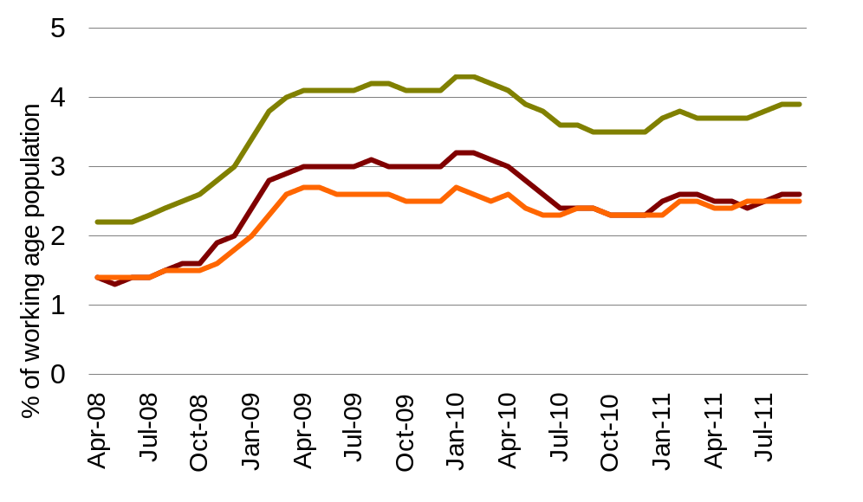
Source: Department for Work and Pensions

Oxford has seen a reduction in business survivals between 2009 and 2010. There were more business closures than start-ups during that period whereas the year before it was one of only two cities in the UK that had a higher number of start-ups than closures.
The number of JSA claimants in the city is rising. At this time last year, 2,600 people were claiming JSA in Oxford. This number has risen to 2,800, with recent increases in JSA claimants falling disproportionately on female workers. The national picture is showing a large number of part-time job losses as well as full time. This is significant because over recent years we have seen growth in part time jobs at the expense of full time jobs.
Overall, there has been little change in the total number of jobs in Oxford over the last 30 years. As the manufacturing sector has declined, its jobs have been replaced by employment in the health, education and service sectors. 89% of employees now work in services, including 46% in public administration, education and health. Oxford is the only city in the UK that has more public sector jobs than private sector jobs (where education is included in the public sector).
The distribution of employment in Oxford is a cause for concern in the light of the government’s austerity measure. These mean that a large number of jobs in Oxford that are directly or indirectly linked to public spending will be under threat over the next five years. The Labour Market Outlook shows that at the national level, large-scale public sector job losses are currently overwhelming a small increase in private sector jobs.

Employees in Oxford 2009 by industrial classification
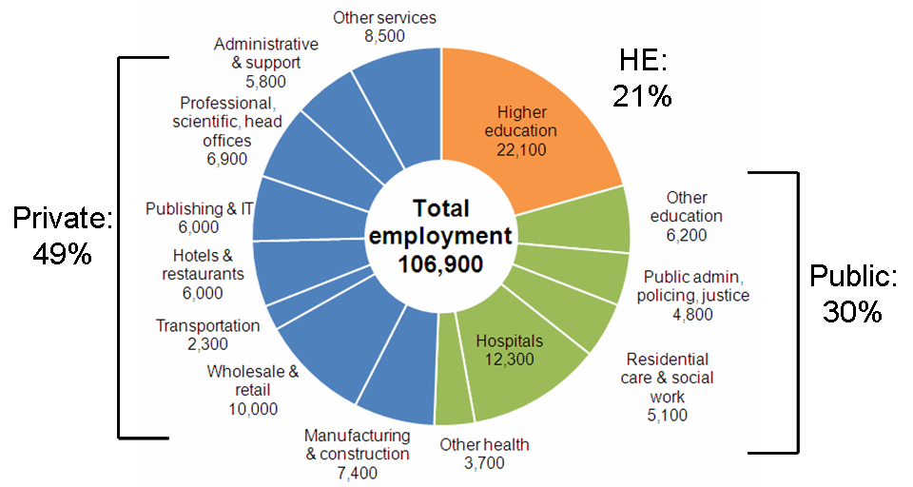

Source: Business Register and Employment Survey, Office for National Statistics

Rebalancing the local economy
The challenge for Oxford in returning to the number of pre-recession jobs, let alone generating new employment, cannot be underestimated. To achieve this there is need for significant business development and growth within our constrained boundaries and in the immediately adjacent areas. Oxfordshire local authorities are working with the Local Enterprise Partnership (LEP) and with the local business community to promote the growth of private sector jobs.
LEPs are the government’s chosen business-led vehicles for delivering private sector growth.The LEP for the Oxfordshire city region was formally launched in March 2011 and is built around the unique concentration of high-tech businesses and academic input from the universities. The City Council has been an active participant on behalf of local businesses and residents.
The LEP is developing a strategy that aims to attract more investment into the county and a skills development initiative that will coordinate the activities of the various skills providers in Oxfordshire. It has been successful in its bid for Science Vale UK to become an Enterprise Zone. The LEP is well placed to support business and other special interest groups who wish to lobby government - nationally and locally - regarding projects that will add to the city and county's economic health.
In the last year the City Council has welcomed the arrival in Oxford of large world class businesses - including Centrica and SAE . BMW have also committed substantial new investment into the MINI plant in Cowley in readiness for a new generation of the iconic vehicle. The University of Oxford and the Oxford Radcliffe have created a new University Hospitals NHS Trust that will provide a formal structure and governance for the close relationship between the two organisations, enhancing their ability to pursue excellence in patient care, research and education as a joint venture.
The delivery of physical regeneration projects to generate new housing and jobs is a priority for the City Council and, over the next four years, we plan to invest around £68million into the local economy through building new houses and improving the city’s leisure facilities. This investment will create up to 900 jobs.
We have entered into a joint venture with Grosvenor to build up to 1000 new homes in Barton and have contracted with Greensquare to build 100 new homes and two new community centres in Northway and Cowley.
We will continue to promote the regeneration of the West End, in partnership with the County Council and other key stakeholders. Negotiations between the City Council, the Land Securities Group and the Crown Estate to redevelop the Westgate Centre are well advanced, and options for the regeneration of the former railway sidings at Oxpens are beginning to emerge. We will work with the County Council and railway bodies to bring forward improvements to Frideswide Square and the rail station.
We are starting work – with developers, local residents and other stakeholders - on an area action plan for the Northern Gateway as a site for mixed use employment-led development. The Northern Gateway site is one of the last major opportunities within Oxford’s administrative boundary to provide significant new employment floor-space that will enhance the local economy and local employment opportunities.
The City Council supports the Chiltern Railways Evergreen 3 proposals for the fast link north through Bicester to Marylebone, including a new station at the Water Eaton Park and Ride site. We believe that this will bring positive benefits to Oxford and the wider city region.
The government’s Localism Act, as well as the White Paper on Local Growth, may provide new opportunities for councils to support their local economies. The government proposes new borrowing powers against predicted growth in locally raised business rates that could enable investment in major infrastructure and regeneration projects. It also proposes changes to business rate rules that could be used to support local businesses. We will be exploring these issues over the coming months.
Oxford City Council is commissioning a new economic and regeneration strategy for the city and this will be the main vehicle for exploring the range of issues relevant to the development of the city’s economy. Working within the Council’s objective to build a world class city for everyone, we will develop a strategy and policy framework for the next 15 years. A partnership board under the Oxford Strategic Partnership will oversee this work which will involve a wide range of partners.

Supporting local businesses
Oxford City Council has a long-standing commitment to support small and medium-sized businesses (SMEs) and set a target to spend 40% of its 2011-12 budget with SMEs. This target was exceeded by July 2011 and we continue proactively to encourage local suppliers to apply for Council opportunities. We also fast-track payment of invoices to these firms and will set a target of 10 days.
We are working with Business Link, the Federation of Small Businesses (FSB), Thames Valley Chamber of Commerce, and the voluntary and community sector to improve understanding of public sector tendering requirements and to encourage better engagement with the public sector. Our Meet the Buyer events have been consistently well attended.

Embedding the green economy
During 2011, the City Council and its partners continued to develop the Low Carbon Oxford Project on behalf of the Oxford Strategic Partnership. Twenty-five organisations including private and public sectors bodies, the universities, and community groups have now agreed to work collaboratively towards the creation of a sustainable, low carbon economy in Oxford. These organisations account for over half of the city’s emissions The City Council has allocated an additional £50,000 per year for two years to ensure that Low Carbon Oxford is able to continue its pioneering work.

Key priorities for the coming year will be:
- Implementing the ‘Green Deal’, the government’s primary energy efficiency programme. Private firms will be enabled to offer consumers energy efficiency improvements to their homes, community spaces and businesses at no upfront cost. Customers will then be able to repay the cost of improvements through savings on their energy bills. The City Council will be investing £54,000 over two years to ensure early and full take-up of the opportunities for insulation.
- producing our first annual report on CO2 reduction across the city
- Attracting funding to ensure Low Carbon Oxford is self sustaining and able to support total community retro-fit.

Oxford City Council will continue to reduce its own carbon footprint and seek to realise opportunities for local skills and businesses through renewables projects. For example, in the last year we have supported the setting up of Low Carbon Barton, which led to the installation of a solar photovoltaic roof on the Community Centre. The government’s decision to halve the incentives promised to home owners who install photovoltaic roof panels through the Feed-in Tariff is unfortunately likely to reduce the scale of the potential for take-up.

Supporting an ethical economy
Since April 2009, Oxford City Council has been paying its own employees a minimum ‘living’ wage calculated according to local cost of living data for housing, transport and services costs which sets it at a level above the national minimum wage,. We have required Council contractors to do the same. The living wage is designed to reflect the real cost of living in this city. The City Council is committed to working with living wage campaigners, low paid workers, trade unions and employers to make Oxford a ‘Living Wage City’ in which every worker will earn at least the minimum living wage. In January 2012, the City Council reviewed the statistical information on local living costs and set the Living Wage at a new level of £8 per hour.
The City Council also seeks to encourage ethical behaviour in the wider economy. Oxford became a Fairtrade City in March 2004 and has recently been reaccredited. This means that the City Council and its partners are contributing to the Fairtrade Foundation's aim of tackling poverty by enabling disadvantaged producers from poor countries to receive a better deal. We do this by working with partners so that Fairtrade products are widely available in the city’s shops and catering establishments and are used by local businesses and community organisations. The Fairtrade convention held in Oxford’s Town Hall in November 2011 attracted positive media coverage and encouraged support for the campaign.

Tourism
The city’s remarkable architectural heritage and the outstanding appeal of the Ashmolean and other museums mean that, tourism plays a key part in the local economy. It is estimated that over nine million tourists visit the city, spending £602million annually and supporting around 13,000 jobs. We are aiming to improve the value and sustainability rather than the quantity of tourism. We would like visitors to stay longer in the city and to explore areas beyond the city as well. In order to facilitate this we have set up a joint venture partnership with private sector partners called Visit Oxfordshire, that will be responsible for managing and marketing the Oxford and county-wide tourism offer. The new company was officially launched in August 2011.
The UK’s cultural and creative industries are the most successful in Europe. They now make up 7.3% of the UK economy and are growing at 5% per year– almost twice the rate of the rest of the economy. Oxford – with its rich heritage and thriving contemporary arts and music scene – is known throughout the world as a city of culture. One of the key aims of Visit Oxfordshire is to support culture and the arts by maximising the role that culture can play in Oxford’s tourism offer. Experience Oxfordshire brings together under one leadership Visit Oxfordshire, which focuses on tourism and Oxford Inspires which focuses on cultural development and events.

City centre
The city centre is the focus for Oxford’s vibrant day and night-time economies and the City Council has been working closely with the County Council and others to manage the centre of the city in ways that are attractive to residents and visitors alike. In November 2010, the Association of Town Centre Management awarded the prestigious Purple Flag to Oxford. This award - for the attractiveness of the night time economy to all people of all ages - is based on an assessment of crime rates, cleanliness standards and the quality and range of public spaces and visitor attractions. It also requires evidence of a successful multi-sector partnership. Oxford is one of only 15 towns and cities to win the award. In December 2011, we successfully renewed our Purple Flag status. Oxford City Council is investing capital funding of £420,000 over three years to improve the quality of toilets in and beyond the city centre.
The City Council has recently consulted on its plans to install a new pedestrian wayfinding system in the city centre, and the responses of residents and tourists have been very positive. The new wayfinding system will support the development of the city centre economy by making the attractions in the city centre more obvious to visitors and increasing footfall on less well used routes. Destinations to be signposted will include business locations, tourist attractions and other places of interest. The new signage will be implemented during spring 2012 and will help the large number of tourists that are expected to visit Oxford during the Olympics to make the most of the city and its attractions.

Measure | 2012/13 | 2013/14 | 2014/15 | 2015/16
Increase the number of apprenticeships, training places and jobs created through Council investment projects and other activities to over 900 by 2014/15 | 261 | 321 | 900 + | 900 +
Increase the percentage of top 20 employers in the city who agree that the City Council is business-friendly. | 78% | 82% | 85% | tbc
Increase City Council spend with local businesses to 43% by 2015./16 | 42% | 42% | 42% | 43%
Attract 500,000 visitors annually to the Oxford Tourist Information Centre and use variations on this figure to track peaks and troughs and their causes. | 500,000 | 500,000 | 500,000 | 500,000

Meeting housing needs
There has been a long term housing shortage in Oxford, and working to increase the provision of high quality affordable housing remains a key priority for the City Council and its partners.
In housing terms, Oxford is the least affordable area in the country apart from some areas of London. The population of the city has been growing as has the number of households requiring housing. Oxford’s population is projected to reach 154,500 by 2020. The Housing Market Assessment in 2007 showed that 1,700 new homes per year would have to be built in the city if demand is to be met.
Demand is high and availability is scarce, as a result of the city’s constrained boundaries, the risk of flooding and other issues. This results in very high house prices. Average house prices have more than doubled in the last ten years and owner-occupied housing is increasingly out of the reach of people on lower incomes.
Average house prices are much higher in Oxford (£260,000 in 2010) than nationally (£185,000 in 2010). Average Oxford house prices are now more than nine times higher than annual incomes. Wages in Oxford are comparable with those in Glasgow, but our average house prices are over double those of Glasgow. The high price of housing leads also to very high private sector rents.
This low level of affordability puts severe strain on social housing provision, with over 6,000 households in need on the housing register, and homelessness - though much improved - is over twice the national average.

Average earnings and house prices for urban areas in England, 2009/10
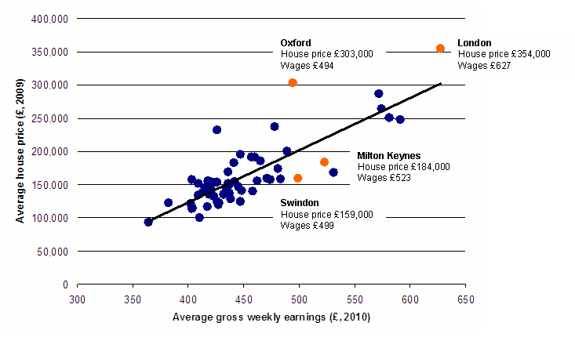
Source: Department for Communities and Local Government; Office for National Statistics; Centre for Cities

Building new houses
Over recent years, we have significantly increased the quantity of affordable housing. 1300 new affordable homes were built in the city from 2004 to the end of 2010.
Oxford City Council is committed to using its own resources to provide new affordable housing wherever possible. Work has recently been completed on the first new council-owned social housing in the city for over twenty years, at Lambourn Road in Rose Hill, and Cardinal House in Littlemore, assisted by grants from the Homes and Communities Agency.
Developments on council land at Cowley and Northway, in partnership with GreenSquare Housing Association will deliver new affordable and market rate homes, two new community centres, and a new home for the Emmaus Furniture Store, which recycles good quality, used furniture while giving skills training and accommodation to formerly homeless people. A new joint venture company formed with our partners, Grosvenor Estates, has begun preparatory work aimed at delivering up to 1000 new homes, a new school and community facilities, and commercial development on land to the west of Barton.
Following a successful bid to the HCA, in competition with many other social housing providers, we have received an indicative award of £2.5 million to build 112 new homes on Council-owned sites throughout the city. HCA funding is conditional on homes let at ‘affordable rents’, with limited exceptions. The Council will fund the balance of the cost of £16 million.
Future funding from the HCA to support genuinely affordable housing is likely to disappear. Future housing grant is to be targeted through Housing Associations, and will be useable almost exclusively on properties let under the government’s proposed new ‘affordable rent’ model where rents are set at up to 80% of the local market rent and tenancies are for a set period rather than the traditional social rent/lifetime tenancies model. This is not an economic model that will meet the needs of families on the Council’s waiting list, and we will be working with partners to overcome the obstacles created by this aspect of government policy.
The Council has worked hard to increase the level of new affordable housing being built in the city. However, economic conditions and reductions in the provision of grant for building these homes means that it is increasingly hard to attract developers willing to provide the level of affordable housing that our planning policies demand.

Improving housing standards
We are aiming to improve the quality of existing homes. The Council has brought all its own homes up to the national Decent Homes Standard and we will ensure that this standard is maintained and improved. For example, while the apartment interiors of our five tower blocks are already at Decent Homes Standard, we have programmed £8.25 million to improve their external and communal areas. This will extend their lives for a further 30 years.
We are also committed to improving housing in the private rented sector. The private rented sector is particularly important in Oxford. It provides essential accommodation for key workers, young professionals, students and people who are unable to access social housing or to purchase homes on the private market. It accounts for 26% of the city’s housing stock, with one in five of Oxford’s population living in a house in multiple occupation (HMO). The combination of exceptionally high demand and high rental values has created an environment where poor landlords can charge high rents for poorly managed and badly maintained properties.
The City Council has sought to tackle these problems in the private rented sector by using the new powers granted to local authorities in 2010 to launch the most extensive HMO licensing scheme in the country. This self-funding scheme began in January 2011 and will require every HMO in the city to be inspected and licensed. The objective of the scheme is to improve the management and condition of HMOs and to tackle the problems for tenants and the wider community caused by poor landlords. A strong enforcement stance has been linked to a range of incentives for landlords to join the accreditation scheme. We are investing £60,000 per year to enable more proactive enforcement of standards in the private rented sector.
The City Council’s is also concerned about the impact of private rented housing on the communities and neighbourhoods in which this housing is located. As HMOs have spread across the city, their impact on the character of local neighbourhoods has generated significant concern amongst residents. In response to this, the Council has introduced new planning controls to come into force in February 2012 that will require planning permission for the change of use from a family or single unit dwelling into an HMO, with a presumption against new HMOs in areas which already have a significant concentration. We are working with Oxford Brookes University and the University of Oxford to tackle issues relating to student housing, particularly in East Oxford.
HMO licensing and new planning controls are linked elements in a coherent programme of assistance that the City Council is developing with partners for neighbourhoods whose character is being adversely affected by HMOs and entertainment venues. This programme will also include more targeted and effective use of noise enforcement.

Home Improvement Agency
The Council also runs a Home Improvement Agency that provides around £700,000 annually of means- tested grants for some 110 disabled or elderly house owners, and parents of disabled children who need improvements to continue living in their home. The Council also provides a Home from Hospital service for 150 people to prevent bed-blocking and a Small Repairs Service that helps nearly 400 elderly and vulnerable owner occupiers deal with minor repairs to their home.
In addition the Council provides £84,450 of means tested grants up to a maximum of £5,000 so that home owners whose houses are in poor condition can carry out essential repairs. The Council has also secured government funding for a flexible home improvement scheme to provide cheap loans for home owners over 60 who need to improve their homes. Nearly £400,000 has been invested in improving private homes in the city since the scheme began.

Reducing homelessness
We have continued to reduce homelessness. Over the last five years the number of households living in temporary accommodation in the city has fallen from almost 1,000 to under 200. We continue to focus on preventing homelessness and helping people who are sleeping rough to get into settled accommodation. New contracts have recently been awarded for the provision of improved and more robust services for single and rough sleeping homeless people in the city.
The Council has been recognised as a centre of excellence in homelessness work, and is proud of its innovative work in this area. In recent months over £150,000 has been diverted into funding that will allow tenants in private rented properties to meet the cost of their rent where Housing Benefit levels are too low. We are working with landlords to reduce the cost of renting for those on low incomes. We support the government’s “No Second Night Out” campaign; we have recently opened, jointly with Crisis Skylight, a new facility which will support single homeless people in particular, giving them access to training and other opportunities. At the same time, we will seek to reconnect rough sleepers without a connection to Oxford back to their home areas.

Future challenges
We face serious challenges around housing in the coming years.
The economic situation is putting downwards pressure on real incomes and contributing to a growth in the number of homeless households across the country. We have so far limited the increase in the city to below national average levels but Oxford will not be exempt from this trend. The ability of the Council to respond to demand - for example, by assisting people into the private rental market - is likely be further restricted. There is a strong risk that the downward trend in the number of households in temporary accommodation might not be maintained. Changes to welfare policy are imposing significant additional pressures on housing and homelessness in the city.
Changes to Local Housing Allowance, which came into force on a rolling basis from April 2011, mean that the maximum Local Housing Allowance can only be paid to properties in the cheapest 30% of the local market. This has severely constrained, housing options for many households. The 'local' housing market includes much of rural Oxfordshire, where rental costs tend to be lower. This will mean that many low income households may be forced out of Oxford to meet their rent obligations while the small size of the private rented sector outside the city may restrict the Council’s capacity to re-house Oxford families within the county itself. This pressure will be most severe on households needing a five bedroom property or larger.
In addition, welfare and benefit changes – for example, reductions in benefit for those claiming Jobseeker’s Allowance for over 12 months - will reduce the available income of many low income households. These pressures will increase over time, as the changes impact on a growing number of households, and as housing costs rise faster than benefits increase.
The proposed introduction of the Universal Credit in October 2013 will replace a number of existing sources of welfare benefit with a single payment to individuals and families. A potential risk is that overall benefit levels will be reduced. A further risk is that if Housing Benefit is paid directly to tenants, who are then responsible for making rental payments, arrears and bad debts could rise. Currently Housing Benefit is paid directly to the landlord.
Oxford City Council is one of a small number of local authority and housing associations who are working with the Department for Work and Pensions on a pilot project that will test the effects of paying monthly housing benefit payments direct to tenants in social housing. The pilot project will take place from June 2012 to June 2013 and will test how claimants manage housing benefit monthly payments and the kinds of safeguards needed to prevent tenants from falling into arrears. The City Council is seeking to find ways of minimising the financial risks of direct payments for landlords while improving the financial awareness of tenants.
The pilot will enable the Council to be more effective in helping tenants avoid getting into arrears and will supplement existing income management policies.
The changes to welfare overall have the potential to cause disruption and distress to many people in our city and are likely to increase the demand for housing and homelessness assistance, and also debt and welfare advice services. The City Council has maintained and increased its funding for the voluntary and charitable bodies which provide this, particularly in areas of the city where need is greatest.
The City Council will do all it can to support local people and advice agencies to make as smooth a transition as is possible to new welfare arrangements.

Changes to Council housing finance
The Housing Revenue Account (HRA) regime will end on 31st March 2012. This means that the full financial responsibility for the Council’s housing stock will change from central government to local authorities in exchange for a final capital settlement. The government has given a provisional assessment that Oxford City Council will be required to make a payment to government of around £200m.
The end of the HRA means that, in future, the Council will run the housing arm of its activities as a separate business, relying on the income collected in rent to deliver repairs, maintenance and management of the stock.

Building sustainable houses
The Council is improving energy efficiency in its housing stock. We are installing efficient gas boilers, improving insulation, and installing water saving devices as part of our on-going stock maintenance programme. We will be applying external cladding to our tower blocks which will improve thermal efficiency in over 400 homes. We are pursuing solar photo voltaic panels and city-wide heating options as part of the Low Carbon Oxford initiative discussed earlier in this report. For example, the new Rose Hill development – bungalows, flats and townhouses – includes air source heat pumps to each home. A sheltered housing scheme in Littlemore has a biomass boiler which will supply heat and hot water to all of the sheltered units and communal areas. Both schemes use solar photovoltaic panels to provide cheaper electricity and feed surplus electricity into the national grid.
The Council will review the opportunities offered by the Green Deal in relation to its own stock when the details are announced in spring 2012.
As part of an Energy Savings Trust study to assess the effectiveness of carbon reduction techniques on difficult to treat properties, the City Council is working with partners to transform a solid walled property in Jericho into an eco-friendly home. Brookes University is monitoring energy usage over two years to inform future projects. This project is also being used as an educational tool for local school children and the wider community.
The Council is also committed to the broader principles of sustainability in relation to housing. The exciting £18m project to build 109 new homes and two new community centres in Northway and Cowley is being undertaken in partnership with companies who have a track record in developing housing based around a strong sense of community, a belief in the importance of public space, respect for cyclists and pedestrians, and a commitment to sustainable lifestyles. For example, the new community facility at Northway will include a sports hall with enhanced changing facilities; helping to meet the requirements of the football leagues based there, educational resource and learning areas, and a community cafe next to a food-growing area.

Measures | 2012/13 | 2013/14 | 2014/15 | 2015/16
Improve the percentage of Council tenants satisfied with our landlord services to 86% in 2014/15. | 82% | 84% | 86% | 88%
Increase the number of individual HMOs subject to agreed licence provisions to over 3,500 in 2014/15. | 2,180 | 2,950 | 3,540 | 3,890
Deliver a programme of new homes at Barton | Get hybrid planning consent and agree phase 1 sale | 50 | 150 | 300
Ensure that the number of households in Oxford in temporary accommodation does not exceed 175. | 175 | 175 | 175 | 175

Strong, active communities

Oxford City Council is working with citizens and community groups in the city to build strong and active communities. This means communities that are socially cohesive and safe, and citizens who are actively engaged in pursuing their own well-being and that of their communities.

Tackling inequality
In contrast to other parts of the county, Oxford is ethnically and culturally diverse, with the third highest minority ethnic population in the south east. In 2009, 19.6% of the population were from black and minority ethnic backgrounds, compared with an England average of 12.5%. The largest non-white ethnic groups represented are Indian, Pakistani and Black African origin.

Oxford’s population is constantly changing. People come to Oxford to live, to study and to work, coming from both within the UK and from other countries. There are over 30,000 students studying full-time at the two universities, and there is significant annual turnover in their number. Around 6,000 people arrive from overseas to live in Oxford each year, about half of these being students and a quarter migrant workers. A consequence of this is that one in five of our residents were born outside the UK – the most common countries of birth being Ireland, USA, Germany, Pakistan and India. Around 4,000 international migrants living in Oxford apply for national insurance numbers every year, usually in order to pay tax on their income. These migrant workers most commonly originate from the USA, Poland, India and Italy.

Diversity is one of our city’s strengths, and social inclusion and community cohesion are key goals for the city and the Council.

There are major inequalities in life chances and life expectancy in our city. Relative to the rest of Oxfordshire, Oxford has high levels of deprivation. The Index of Multiple Deprivation 2010 ranks Oxford 131st out of 354, placing it in the top half of the most deprived local authority areas in England. Of 85 areas in Oxford, 12 are among the 20% most deprived areas in England, with one area in Northfield Brook ward among the 10% most deprived.

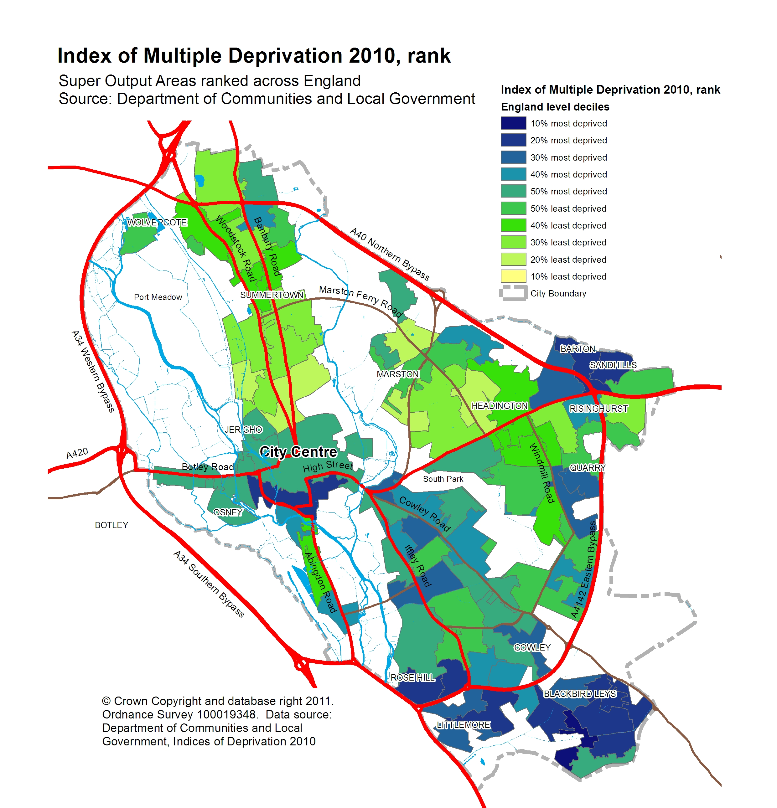

Around 23% of Oxford’s under-16s live in low-income households and child poverty is a key concern in eight neighbourhoods which feature among the 10% worst affected in England. In some areas, half of all adults have no qualifications and this is linked to lower incomes, poor health and child poverty. Oxford has over 10,000 working age residents claiming benefits – the highest percentage in the county. Life expectancy in the most deprived areas is up to ten years less than those in the wealthiest areas.
Our ambition is to reduce the extent of inequality and to improve the lives of the most vulnerable members of our society and, particularly, to improve outcomes for young people. Many of the issues that contribute to inequality in our city are beyond the remit and control of the City Council. Our challenge is to encourage our partners in local government, education, and health to work with us in a co-ordinated way to tackle these deep-seated issues despite the decision by the government to abolish the local partnerships focused on these issues.

Supporting young people

Improving educational attainment

Improving educational attainment is at the heart of our ambition. Attainment levels of pupils in state schools are significantly lower than the national average. In 2009/10 only 67% of Oxford pupils gained five or more A* to C grade GCSEs, compared to a 76% national average. This was the fifteenth worst result of any local authority area in England. Pupils living in deprived areas have particularly poor results. In the same year 46% of Oxford children achieved the benchmark of five or more A* to C grades at GCSE. This was below the national average of 55% and the lowest result among the local authority areas shown below.

All Pupils achieving 5+ A*-C including English and Mathematics, 2009/10
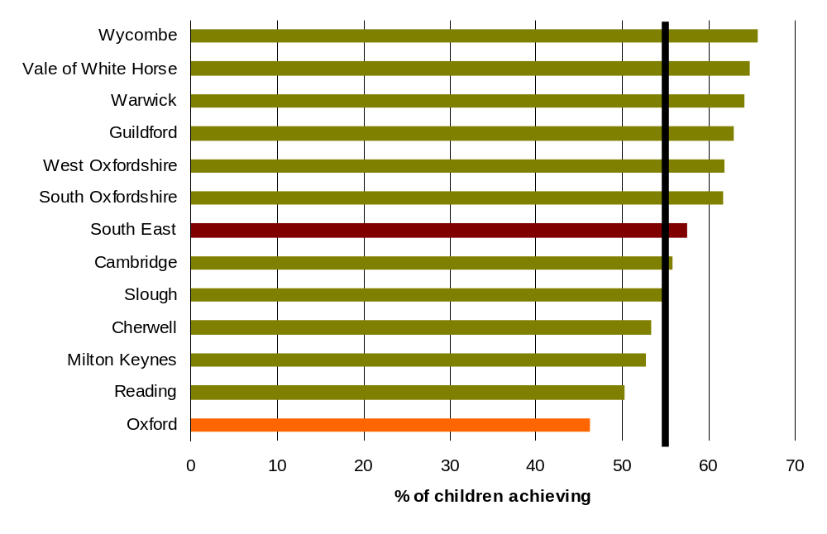
England average
Source: Department for Education

This poor attainment at both primary and secondary levels impacts directly on access to the labour market and to economic and social life chances. For Oxford to become a world class city for all its people, this situation must be addressed.
In June 2011 the City Council and Oxford Strategic Partnership hosted a seminar with Heads and Chairs of Governors from local primary schools and the County Council to begin developing a partnership approach to tackling these issues. The County Council has since developed a new Raising Educational Attainment Strategy. The City Council will be working with the County Council, schools, and other partners to develop a joint Raising Educational Attainment Action Plan for the city.
The Council has allocated £350,000 annually over the next four years so that it can play its role in improving educational attainment in the city, particularly in the more deprived neighbourhoods., We will set up an education improvement partnership for the city, drawing on the experience of educational experts in the field, some drawn from the city’s universities, as well as local stakeholders. The education improvement partnership will work with schools to design a programme of interventions focused on areas of under-achievement. These interventions will be designed and led by the schools themselves. Schools will be able to bid for funds from the City Council on a matched basis with funding from the County Council’s strategy budget, and funding from the school’s pupil premium income.
The criteria for deciding funding allocations will include clear evidence of ambition, leadership commitment, an evidence-based work programme, and effective oversight by school governing bodies. This work will be aligned with and complementary to the work initiated under the County Council’s strategy. The long term aim is to move Oxford schools and their pupils to a position where they are achieving results at key stages 2 and 4 that are at least 10% above the national averages at those stages
The City Council’s commitment to improving educational attainment is reinforced by our broader commitment to promoting the well-being of our young people. More effectively integrating our schools and communities will be a key priority over the coming years.
Improving youth provision
Encouraging young people to take part in sport is a key part of our programme to improve youth provision.
Sport cuts across social boundaries, improves health, offers positive activities that help to reduce anti-social behaviour and also improves wellbeing and educational attainment. Young people who are active have numeracy scores, on average 8% higher than non-participants according to the Culture and Sport Evidence programme research (July 2010). We have worked hard to develop a broad leisure offering which has resulted in Oxford having one of the most significant increases in adult participation nationally over recent years. Unfortunately, when last measured in 2009, Oxford had the lowest percentage of physically active children with just 26.74%; the national average is 55.1%.
We have allocated £33,000 per year over the next three years to enable more effective use of Oxford City Council leisure facilities by local schools. We have also allocated £28,000 per year over four years to ensure that young people have the opportunity to access free swimming. This investment will add to the current 50 hours of free swimming that we currently provide. It will create a targeted, means-tested programme for those who are unable to swim and those who are unable to afford standard lessons. We are working with Fusion Lifestyle, Oxford City Swimming Club, and the amateur swimming association (ASA) to help to create a programme that maximises the benefit of this investment.
There is an increasing need to deliver other high quality activities for young people in the city as youth unemployment grows. We are also allocating £240,000 per year for four years to provide support in areas of the city where changes to youth provision have had the greatest detrimental impact.
We will be working with our partners to offer a wider range of activities that reflect the interests of young people and at the same time provide them with the skills and confidence to access educational, employment and training opportunities. We will also provide specific interventions for those in greater need.
Creating an integrated offer - including culture, sport and community activities - for young people who are at risk of becoming socially marginalised is at the heart of the City Council’s approach to building safer communities. We will continue to work with partners to provide free holiday activities for up to 1,200 young people between 5–19. This Positive Activities programme has included Streets Sports as well as a summer holiday programme with 3v3 basketball sessions and targeted free swimming sessions. We will be working closely with the schools in order to integrate their in-house facilities with City Council managed playgrounds, leisure centres, sports fields and parks.

Training and apprenticeships

Young people in many parts of the city already face significant difficulties in gaining employment because of the lower levels of educational attainment at the school leaving age. As the growth of high value jobs is increasingly driven by high-tech businesses and academic spin-outs from the universities, there is a clear danger that this exclusion will deepen. The City Council is encouraging high tech companies wishing to make Oxford and Oxfordshire their base to create additional new apprenticeships and development opportunities so that young people can improve their skills and experience.
The Council is also using its procurement processes to support young people from the city to gain apprenticeships and get into employment. We now require Council contractors to create apprenticeship opportunities as part of any large construction project. Our joint venture with Grosvenor on the Barton development will involve a training and apprenticeship programme. The Green Square project in Northway and Cowley will create a minimum of 12 new apprenticeships during the construction stage through its '4ward2work' programme.
The City Council has allocated £50,000 for two years to provide five new apprenticeships with the Council’s own workforce. In August 2011, the City Council hosted a very successful Youth Job Fair, organised by one of our apprentices. Building on the success of this event, we are working with Job Centre Plus and Oxford & Cherwell Valley College to launch a new Work Club which will help people to find their first job, return to work, or look for a new career direction.

Social and economic regeneration
The City Council’s comprehensive Regeneration Framework, adopted in 2009, focuses on strengthening the city’s economy and providing training and jobs; it seeks to regenerate a number of targeted geographical areas both physically and socially; and to target and improve mainstream services so that they meet the needs of disadvantaged groups and communities.
Delivery against the Framework is linked to our partnership working around breaking the cycle of deprivation in some key parts of the city. This is a two-year programme aimed at supporting vulnerable families, improving employability and reducing health inequalities. The Council and its partners are currently refocusing this work by concentrating on early intervention and other social programmes aimed at children and families. While the formal project is scheduled to last only two years, we will be seeking to sustain a longer term commitment from all our partners to maintain the momentum of this project into the future.
This plan referred earlier to the fact that Oxford City Council is commissioning a new economic and regeneration strategy for the city and that this will be the main vehicle for exploring the range of issues relevant to the development of the city’s economy. The new strategy will build on the current Regeneration Framework and, in particular, recommend ways of improving delivery mechanisms.
.The City Council is also looking to respond more effectively to the needs of vulnerable older people and to consider how they can be supported to live in their homes and local communities for as long as possible. We have allocated £20,000 per year over the next two years to encourage new initiatives to support isolated older people in the community. We have also initiated a £10,000 per year project with Age UK Oxfordshire to promote home sharing by older and younger people.
More generally, we are working with other agencies to identify changes to services in our neighbourhoods and looking at ways in which we can mitigate the impact of budget reductions made by other public service providers. A new fund of £50k per year for two years has been established so that councillors can bid to fund local projects with social inclusion aims.

Engaged communities
Area Forums and Neighbourhood Boards
The City Council has sought to create a range of innovative ways in which the people of the city can become directly involved in decisions that affect their local communities. Six Area Committees were introduced in 2001 after a period of experimentation in the previous two years. Over the past twelve months the more rigid format of the Area Committees has been replaced by more informal Area Forums, involving local stakeholders and residents in an open and flexible style of meeting, alongside Community Partnership meetings and Neighbourhood Partnership Boards that are being established for defined community areas.
These local forums seek to provide a space in which residents and community groups can work with mainstream service providers - health, education, police, businesses and the voluntary sectors - to ensure that local services are responsive to the needs of the community. Each councillor has an annual budget of £1500 that can be used for small projects that link to the priorities emerging from forum discussions and other local consultations. These arrangements work alongside the highly successful Crime Partnership Neighbourhood Action Groups which bring residents, councillors and the police together to identify local policing priorities.
These arrangements are relatively new and will be further developed to ensure that all of our communities, including the more ‘hidden’ groups, have the opportunity to engage with them. Experience so far has been positive, and the indications are that these local forums will play a creative role in addressing emerging local issues by bringing the various agencies and organisations together in flexible and area-specific ways. In relation to the reduction of youth provision, for example, the forums are offering a more joined up approach to local needs, reflected in the Northway youth partnership, the Rose Hill Sports Development Group, and the Barton youth partnership.
The Area Forums and Neighbourhood Partnership Boards provide a good basis for the community-led planning processes that are also being developed which will link service planning closely to meeting local needs and aspirations. Local Councillors will play a central role in working with community representatives to draw up neighbourhood plans. Their role will involve supporting, explaining options and finding solutions.

Tenants, residents and community associations
The Tenant and Leaseholder Compact has been in place since 2007 and the Council’s dialogue with tenants and residents on its estates has taken a number of different forms. For example, Leaseholders and officers worked together to produce a Leaseholders’ Handbook and the Leaseholder Satisfaction Survey. The Council has also invested in a well-equipped Tenant Resource Centre at Horspath Road. A new tenant involvement strategy is in preparation, drawing on best practice in the social housing sector. .
As part of the Council’s plan to buy out its housing stock from the national pool, there will be close attention to the governance and tenant engagement aspects of the post buy-out arrangements.
We have worked with community associations to improve the management and use of community centres through trustee training, developing user satisfaction surveys and providing small grants and to develop the governance structure for the new facilities at Wood Farm, Northway & Cowley.
.
The voluntary sector
The City Council is part of the Oxfordshire Stronger Communities Alliance, which aims to strengthen the role of the voluntary and community sectors and to increase the number of volunteers in the city. We provide funding to a range of voluntary and community groups who help deliver the objectives set out in the Corporate Plan.
We hold two City Forums annually with the Oxfordshire Council of Voluntary Associations (OCVA) to promote partnership working between the City Council and the voluntary sector.
Through its grants programme, the City Council contributes £1.4 million per year to support the work of a wide range of voluntary and community organisations that make collectively a huge contribution to the life of the city. The grants programme has two elements:
- open bidding, where community and voluntary organisations can apply for one-off grants on an annual basis or, on a smaller scale, throughout the year
- commissioning, where funding is provided for activities that have been identified by the Council as making a substantial contribution to the achievement of our corporate priorities goals.

Volunteering has the potential to benefit those who volunteer as well as the wider community. Oxford City Council has arrangements in place which encourage its own staff to volunteer. It will also work with its partners to increase the quality, quantity, and accessibility of volunteering in our city. The City Council hosted the annual volunteers awards this year and will be hosting a Volunteers’ Fair in the Town Hall in 2012 where different groups will be able to publicise their work.

Healthy communities
The City Council is responsible for a range of functions that affect people’s health and well being. Some of these – such as planning, housing quality, homelessness, social cohesion, and employment - have already been referred to in this plan. The City Council will use its powers and duties to improve all of these and the other wider determinants of health – environmental health, air quality, and green spaces for example - to help improve the health of local people.
Our ambition for our leisure services is to deliver the quality of service found in private clubs at an affordable price. We have made significant steps in this direction over the last twelve months.
Following public consultation, new facilities have been installed in our leisure centres at Barton, Blackbird Leys and Ferry have all been revamped as part of a £2.2 million upgrading programme. These improvements include a new cycling spinning studio at Blackbird Leys, a brand new gym and replacement sports pavilion in Barton, and a large extension to the gym at Ferry. The centres have also benefited from refurbished changing facilities and upgraded reception areas.
These improvements have been funded from the savings that have flowed from the management partnership for leisure facilities between the City Council and Fusion Lifestyle, a charitable trust. There has been an increase of around 5% in leisure centre membership over the last twelve months.
Nationally, less than half of the leisure centres rated in the country have so far achieved a rating of ‘good’ from Quest, the leisure industry standards body. However in Oxford, Blackbird Leys Leisure Centre, Ferry Leisure Centre, and Hinksey Outdoor Pool, - Oxford’s only public heated outdoor pool - have all reached this quality level in recent assessments. Quest assessments take place every two years and involve mystery visits and two full days of investigations into management and operational procedures.
These developments have helped drive some significant improvements in adult participation in sport. Oxford now has the second highest activity rate in the county, up from one of the lowest just four years ago. 27.6 per cent of adults are now taking part in 30 minutes of moderate intensity sport or active recreation three days a week which is a 6.9 percentage point increase from 20.7 per cent in 2005
To further improve our leisure facilities and the participation rate, the Council is progressing plans to build a new competition standard swimming pool in Blackbird Leys. This is planned to be a high-quality facility which will help increase community participation in swimming, as well as providing a venue where county-standard swimming competitions can be held. The new facility will include an eight lane, 25 metre pool with a moveable floor, a teaching pool, the possibility of fun water with jets and sprays, and modern changing facilities. The new pool will adjoin the existing Blackbird Leys Leisure Centre. It will replace Temple Cowley Pools and Blackbird Leys Pool, both of which are in poor condition, very costly to run, and major contributors to the Council’s carbon footprint.. The new pool will further improve our leisure offer, contribute to the ongoing regeneration of Blackbird Leys, and reduce the Council’s own carbon footprint. The large savings in running costs over the facilities that it will replace will substantially meet the cost of the capital investment involved.
Oxford Health Walks, run by GO Active and Oxford City Council, encourage walking – particularly in the city’s beautiful parks - as a form of more gentle exercise for those unaccustomed to physical activity. The scheme has been formally accredited because of its high standards and supportive environment. The scheme provides health professionals with another avenue to promote healthy living in Oxford through the Exercise on Referral scheme. The Council’s StreetSports programme has won the prestigious StreetMark accreditation, a national recognition of quality and we will continue to encourage healthy living by improving the quality of the outdoor sports offer in the city. For example, we have allocated more than £300,000 capital over four years to encourage cycling with more cycle lanes and better signage.
We are also working in partnership to deliver the Active Women programme within the city.
The Olympics and Paralympics will be major sporting events in 2012. Oxford has been selected to host the Torch relay and evening event in our region on 9th July and this is being planned to be an exciting and memorable event. Our key focus, however, is to use the interest generated by the Olympic and Paralympic programmes to encourage people of all ages and levels of fitness to embrace healthy and physically active lifestyles.
Healthy living is obviously about more than just physical activity. Community understanding of environmental health issues, for example, is essential to health and safety. There are over 1300 food businesses in Oxford. The City Council carries out 700 inspections a year and displays the results of food hygiene inspections on the Scores on the Doors website. In order to raise industry standards and reflect the diversity of Oxford’s communities, the Council has developed food hygiene training courses that are delivered in different languages as well as providing foreign language exam papers. Nearly 50% of all the people trained on our food hygiene training courses do not have English as their first language.
The government’s large-scale reorganisation of the way that health services in England are managed, commissioned and delivered has prompted national debate and raised concerns about the consequences for public health that will flow from the changes. The details of the legislation are still being debated. However, the structures through which it will be delivered are becoming clear.
The Health and Social Health Care Bill will establish Health and Well Being Boards in all upper-tier authorities in order to promote integrated health care services and increase accountability. The Boards will include elected councillors, clinical commissioning groups of GPs, local Health Watch and Directors of Adult Social Services, Children's Services and Public Health. The task of the Boards is to assess local needs and develop an integrated strategy for addressing them.
In Oxfordshire a Shadow Health and Well Being Board has been established with four supporting Boards:
- Health Improvement Board
- Children and Young People Board
- Adult and Social Care Board
- Public Involvement Board.

A member of the City Executive Board represents the City Council’s interests on the Health and Well Being Board and also serves as vice chair of the Health Improvement Board. The City Council will ensure that the Health and Well Being Strategy fully reflects the needs and aspirations of Oxford’s communities.

Creative communities
Oxford City Council believes that culture and the arts can also be key drivers of regeneration in the city, with the potential to build community cohesion by encouraging different community groups to enjoy and have access to their different traditions. Our aim - working with our partners in the cultural sector - is to increase access for all our communities to good quality cultural opportunities and events, at affordable prices, in a range of venues and locations. We aim to provide cultural experiences befitting Oxford’s world-class status.
The range of achievements over the last twelve months is impressive. The Old Fire Station opened in November 2011. The Old Fire Station (OFS) is unique in that it brings together a new Crisis Skylight Centre and Arts at The Old Fire Station. Arts at the Old Fire Station is a new organisation, created by the City Council to support the development of the creative industries, to offer flexible and high quality space to local performers, and to help to regenerate the west end of the city. The OFS offers a unique model of social inclusion by bringing artists, homeless people and the public into the same building which combines a range of flexible spaces and facilities, as well as training and support for employment in the creative and hospitality industries.
Pegasus Theatre, Oxford's youth theatre in East Oxford – modernised and transformed by a £4m rebuild project - goes from strength to strength. In 2011, Pegasus initiated Mesh, Oxford’s first International Youth Arts Festival. Mesh was co-planned, run and hosted by and for young people from Oxford, France, Germany, the Netherlands, Croatia, Palestine and Russia. This project complemented the work done through the City Council’s own international links programme which offers opportunities for exchange projects involving young people from our twin cities. Modern Art Oxford continues to stage exhibitions of international standing. Our successful annual dance festival Dancin’ Oxford continues to be strongly supported by the citizens of Oxford and has just received over £55k in grant support from Arts Council England. Get Moving! – a dance project for the over-50s in Oxford has also proved to be very popular.
Oxford’s Town Hall continues to make its own contribution to the city’s cultural offer. This iconic Victorian Grade II* listed building is being successfully renovated and remarketed and is now a popular venue for concerts from a diverse range of performers, and events, including the annual Beer Festival. Oxford Philomusica’s regular concerts for children have become sell-out events. In 2011, the Town Hall was the main site for Oxford’s internationally acclaimed Jazz Festival. Exciting improvements to the Town Hall are planned over the next twelve months. The City Council is investing in improvements to the Town Hall infrastructure, including an upgrade to the acoustics in the Main Hall. We are planning for the Town Hall to enhance its role as a primary community facility for the city and also to provide facilities for the conference and concert markets. The Town Hall café is being refurbished in the early part of 2012 and will reopen with an upgraded offer in May 2012. The Town Hall’s high quality gift shop, focusing on products related to the Museum and Town Hall collection opened in early November 2011.
We are also upgrading the Museum of Oxford and integrating it more closely with the Town Hall. Our plans for the Museum have attracted over £80k in grant support from external funders, and the Museum will reopen in June 2012. The City Council has joined with the University of Oxford Museums and the County Museum Service in a successful partnership bid to the Arts Council for three –year Renaissance funding that will promote public access to Oxfordshire’s museums and train museum staff to develop their public programmes.
The City Council continues to work closely with Oxford Inspires, the county’s cultural development agency. Together with other cultural organisations in the city, we are working on a bid to secure Oxford’s designation as UNESCO’s World Book Capital in 2014. In partnership with the Poetry Centre from Oxford Brookes University, the City Council has appointed Oxford’s first City Poet. Kate Clanchy is a widely published and respected poet who will use her term as City Poet to encourage people to write about life in our multi-cultural city. Kate will work with students at Brookes University, and with the help of the charity First Story, she will also have a base at the Oxford Spires Academy. Kate is aiming to visit all schools across the city and to establish partnerships and projects with community groups.
Large scale events play a key role in building cohesion and celebrating life in our city. Around 20,000 people attended this year’s successful May Morning celebration, organised for the first time by the City Council. Christmas Light Night – where the City Council, Oxford Inspires, the University Museums and other cultural organisations from across the city work together to celebrate the festive season - has become so popular that last year’s main outdoor celebrations were relocated from Broad Street to St. Giles. Around 29,000 people attended events across the city. The Olympic Torch relay event, taking place in July 9th 2012, will give people across the city the opportunity to savour the Olympic spirit. The 2012 Jubilee celebrations will provide an excellent opportunity for people to organise street parties and other neighbourhood events that will be facilitated through our joint working with Streets for People.

Safe communities
Crime and the fear of crime have an adverse effect on the well-being of our communities. As a lead member of the Oxford Community Safety Partnership, Oxford City Council has made a significant contribution to the reduction in the levels of crime and anti-social behaviour in the city. Between April and October 2011, total crime fell by 6%, compared to the same period in 2010. Car crime fell by 9% and there have been great successes in reducing violent crime; total violence against the person decreased by 26% compared to the same period last year. Unfortunately, burglary of people’s homes - a key priority for residents in the city - rose by 17% during this period albeit from a historically low base. The low base is no consolation for victims and the partnership remains committed to maintaining tight control on crime in the city.
The NightSafe scheme tackles the problems of alcohol-related disorder in the night-time economy and its success is one of the key factors that enabled Oxford to obtain its Purple Flag accreditation. We have re-structured our Community Warden service and improved co-ordination between them and our Crime and Nuisance Action Team, specialists in the investigation of anti-social behaviour.
We use Talkback - our citizens’ panel – to survey people’s opinions on a range of anti-social behaviour issues. In our 2008 survey, young people hanging around the streets was cited as an important concern by respondents. This issue has dropped from second to seventh in terms of people’s concerns. This is due in part to the Council’s Positive Futures Programme which aims to offer alternative activities to young people who might otherwise be drawn into various forms of anti-social behaviour.
Engagement with the community on safety issues, through the successful Neighbourhood Action Groups (NAGS), has been an important feature in the drive to reduce crime in recent years. However, the community safety partnership is likely to face major challenges in the coming years, as the government has made significant cuts to community safety grants and the partnership will have to respond to the new National Crime Strategy and the introduction of directly elected police commissioners. These changes could cause major disruption of the existing expenditure and policing priorities

Measure | 2012/13 | 2013/14 | 2014/15 | 2015/16
Improve satisfaction with our neighbourhoods to 88% in 2014/15. | 87% | 871% | 88% | 88%
Maintain the percentage of Oxford's population volunteering at 41% | 41% | 41% | 41% | 41%
Increase the percentage of adults participating in sport (as measured by Sport England's Active People Survey) | >26% | >26% | >27% | >27%
Increase the number of young people attending our Holiday Activity programme to more than 1,200 in 2012/13 | 1,200 | 1,200 | 1,200 | 1,200

A cleaner, greener city

Survey after survey makes it clear that Oxford’s citizens place a very high priority on the quality of the local environment. The City Council’s objective is to maintain and develop a cleaner, greener city – in the historic and commercial city centre, in our neighbourhoods and in all public spaces.

Recycling and refuse collection
The City Council has made significant improvements in recycling and waste collection in recent years. The city presents particular challenges due to the diverse nature of its population, its high population churn (25% per annum) the large number, (5000) of houses in multiple occupation, and the large number of self-contained flats. In 2009-10, we market tested our recycling and waste service in order to make the service more efficient and to improve customer satisfaction.

The City Council now offers a high quality and inclusive service. We have expanded the weekly food waste recycling programme across the whole city. We are giving householders choice about containers; wheeled bins, boxes and sacks are all available in order to reflect the different kinds of housing stock in the city. The blue wheeled bins make recycling easier for residents as nearly all recycling materials can be placed into one container. We have also introduced recycling bins into the city centre and ring road. We have introduced a new garden waste collection service to which over 12,000 customers subscribed in its first six months of operation. We have also introduced a new textile and clothes recycling bank and composted over 2,000 Christmas trees.

The Council will spend £270,000 per year over the next four years to extend recycling to flats by improving the provision of commingled recycling facilities and bin stores. We will also work to enhance refuse collection on the more densely populated estates with limited or no front gardens.

Our aim is to achieve the best recycling rate for an urban authority and we are making progress in achieving this. Between 2005 and 2006 we recycled just 20% of our domestic waste in Oxford; our recycling rate is now approaching 50% and we aim to achieve 53% by 2015/16. We are working to further reduce waste and to maximise reuse, recycling and composting, with the longer-term goal of reducing land-filled waste to zero.

Clean streets, neighbourhoods and open spaces: The Cleaner Greener Oxford campaign – a successful partnership between the City Council and the Oxford Mail – has delivered significant improvements in outcomes in street cleanliness. The Council is tackling inappropriate refuse disposal, fly-tipping, littering, dog-fouling, and graffiti through a mix of education and enforcement. We have continued to target resources so that we can keep the city centre clean and this is reflected in our Purple Flag accreditation. We will be spending an additional, £2,000 per year for the next four years on a new low-emission litter picking machine which will remove side-waste more effectively from around bins in the city centre.
Targeted clean-up campaigns have also been effective in East Oxford, Blackbird Leys and Jericho. New powers to control litter caused by leafleting have been introduced and the work of the Community Wardens Team has been reorganised so that they can play a bigger role in environmental enforcement. We will be spending an additional £12,000 per year for the next four years to embed Cleaner Greener Oxford through a door-to-door campaign of encouragement and enforcement.
Four of the city’s parks - Bury Knowle, Hinksey, Cutteslowe and Sunnymead, and Florence Park have secured Green Flag status and plans are in place to make the parks and green spaces even safer and cleaner. An additional £15,000 per year for four years has been allocated to improve litter picking and maintenance in our parks, reflecting the increased use of these facilities in recent years. We will also be spending £1.1 million on a major refurbishment of parks pavilions including those on Blackbird Leys, Barton and Quarry Fields.
The Council is currently spending £2.5million to improve the quality of the majority of our 92 play areas; over 50 have so far been completed. We have introduced dog control orders across the city to strengthen our powers in respect of dog fouling and controlling dogs accessing parks’ play areas.

Education is at the heart of the campaign for a cleaner, greener city, but this is backed by the use of environmental enforcement notices where appropriate.

Reducing the Council’s carbon footprint
Over the past three years the Council’s focus has been on its internal carbon management programme. Over the last couple of years, measures have been taken to reduce carbon dioxide emissions from our buildings and operations by over 800 tonnes per year. This represents an 8% reduction on 2005/06 levels. By the end of March 2011 we had reduced emissions by a challenging 25% and are planning 5% reductions year-on-year thereafter. We are on track to achieve this. This will deliver potential savings to the Council of around £1.24 million over five years.

City Council carbon dioxide emissions by source, 2005-06
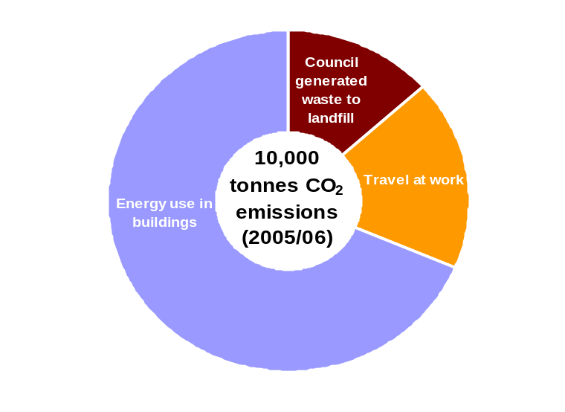
Source: Oxford City Council

The Council’s innovative work on sustainable housing has been referred to earlier in this report. The City Council’s fleet now includes electric vehicles and we are actively involved in the local Mini E trial. We have won the Energy Saving Trust Fleet Hero Awards for ‘Smarter Driving’, resulting in a 6% reduction in fuel use across our whole fleet. We won the Carbon Trust Innovation Award 2009: Innovative use of Technology (Public Sector). In 2010 we were runners-up in the Guardian Public Sector award for Innovation on sustainability issues.

Reducing the city’s carbon footprint
The City Council is committed to reducing its own carbon footprint, and to leading efforts to reduce the city’s footprint. Low Carbon Oxford’s groundbreaking work to embed a green economy has been referred to earlier in this report, as has our decision to allocate an additional £50,000 per year for two years to the initiative

Carbon dioxide emissions by source, Oxford 2008
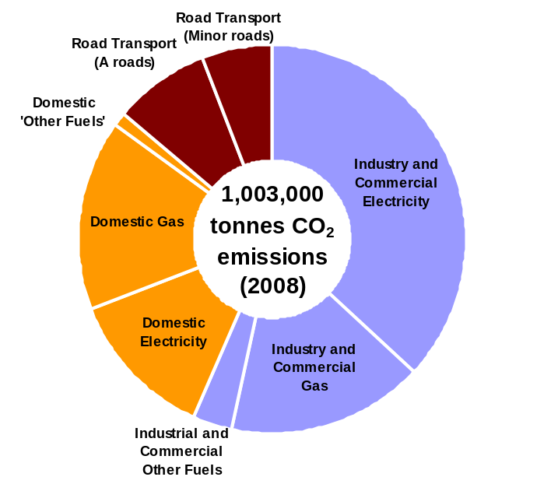

Source: Department of Energy and Climate Change

From 2014, the City Council will be implementing a Low Emission Zone (LEZ) which will place restrictions on the types of vehicle engines that can operate within central Oxford. This has particular implications for public service buses. The introduction of the LEZ – along with the desire of the main bus companies to play their role in making Oxford cleaner and greener – has led the Oxford Bus Company and Stagecoach to upgrade their fleets and successfully launch a joint ticketing scheme in the city. They are replacing many of the old polluting vehicles with new diesel electric hybrid double decker buses, funded through the Green Bus Fund. These hybrids have extra low NOx emissions.

The Council has implemented a planning requirement for 20% on-site renewable energy production for all large developments. We will be assessing the possibilities offered by the Green Deal for energy improvements in our own housing stock and, through the Low Carbon Oxford partnership, helping to roll out this programme to tenants, residents and businesses when the first Green Deals are launched in Autumn 2012. As set out earlier in this report, the City Council will be investing £54,000 over two years to ensure early and full take-up of the opportunities for insulation.
We are also working through strategic partnerships to combat the adverse effects of climate change, including the increased incidence of flooding within the City. We are implementing a broader strategy for dealing with the management of natural resources through a strengthened sustainability strategy.
Low Carbon West Oxford (LCWO) was set up after the summer floods of 2007 by residents concerned about climate change and local flooding. LCWO is a community-led initiative which aims to combat climate change by cutting our community carbon dioxide emissions by 80 % by 2050, encouraging residents to live more sustainably, and contributing to a more cohesive and resilient community. LCWO volunteers have helped plant 600 new trees on the edges of Botley and Oatlands park to absorb Co2, reduce local flooding and attract wildlife.
We are working with partners and local communities to ensure that people on low incomes can benefit opportunities to reduce carbon usage.

Measures | 2012/13 | 2013/14 | 2014/15 | 2015/16
Reduce the City Council’s carbon footprint by 3% (tonnes Co2) each year | 235 | tbc | tbc | tbc
Reduce the amount of residual household waste collected per household per annum and sent to landfill to 440kg in 2014/15. | 450kg | 445kg | 440kg | 440kg
Increase satisfaction with our street cleaning to 75% in 2014/15. | 71% | 73% | 75% | 76%
Carry out 730 enforcements as a result of environmental offences in 2012/13 | 730 | tbc | tbc | tbc

An efficient and effective Council

The City Council embarked on a major modernisation and service improvement programme in 2008 with a series of objectives across the organisation designed to create a flexible and digitally enabled organisation, delivering high quality, value for money services.

The Council’s efficiency and effectiveness have improved significantly over that period, and by the end of 2010-11, the General Fund will have seen a reduction in spend of £4.9m (16%) over a 3 year period (2008/9 – 2010/11). Further General Fund reductions of £9.5m are planned over the period 2011/12 – 2014/15 following the 28% reduction in government grant during this period. £5.9m of the total savings relate to the delivery of efficiencies across the organisation. A further 2% reduction will be made thereafter up until 2016-17.

There has also been a significant improvement in performance against our targets. In 2007/08, 49% of targets were met; in 2008/09 this had increased to 53%, and in 2009/10, 69% were achieved. In March 2009 we were achieving 59% of targets set out in our corporate plan. By year end of 2009/10, this figure had increased to 76%. We are now achieving improvements across 84% of our indicators.

In order to manage the financial constraints which government has imposed upon local authorities, the Council has had two options. The first is to balance the budget through service cuts and reductions in investment, which would lead to an impoverished organisation susceptible to unplanned cuts and redundancies. The second option – the option that we have chosen – is to speed up our pace of improvement so that we can protect and improve our front-line services with reduced resources.

Council 2012
In the previous Corporate Plan the Council’s 2012 programme was highlighted, and it has been this programme which is now driving the important changes in the ways in which we manage our people, processes and systems.

Four principles underpin the Council 2012 programmes:
- One Council: one vision, integrated policies and procedures across all services
- Rationalise the use of buildings and make the most of our assets: make more efficient use of our buildings and offices and dispose of those that are surplus to requirements.
- Simplify, standardise and automate our processes: Eliminate duplications in systems and processes and e-enable wherever possible, both internally and externally.
- Modern and flexible working practices: enable staff to work more flexibly and more productively in order to reduce the Council’s cost and carbon footprint.

The Council 2012 programme is nearing completion and has delivered significant achievements.

1. Customers First
We have:
- Opened a new, state-of-the art customer services centre in St. Aldate’s Chambers where customers can receive answers to queries about all Council services, including planning and building control issues
- introduced one telephone number for all Council services
- combined the contact centre operations previously located within different Council departments to create one generic, corporate front of house and call centre service.
- implemented a customer relationship management system which holds consistent information about our services and helps us provide a ‘get it right first time’ service regardless of whether customers are contacting us over they web, by telephone, or face-to-face
- begun a fundamental service review of our benefits service to ensure that we get things right in this most important of services
- increased the range of services that can be accessed on-line and through the contact centre. These channels are cheaper for the Council to run and deliver better value for money to the taxpayer. We are on track to increase the proportion of online transactions by 20% by March 2013 against the 2009 baseline figures and to reduce the proportion of face-to-face contacts by 20% by 2013 against the 2009 baseline figures. We will be launching our “click, call, come in” campaign in the new year, aimed at encouraging our customers to prioritise those access channels which are cheaper and more convenient
- significantly improved management in the contact centre. By March 2012, we expect at least 90% of our customers to be able to reach us first time on the Council’s main service lines.

Our aim is to resolve 80% of customer enquiries in the customer service centre and contact centre by March 2012 and 85% by March 2013.

2. Offices for the Future
We have:
- improved working conditions for our staff by transforming St Aldate’s Chambers into modern, flexible office space. This has enabled us to improve staff satisfaction as well as reducing our costs and our office footprint
- made good progress on reducing our city centre office and carbon footprint. We have moved out of our Blue Boar Street offices and sold them; Ramsay House is also on the market. The aim over time is to locate most of our staff in our city centre offices and reduce the Council’s office and carbon footprint by 25%.
- put arrangements in place to increase the productivity and efficiency of the facilities management service over the coming months.

3. Corporate Services Modernisation
We have:
- Rationalised and centralised our back office functions by bringing together finance and ICT staff from across the Council into centralised teams.
- Made good progress on rationalising back office processes. For example, Finance has developed a single invoice and payment process. The Council also now has one integrated performance reporting tool, CorVu. This is enabling us to move to a self-service model whereby managers are able to access information about performance and finance directly, without reference to intermediary officers. This makes our processes more efficient and it also gives managers more ownership of the information relevant to their services. The roll-out of the iTrent system is providing similar benefits for human resources management processes.
- Significantly improved the management of our ICT service by creating a small team of experts within the Council to liaise with the County Council. A new ICT strategy will be implemented over the next twelve months. This will play a role in rationalising our ICT systems architecture, as will a major review of the City Council’s licensing arrangements. We will be investing an additional £1.1 million over 4 years to further improve ICT
- Increased the efficiency of our asset management function by centralising maintenance and property related functions in the corporate Asset Management team.
- Developed a new performance management framework, which will be embedded over the coming year. Performance management across the Council has improved significantly over the last few years. New framework builds on these improvements by requiring managers to look at good practice beyond the City Council. The new framework requires service managers to:
  - carry out at least one benchmarking exercise per year within our own sector and, where there is potential, outside the sector
  - gather market intelligence on their sector to inform service development
  - have arrangements in place to obtain customer feedback biannually.

4. Direct Services
We have:
- set up a Direct Services unit which brings together front-line services previously delivered by different service areas. The unit includes: recycling and waste; street scene; highways and engineering; and building maintenance. All services will report through trading accounts overseen by a Commercial Services Board reporting to the Executive Director for City Services.
- agreed to move to a single depot and stores operation to support Direct Services and are currently looking at site options.

5. City Housing Review
We have:
- transferred the non-maintenance delivery elements of the housing landlord function to a new combined Housing and Communities Team. This is enabling us to address the changing nature of issues on our estates which are increasingly characterised by mixed tenure.

We aim to improve aggregate performance on tenancy services key performance indicators by 8% by 2012 and improve overall resident satisfaction with services by a minimum of 3% by 2013.

People and equalities
The Council’s key asset is its staff and we are continuing to invest in them. We recruit good employees through an improved recruitment process and have significantly increased the number of trainee and apprenticeship roles, to help secure the long-term future of the Council’s skills base. Increasing the diversity of our workforce is an important part of this. How we manage and develop people is fundamental to the delivery of better services and value for money and to do this our managers must know how to manage people well. We have provided training in this area and results are positive.

Communicating with staff, managing their performance and giving feedback are all essential parts of the employment relationship. We expect our managers to fulfil these aspects and employees also have their role to play, as laid out in our Employee Charter and Behavioural Framework. We have made good progress in driving high performance through our appraisal process, where staff and managers agree objectives – linked to delivery of Council services - and regularly review progress over the year. We have improved employee attendance by reducing sickness absence by 25% over the last twelve months and, for the first time in many years some staff have been dismissed for poor attendance. However, we have more work to do in this area.

Investors in People
We were pleased to achieve the Investors in People accreditation in May 2011. Investors in People reviews all aspects of people management - setting and communicating our business strategies and including staff in those processes as well as developing employees so they are well equipped to deliver business outputs. The award reflected the contribution that people at all levels of the Council have made to improving the way that the Council conducts its business.

The IIP assessors commended the Council for:
- its clear and ambitious vision to be “World Class”
- the clarity of its objectives at all levels, as a result of the consistency with which the planning process is implemented through team and personal plans. Every service and every team has its own plan, produced in the context of the Corporate Plan, which sets out the overall council priorities, aims and objectives that dovetail with the ambitions of the various different agencies and partnerships that exist throughout the city. Individuals, through regular team meetings and their individual one-to-ones with their managers, are clear of their own personal objectives and contributions, and how these link through team plans and services to help the council achieve what it sets out to do for the city and its residents.
- strong internal communications, through Council Matters, corporate briefings, Wider Leadership team meetings, Management Practice Group, and one-to-ones
- a well understood and managed Behaviours Framework
- people working cooperatively within teams and between teams to deliver the outcomes that the Council or the service requires
- its distinct focus on management and management behaviours that has helped to bring about some high levels of management competence and effectiveness throughout the organisation. The council has run three levels of management training, which was mandatory for all managers at the appropriate level: Stepping On (first line managers and supervisors), Stepping Up (managers of managers) and Stepping Ahead (senior managers).
- placing effective learning and development as a key feature of the council
- excellent use of measurable data, utilised effectively in setting clear goals and objectives, and then being used to measure progress towards objectives and to demonstrate improvements in specific areas
- an organisational ethos of honesty and openness which enables people to voice opinion, challenge practices and develop effective methods to make improvements to local and council practices.

We are planning to build on the recommendations in the IIP report to drive further improvements in preparation for a future application for IIP Gold accreditation.

Equalities Framework for Local Government
In January 2012, the City Council successfully reached Achieving Level as set out in the Equalities Framework for Local Government. The peer review focused on the following themes:
- knowing your communities and equality mapping
- place shaping, leadership, partnership and organisational commitment
- community engagement and satisfaction
- responsive services and customer care
- modern and diverse workforce

Industrial relations
Working relationships between management and trade unions remain strong and we continue to work together across a range of employment issues, including those arising from the major budget pressures. As part of the 2011 budget process, the Trade Unions agreed to enter into a ground breaking partnership agreement which has suspended the incremental system in favour of a bonus payment for staff who have an acceptable performance and appraisal rating This bonus is dependant on the Council achieving its savings targets This agreement has helped the Council to tackle the need for budget reductions to invest in the city, protect our core services and to minimise redundancies.

The Council’s Partnership Payment introduced as part of the 2011 budget process was an important step forward in changing the contract with staff and an explicit recognition of their fundamental role in performance delivery. We aim to create a culture in which all staff are actively encouraged to challenge accepted practice positively, suggest and pilot new approaches. Allowing risk-taking within defined parameters, actively managing talent, and engaging customers in service design will energise the individuals involved and the organisation as a whole. These are the issues with which we will be engaging in the coming months, as we take the Council to its next phase of development.

Enterprising council
As the City Council becomes more efficient and effective, it is increasingly well placed to deliver services on behalf of others. Oxford City Council already manages a collaborative procurement hub that operates across all the councils in Oxfordshire. A dedicated procurement officer ensures that the majority of procurements undertaken benefit all the partners in the hub.

In 2010, Legal Services entered into a shared services arrangement with the other Oxfordshire councils. The Oxfordshire Legal Hub is coordinated by the City Council. The purpose of the Hub is to share legal resource and expertise between the authorities, increasing the resilience of each partner and providing an alternative to placing work with the private sector. The partner authorities have already collaborated on the joint procurement of legal research facilities and external legal advice.

Our Direct Services team – providing services such as building maintenance, street scene, engineering, recycling and waste collection – are well placed to market a wide range of operational services to other organisations.

We are putting arrangements in place to encourage trading and business development across the Council.

Open council
Oxford City Council is committed to open government and transparency. In order to deliver this commitment we have published on our website:
- All expenditure over £500, including costs, supplier and transaction information. This information is published quarterly
- Senior employee salaries, job descriptions, responsibilities, budgets and numbers of staff. ‘Senior employee salaries’ is defined as all salaries which are above £58,200. We will also be publishing the ‘pay multiple’ – the ratio between the highest paid salary and the median average salary of the whole of the authority’s workforce
- An organisational chart. This is also published in our Corporate Plan
- Job vacancies see
- Councillor allowances and expenses
- Copies of contracts and tenders to businesses and to the voluntary community and social enterprise sector.
- Grants to the voluntary community and social enterprise sector should be clearly itemised and listed. Information related to the democratic running of the Council, including the constitution, election results, committee minutes, decision - making processes and records of decisions.

We are also planning to include on the site information commonly asked for through Freedom of Information requests.

Measures | 2012/13 | 2013/14 | 2014/15 | 2015/16
Increase the percentage of customers satisfied at their first point of contact across all access channels (web, telephone, face to face) to 75% | 70% | 75% | 75% | 75%
Reduce the cost of delivering Council services per resident from £172 in 2011/12 to £162 in 2014/15. | tbc | tbc | £162 | tbc
Deliver efficiency savings of £6m by 2011/12 and over £9, by 2014/15. | tbc | tbc | £9m + | tbc
Achieve IIP Gold by 2013/14 | Standard | Gold | Gold | Gold

Working in partnership

Many of the challenges that face Oxford cannot be solved by the City Council (a district authority) on its own. The Council works with other organisations at many levels to deliver and enable services for the residents of Oxford and this will become increasingly important as budgets become tighter.

The government has made announcements on a range of policies and guidelines which will affect the statutory functions of public bodies and which will impact upon the way in which the public sector delivers services. Of particular importance is the Localism Act. This Act aims to devolve some powers and freedoms to local authorities and neighbourhoods and may give communities the opportunity for greater influence over planning and housing decisions. The details of how changes are to be implemented are however still not clear.
The Chief Executives of the public sector in Oxfordshire (local authorities, police and primary care trust) meet regularly together to review changes to government legislation and new policies. As a part of this process there has been a review of the existing partnership arrangements. Partnerships are in a period of transition and the changes that they are going through are set out below.

Local Strategic Partnerships
The statutory requirement for each local authority area to have a Sustainable Community Strategy and a Local Strategic Partnership to oversee the development and delivery of the Strategy will be removed from April 2012. These partnerships brought together key organisations from the public, business, community and voluntary sectors to develop and implement long-term visions for their areas.

These local partnerships were complemented at the upper tier of local authority by a Local Area Agreement (LAA) between central government and all local authorities. This agreement set out the priorities for the area, and targets for delivering them. In Oxfordshire the delivery of the LAA was overseen by the Oxfordshire Public Service Board. However, the Government has now abolished the Local Area Agreement and invited local authorities to decide for themselves whether or not they wish to maintain their Local Strategic Partnerships.

Oxford City benefits from an active and well supported Local Strategic Partnership (OSP) and the members of the partnership have confirmed their intention of maintaining and strengthening it to tackle the issues which face the city over the next decade. The Partnership has taken a lead on six key issues for the City since its inception in 2002/3. These are:
- Affordable Housing
- Health and Social Inclusion
- Climate Change
- Quality of the Public Realm
- Safer, Stronger and more Cohesive City
- The Economy of the City

More recently the OSP has taken on the role of overseeing the delivery of the City Regeneration Framework and Breaking the Cycle of Deprivation programme as well as Low Carbon Oxford.

Oxfordshire County Council has expressed a commitment to maintaining the Oxfordshire Partnership as a county wide information sharing and consultative body that helps to set high level strategic objectives for joint action. It is proposed that the Oxfordshire Public Service Board will only meet if future circumstances require it to do so.

Spatial Planning and Infrastructure Partnership (SPIP)
This partnership between the City Council, the Oxfordshire Districts, the County Council, and other relevant Government organisations oversees infrastructure development, economic development, spatial planning and housing development across the county. The government has abolished Regional Spatial Strategies, Regional Development Agencies and there are no longer regionally imposed housing targets. However, the Localism Act imposes a duty on local planning authorities to cooperate on spatial planning. SPIP will enable the Oxfordshire authorities to meet this obligation

Local Enterprise Partnership (LEP).

Oxfordshire City Region LEP was successful in its bid to become a Local Enterprise Partnerships (LEP). It is a business-led body tasked with developing a clear vision for the area’s longer term future, removing barriers to economic growth and creating new markets and employment, particularly in hi-tech and green technologies. The key priorities of the LEP are: improving skills; generating inward investment; and infrastructure planning. It has agreed to prioritise its support in three localities - Bicester, Oxford, and Science Vale UK. The LEP has been successful in its bid to have Science Vale UK designated as an Enterprise Zone and will be receiving £6 million from the Government’s Growing Places fund to be invested in infrastructure on a rolling funding basis.
Environmental and Waste Partnership
This partnership currently oversees work across the county on reducing carbon, climate change and adaptation. It also oversees the waste reduction and encourages recycling, improved street cleanliness and the public realm.

The government has announced its commitment to reducing carbon and introducing the ‘Green Deal’, aimed at providing resources for householders to improve energy efficiency.

The delivery of waste services and waste reduction is currently under review in order to see if there are opportunities for budget savings. The partnership is in the process of reviewing its remit and functions.

Health and Well Being Board
A new Shadow Health and Well Being Board has been established for Oxfordshire (replacing the previous Health and Well being Partnership). Health and Wellbeing Boards are a significant element in the Government’s strategy of joining up the health policy of the NHS and local government, working alongside other partners including the new Healthwatch. The responsibilities proposed by Government for the new Board includes:
- preparing a Joint Health and Wellbeing Strategy for Oxfordshire covering all age groups.
- ensuring that there is a Joint Strategic Needs Assessment that provides for the Board a strong evidence base and a clear analysis of population need
- having oversight of the joint commissioning arrangements for health and social care across the County;
- oversight of the involvement of the new Clinical Commissioning Groups (i.e. the new GP commissioners) in joint planning across the County

The arrangements include establishing four supporting Boards.

A new Health Improvement Board will take forward a work programme to develop health in the broadest sense, incorporating the new local authority responsibilities for public health, housing issues, recreation, leisure, and use of green spaces.

A new Adult Health and Social Care Board will be responsible for delivering existing key performance targets for the NHS and County Council and for the joint governance of pooled budgets.

A new Children and Young Peoples' Board will build on and develop the existing work programme of the existing Children’s Trust.

A new Public Involvement Board will incorporate Healthwatch, service users, the advocacy role of the voluntary sector, advocacy groups and the carers' voice.

Safer Communities Partnership
The City Council are a lead partner on the Oxfordshire Safer Communities Partnership (OSCP) whose aim is to make Oxford a more cohesive city by reducing crime, antisocial behaviour, fear of crime and domestic violence. The partnership has been identifying and tackling the city’s community safety priorities for the last 10 years.

The government has made significant cuts to a number of community safety grants and, alongside a restructure of Thames Valley Police, these present significant challenges for the partnership. In addition the partnership will need to respond to the new National Crime Strategy and the introduction of directly elected police commissioners. There are currently discussions on the future functions and remits of both the Oxfordshire and Oxford City Community Safety Partnerships.

Oxfordshire Community and Voluntary Sector
The City Council is part of the Oxfordshire Stronger Communities Alliance, which aims to strengthen the role of the voluntary and community sectors and increase the number of volunteers in the city.

The City Council provides funding to a range of voluntary and community groups who help deliver the objectives set out in the Corporate Plan.

The government’s ‘Big Society’ concept seemed to offer potential opportunities for the voluntary and community sector as deliverers of services. However, significant cuts in public sector funding have resulted from the government’s own budget cuts and these are likely to lead to groups loosing grants and/or contracts for services. The Oxfordshire Stronger Communities Alliance is analysing the potential impact of these changes and supporting the development of a business plan which will prepare them for the anticipated changes ahead.

Procurement
The procurement team actively engages with Business Link, Federation of Small Businesses (FSB), Thames Valley Chamber of Commerce and the voluntary and community sector. The team regularly supports the work of these groups by giving talks to members and offering training. They also work with local professional services such as banks, solicitors and accountants who provided free advice to businesses.

Oxford City Council manages a collaborative procurement hub that operates across all the Councils in Oxfordshire. A dedicated Procurement Officer ensures that the majority of procurements undertaken benefit all of the partners in the hub.

This area of work will be of growing importance given the budget reductions required from the public sector and the potential to make savings through the joint purchasing of goods and services.

Conclusion
This Corporate Plan reaffirms the Council’s ambition for Oxford to be a world-class city for all its citizens. It also reaffirms our plans for transforming the way that the Council delivers its services.

The Corporate Plan sets out the significant steps that we have taken over the last few years toward realising these ambitions. We have made extensive efficiency savings and at the same time improved performance across over 80% of our indicators. We have continued to make steady progress in delivering our broader aspirations for the city. We are investing in Oxford’s future by using Council money to drive projects which will create housing, jobs, and an improved quality of life for our citizens.

We remain committed to our core ambition of building a world class city for everyone. The priorities that underpin our core ambition remain unchanged:
- A vibrant and sustainable economy
- Meeting housing needs
- Strong and active communities
- Cleaner greener Oxford
- An efficient and effective council.

The budget that has been agreed for 2012 13 will support the delivery of the aspirations and projects set out in this Corporate Plan. They represent a major investment by the City Council into the city’s economy. Our plans to improve educational attainment and youth provision in the city – key factors in enabling our young people to access the labour market and economic and social life chances - represent significant new areas of investment for the City Council, with long term aspirations for our community.

