

To: City Executive Board

Date: 8th February 2012

Report of: Head of Finance

Title of Report: BUDGET MONITORING AS AT 31ST DECEMBER 2011 – QUARTER 3

Summary and Recommendations

Purpose of report: This report sets out the forecast outturn position for the Council’s Capital and Revenue budgets as at 31st December 2011 compared to the approved 2011-12 budget. In addition it provides information on key financial indicators in order to provide an assessment of the overall financial health of the organisation.

Key Decision: No

Executive lead member: Councillor Ed Turner

Policy Framework: Budget

Recommendation(s): That the City Executive Board:

1. Note this report.

2. Recommend to Council the inclusion of £400k Feed-In-Tariff solar panel capital works to the 2011/12 HRA capital programme and to recommend to Council the approval of the use of Capital Programme under spends to fund this project.

3.Determine how, if at all, the Board wish to fund the inclusion of £300k Feed-In-Tariff solar panel capital works within the 2011/12 General Fund Capital Programme in the absence of any under spend on the Programme and recommend to Council the approval of such funding as appropriate.

4.Approve the budget movements within the HRA as detailed in this report relating to the virement of £500k from the responsive repairs budget to both planned gas maintenance (£300k) and void repairs (£200k), together with budget movements of £212k from other planned maintenance schemes to cover overspends within the Tenancy Management area.

5. Agree that £50k of capital expenditure be brought forward from 2013-14 to 2011-12 to fund feasibility work associated with the £2m Depot Relocation Project planned for 2013/14 and recommend to Council approval of this work being brought forward.

APPENDICES TO REPORT:

Appendix A: December 2011 monitoring – General Fund table
Appendix B: December 2011 monitoring – Capital Programme
Appendix C: December 2011 monitoring – Housing Revenue Account
Appendix D: December 2011 monitoring – General Fund year to date position

EXECUTIVE SUMMARY
1. This report sets out the Council’s projected outturn position as at the 31st December 2011 and highlights major variances to the approved budget.

- The projected outturn as at the end of December (Q3) shows a £(351k) favourable variance to the 2011-12 approved budget. This is £(293k) favourable to the position reported in September 2011 (Q2).

- The Council's budget contains major savings and efficiency proposals, totalling some £4.2 million in this financial year, with sufficient contingencies set aside to ensure cover, in the event of non achievement. The Council is currently facing some major financial challenges, arising from changes to the housing benefit system, rising fuel costs, and income pressures due to the recession.

- Finance have had discussions with Cost Centre Managers and Heads of Service and have identified the following variances which are reflected in the outturn projection:

- Communities and Housing - £(92k) favourable variance relating to an under spend in supplies and services and additional income from the return of rent deposits from landlords over and above those budgeted for through the Home Choice scheme.

- Commercial property income - £(166k) favourable driven mainly by additional income from rent reviews and business rate savings on Council offices, namely St Aldates, Town Hall and Ramsey Street. A detailed analysis is provided in the Directorate section of this report.

- Employee costs within Health Development are projected to be £(30k) favourable variance against budgeted expenditure.

- Savings relating to court fees within Customer Services of £(57k).

- ICT are projecting additional a favourable variance of £(20k) arising from external consultancy income charged to Geoplace LLP and savings brought forward relating to Citrix system purchase that is now no longer required.

- A £40k adverse variance in Town Hall income.

- Investment income is expected to be £(40k) favourable due to the implementation of a more proactive approach to treasury management.

- Appendix A provides an analysis of the forecast General Fund revenue outturn position broken down by directorate. Table 1 below provides a summary.

Table 1 – General Fund Forecast Outturn as at 31st December 2011
December 2011 | Approved Budget 11/12 | Latest Budget | Actual YTD | % Budget Spent to 31st Dec 2011 | Projected Outturn @ 31st Dec 2011 | Outturn Variance to Latest Budget | Movement in Variance Q2 to Q3
 | £000's | £000's | £000's | % | £000's | £000's | £000's
Directorates:
Chief Executive | 4,947 | 4,861 | 3,489 | 72% | 4,911 | 50 | 50
City Regeneration | 4,218 | 5,138 | 2,545 | 50% | 4,880 | (258) | (258)
City Services | 8,958 | 7,948 | 5,011 | 63% | 7,891 | (57) | (13)
Finance & Efficiency | 6,107 | 7,710 | 4,301 | 56% | 7,690 | (20) | (20)
Total Excluding SLAs And Capital Charges | 24,230 | 25,656 | 15,346 | 60% | 25,372 | (285) | (241)
SLA's and Capital Charges | (1,746) | (3,218) | 0 | 0% | (3,218) | 0 | 0
Total of Corporate and other associated Budgets | 2,478 | 2,549 | 312 | (0) | 2,037 | (512) | 0
Transfer to Balances | 816 | 816 | 0 | 0% | 1,262 | 446 | (26)
Transfers to and (from) reserves |  | (26) | (26) |  | (26) | 0 | (26)
Net Budget Requirement | 25,778 | 25,778 | 15,632 | 61% | 25,427 | (351) | (293)
Funding
External Funding | 13,399 | 13,399 | 7,747 | 58% | 13,399 | 0 | 0
Council Tax | 12,528 | 12,528 | 0 | 0% | 12,528 | 0 | 0
Less Parish Precepts | (173) | (173) | (168) | 97% | (173) | 0 | 0
Collection Fund surplus | 24 | 24 | 0 | 0% | 24 | 0 | 0
Total Funding Available | 25,778 | 25,778 | 7,579 |  | 25,778 | 0 | 0
(Surplus) / Deficit for Year | (0) | 0 |  |  | (351) | (351) | (293)
Working Balance
1st April 2011 | 4,428
Transfers in | 816
31st March 2012 | 5,244

- The approved budget contains £606k of contingency funds to mitigate unachieved savings. Table 1 assumes that this sum will be utilised in making a ‘partnership payment’ to eligible staff, with any residual balance being transferred to earmarked reserves. The extent to which the payment exceeds the initial £350k will be determined once the final outturn position is known.

- The Council has also received £472k in respect of New Homes Bonus which in the above statement has been assumed to be transferred to reserves in line with the savings contingency.

- Overall the HRA outturn position indicates that the projected in-year surplus for 2011/12 will be £(457k), slightly lower than the estimated £(500k).

- The Capital outturn for the year now suggests in-year spend to be £ (1,076k) lower than the previous latest budget due to slippages and underspends as explained later in this report. CEB on 7 December 2011 resolved to grant project approval for the installation of photovoltaic solar panels at several HRA sheltered blocks and Council leisure buildings subject to sufficient under spends being identified within the Capital Programme at quarter 3. The HRA Capital Programme has sufficient shortfall to accommodate the planned £400k

10.CEB are therefore recommended to agree the FIT scheme for inclusion within the 2011-12 Capital Programme and recommend to Council the use of Programme under spends to fund the scheme.

GENERAL FUND OUTTURN
11. As at the end of December the forecast outturn position is £ (351k) favourable to the 2011-12 approved budget. The section below explains the reason for this variance. The position reported is £ (293k) favourable compared to the September position (Q2).

12. Chief Executive - currently projecting an over spend against the approved budget of £50k. This is £50k adverse to the position reported at (Q2): Law and Governance is reporting a £10k adverse variance relating to a partial unachievable saving arising from alternative restructuring proposals within Democratic Services. Policy Culture and Communications are projecting an adverse variance of £40k driven by reduced Town Hall income:

£20k relates to 3 large bookings that were lost as a result of the on-going work to the fire escape between Blue Boar Street and the Town Hall.

£15k relates to income lost due to occupation of the Long Room by Customer Services, and a further £5k due to the Museum shop opening later than originally anticipated.

13. City Regeneration – currently projecting a favourable variance of £ (258k), this is £ (258k) better than reported in September 2011 (Q2).
Income from planning fees is estimated to be lower than budgeted; however, this is offset by savings across other service activities within City Development.

Communities and Housing are projecting additional income from Home Choice of £ (77k), which relates to the return of landlord rent deposits being higher than expected. There is an additional £ (15k) saving on CCTV spend in year.

Corporate Assets are projecting a £ (166k) favourable variance driven by favourable rent reviews £(138k), this is one off release of accruals made in 2010-11 no longer needed. A further £(4k) net favourable position associated with the Gloucester Green Market, and savings associated with NNDR settlements £(24k)

14. City Services - £(57k) favourable variance compared to the 2011-12 approved budget, this is a £13k better than reported in September 2011 (Q2)

15. Direct Services - in line with budget and no change from September 2011 (Q2). However, there are variations within service areas to achieve this overall position, these are as follows:-

16. Waste & Recycling Service + £250k
Modifications to the trade waste service in the city centre as part of the Cleaner Greener campaign and legislative changes to the definition of domestic and trade waste in relation to Schedule 2 has an additional cost of £180k.

Fuel prices have risen by 26% during the year costing an additional £90k for 2011/12. Direct Services has undertaken a route optimisation exercise which will potentially realise a £ (30k) saving, leaving a net pressure of £60k

Long term sickness cover is at present estimated to be £82k for 2011-12.

Additional service provision in relation to the Royal Wedding Bank Holiday, was provided at a cost of £10k

An additional contribution of £ (50k) in relation to excess mileage has now been negotiated with the Oxfordshire Waste Partnership for 2011-12.

The uptake of the Garden Waste Scheme has been higher than anticipated and is estimated to deliver additional year one savings (2011-12) of £ (30k).

17. Off- Street Car Parking £50k
Car parking income overall is over budget by £ (90k). New charges for Parking in the Parks were delayed 2 months due to the consultation and traffic order process.

An area of concern is that the rent payable to Nuffield College in relation to Worcester Street Car Park will increase by £90k since it is linked directly to income (every £1 taken results in rent payable £0.5769.) Rent Payment is currently budgeted at £680k but based on budgeted income of £1,336k the rent payable to Nuffield College is likely to be £770k.

St Clements Car Park temporary closure has been delayed and it is anticipated that it will not close prior to year end. This will drive additional income of £ (140k). The mild winter has also had a positive effect as usage in the car parks has increased compared to December 2010.

18. Engineering £ (200k)
Additional works have been obtained from the County Council and other sources increasing net turnover by £ (450k). This was not anticipated when the budget was established. Overhead recovery on this additional works has averaged at 35% which has resulted in a surplus of £(157k) due to the fact this additional work has been undertaken without increasing fixed overhead costs. In addition 2 FTE’s have been vacant for six months providing savings of £ (43k). This combination of changes has resulted in a £ (200k) positive variance.

19. Customer Services - £(57k) favourable, this is £(13k) better then the position reported in September 2011 (Q2)
A review of court fees paid (relating to defaults) shows that year to date the budget is £(44k) favourable. The service does not require these funds to progress the court cases over the remainder of the year.

The additional £(13k) in this quarter is driven by a saving on business rates related to the One Stop Shop at Cowley, which has recently been subject to a valuation review.

20. City Leisure - £ 30k adverse, this is £ 30k worse than the position reported in September 2011 (Q2).
This is caused by not achieving all of the planned in-year service savings estimated for 2011/12.

21. Environmental Development - £ (30k) favourable, this is £ (30k) better than the position reported in September 2011 (Q2).
Health Development are projecting a £(30)k favourable variance driven by lower establishment compared to budget

22. Finance and Efficiency - £ (20k) favourable, this is £ (20k) better than the position reported in September 2011 (Q2).
This is due to additional ICT consultancy income charged to Geoplace LLP and a core system budget that is now no longer required.

23. Corporate and other associated budgets £(512k) favourable, this is the same position as reported in September 2011 (Q2)
Investment income is projected to deliver a favourable variance of £ (40k) (see investment performance below).The Council has also received £(472k) in New Homes Bonus which was unbudgeted (see paragraph 6).

ACHEIVEMENT OF SAVINGS AND EFFICIENCIES
24.The approved budget for 2011/12 includes service reductions and efficiencies of £4.2m.

Table 2 below sets out the savings position as at 31st December 2011

Table 2 – Savings Status
 | Efficiencies |  |  |  |  | Service Reductions
 | Approved Savings | Projected outturn | Var | Savings made to date |  | Approved Savings | Projected outturn | Var | Savings made to date
 | £000's | £000's | £000's | £000's |  | £000's | £000's | £000's | £000's
People & Equalities | (260) | (260) | 0 | (195) |  | (18) | (18) | 0 | (18)
Law & Governance | (39) | (39) | 0 | (26) |  | (111) | (101) | 10 | (101)
PCC | (102) | (102) | 0 | (100) |  | (65) | (65) | 0 | (14)
Chief Executive | (401) | (401) | 0 | (321) |  | (194) | (184) | 10 | (133)
Finance | (107) | (77) | 30 | (43) |  | (49) | (49) | 0 | (33)
ICT | (100) | (100) | 0 | (75) |  | 0 | 0 | 0 | 0
Business Trans | (83) | (83) | 0 | (61) |  | 0 | 0 | 0 | 0
Finance and Efficiency | (290) | (260) | 30 | (179) |  | (49) | (49) | 0 | (33)
Direct Services | (680) | (680) | 0 | (516) |  | 0 | 0 | 0 | 0
City Leisure | (511) | (461) | 50 | (363) |  | (12) | (1) | 11 | (1)
Customer Services | (241) | (241) | 0 | (172) |  | 0 | 0 | 0 | 0
Environmental Development | (110) | (85) | 25 | (85) |  | (110) | (110) | 0 | (85)
City Services | (1,542) | (1,467) | 75 | (1,136) |  | (122) | (111) | 11 | (86)
City Development | (123) | (123) | 0 | (123) |  | (136) | (136) | 0 | (125)
Housing and Communities | (624) | (624) | 0 | (491) |  | (373) | (373) | 0 | (311)
Corporate Assets | (317) | (317) | 0 | (185) |  | (9) | (9) | 0 | (8)
City Regeneration | (1,064) | (1,064) | 0 | (799) |  | (517) | (517) | 0 | (444)
Mitigating Savings
Law & Governance
Finance |  | (30) | (30) | (30)
City Leisure | 0 | (50) | (50) | (50) |  |  | (11) | (11) | (11)
Environmental Development |  | (25) | (25) | (25)
 | 0 | (105) | (105) | (105) |  | 0 | (11) | (11) | (11)
Total | (3,296) | (3,297) | 00 | (2,540) |  | (883) | (873) | 10 | (707)

25 As at 31st December 2011 £126k of savings as set out within the 2011-12 budget are not being met, £105k of these relate to efficiency savings and these are being mitigated in full. The remaining £21k relate to Service reductions of which £11k are being mitigated.

26 Law and Governance are reporting they will be unable to mitigate the £10k residual savings target within the Service due to alternative restructuring proposals within Democratic Services (Service Reduction) being implemented.

27 Finance have highlighted that a specific saving of £50k relating to the roll out of direct debits will not be met in full. The saving was predicated on staff costs associated with processing invoices, bank charges and debt recovery. Savings will be realised in relation to invoice processing and bank charges, however work to deal with inherited aged debt is still continuing. Of the £50k, £20k is achievable; the remaining £30k will be met through other structural saving initiatives within the service.

28. The Environmental Development saving was predicated on the existence of an anticipated funding stream in the 2011-12 budget. In this case the funding ended in 2010-11 and did not roll in to the 2011-12 base. As a result it is not possible to make this saving. The service will find alternative savings through an under spend in supplies and services budgets in the year. The error has been corrected within the proposed 2012/13 budget.

29. Leisure Services were using a reduction in their fleet as part of their savings this year, £50k. However, the vehicles when decommissioned would be savings realised by City Works, where the costs originated rather than Leisure Services. In addition the Service is reporting an £11k non-achievable service reduction saving relating to the disposal of a mini bus.

30 Finance will continue to monitor progress against savings and report on a monthly basis.

CONTINGENCIES, RESERVES AND BALANCES

31 To date there have been no movements in working balances. The 2011-12 approved budget provides for a £816k transfer to the working balance. The New Homes Bonus is shown as being transferred to reserves and will be utilised as part of the MTFS.

32 £26k has been released from Earmarked Reserves to fund the Oxford City Football Project (£20k) and the Cemeteries Project (£6k). This was part of the 2010/11 carry forward requests submitted by Services and approved by CEB at year-end.

HRA – Budget Monitoring December 2011

33 The HRA position as at 31st December 2011 is set out in the following table.

HRA Summary 2011/2012
December 2011
 | Approved Budget 11/12 | Latest Budget | Actual YTD | % Budget Spent to 31st Dec 2011 | Projected Outturn @ 31st Dec 2011 | Outturn Variance to Latest Budget | Movement from Q2 to Q3
 | £'000 | £'000 | £'000 | % | £'000 | £'000 | £'000
Income | (38,182) | (37,925) | (28,846) | 76% | (37,925) | - | -
Expenditure Tenancy Management | 17,446 | 17,520 | 13,186 | 75% | 17,775 | 255 | 255
Expenditure Direct Services | 11,540 | 11,385 | 7,523 | 66% | 11,173 | (212) | (212)
Subsidy, Finance & Appropriations | 8,696 | 8,520 | 6,338 | 74% | 8,520 | - | -
Total HRA Surplus/Deficit | (500) | (500) | (1,800) |  | (457) | 43 | 43

34. The projected outturn surplus for the HRA as at the end of December 2011 (Q3) is £ (457k), which is £43k less than the budgeted position of £ (500k).

35.Income – Income projections across all the various activities within the HRA are anticipated to continue to collectively be in line with the latest budget position of £37.9m. This is the same as that projected at September 2011 (Q2).

36.Shop income is slightly up on profiled estimates for December but this is believed to be a timing issue related to quarterly rent demands for HRA commercial property being billed in advance. Rechargeable repairs income is similarly higher than budgeted. However, no year-end increases have been applied due to the small amounts involved.

37 Expenditure on Tenancy Management – This area is expected to overspend by £255k as a result of:-
- The provision for the bad debts increasing, from £154k to £221k to reflect rising rent arrears.
- £30k of unbudgeted open space maintenance work associated with the cleaning of the HRA forecourt areas which has recently arisen. This will be accommodated within the planned maintenance budget for 2012/13.
- Additional disturbance payments and decanting costs associated with the Tower Blocks and Flats section has occurred amounting to £102k.
- Furnished Tenancies expenditure has increased by £56k to cover bad debts and additional Furniture and Equipment purchases.

38. The authority has for several years been involved in a rent review dispute at Southfield Park. The HRA has been budgeting and making annual provisions into a reserve to provide for backdated rent. In 2011/12 we have budgeted for a further contribution of £191k. Information from the arbitrator suggests that both the current budgeted provision and a sizeable proportion of the £1.3m reserve (31 March 2011) will not be required. Specific sums are still being finalised and once known the suggested budget revisions will be reported.

39. Expenditure on Direct Services – This area is estimated to underspend by £ (212k) caused by the following:-
- Day to day responsive repairs is likely to under spend by £ (500k) reflecting the significant capital and planned investment into the HRA stock in recent times. A budget virement is requested to re-direct the available resources to planned maintenance voids work (£200k) and gas maintenance (£300k) to reflect current levels of demand in these areas as well as higher material costs. The increased revenue voids work reflects the work needed to re-let our properties as budgeted capital voids work has reduced significantly.

- Under spends detailed in the following table within planned maintenance

Extract Planned Maintenance
Account(T) | Approved budget | Budget Adjustment Required | Revised Budget
 | £'000 | £'000 | £'000
Fire Regulations | 112 | (100) | 12
Paint & Repair External Joinery | 506 | (150) | 356
Other | 12 | 9 | 21
Aerial Upgrades | 14 | (9) | 5
Laundry Appliances | 32 | (12) | 20
Controlled Entry Maintenance | 71 | 50 | 121
 | 747 | (212) | 535

40.Subsidy, Finance and Appropriations - No changes to theses items are anticipated and given most transactions are undertaken at year-end no movements in the budget levels are anticipated.

CAPITAL PROGRAMME

General Fund and HRA Capital Programme
41. The budget approved for the General Fund and HRA Capital Programme for 2011/12 is shown in summary in Table 3 below. Appendix B attached shows the Capital Programme on a scheme by scheme basis.

42. As at the 31st December the Capital Programme is showing a favourable variance of £ (1,476k) against the latest budget. Of this £ (1,184k) relates to project slippage and £ (291k) to project under spend.

Table 4 – Capital Programme as at 31st December 2011

Capital Scheme | Approved Budget 2011/12 | Latest Budget 2011/12 | Spend as at 31 Dec 2011 | % Spend Against Latest Budget | Projected Outturn at 31 Dec 2011 | Outturn Variance to Latest Budget | Outturn Variance due to Slippage | Outturn variance due to Over/ Under spend
 | £000's | £000's | £000's | £000's | £000's | £000's | £000's | £000's
General Fund
City Development | 1,064 | 555 | 119 | 21% | 445 | (110) | (110) | 0
Environmental Development | 724 | 779 | 388 | 50% | 779 | 0 | 0 | 0
Communities and Housing | 2,937 | 2,920 | 2,700 | 92% | 2,920 | 0 | 0 | 0
Corporate Assets | 6,027 | 5,846 | 3,137 | 54% | 5,791 | (4) | (140) | 136
Customer Services | 179 | 65 | 43 | 67% | 65 | 0 | 0 | 0
City Leisure | 11,376 | 3,500 | 1,321 | 38% | 2,952 | (547) | (551) | 4
Direct Services | 1,171 | 1,605 | 799 | 50% | 1,573 | (31) | 0 | (31)
ICT services | 300 | 363 | 10 | 3% | 213 | (150) | (150) | 0
GF Total | 23,779 | 15,632 | 8,518 | 54% | 14,738 | (842) | (951) | 109
HRA
Adaptations for disabled | 900 | 798 | 647 | 81% | 868 | 70 | 0 | 70
Major Voids | 900 | 900 | 494 | 55% | 900 | 0 | 0 | 0
Kitchens & Bathrooms | 3,500 | 3,127 | 2,306 | 74% | 3,127 | 0 | 0 | 0
Heating | 1,000 | 1,240 | 1,071 | 86% | 1,315 | 75 | 0 | 75
Windows | 900 | 900 | 322 | 36% | 500 | (400) | 0 | (400)
Grantham House - Refurbishment | 0 | 0 | 0 | 0% | 0 | 0 | 0 | 0
Other | 4,001 | 2,248 | 1,330 | 59% | 1,870 | (378) | (233) | (145)
HRA Total | 11,201 | 9,212 | 6,170 | 67% | 8,579 | (633) | (233) | (400)
Grand Total | 34,980 | 24,844 | 14,688 | 59% | 23,317 | (1,476) | (1,184) | (291)

43. City Development is showing slippage of £ (110k) due to two s106 schemes (Headington Environmental Improvements and Artwork at Said Business School) that will not be undertaken this financial year.

44. Corporate Assets are projecting a £ (4k) favourable variance against the latest budget driven by slippage associated with Leisure Centre Improvements £ (140k). The £136k overspend relates to repairs to the Ice Rink £85k and improvements to General fund houses and Lodges to enable decent homes standards to be met

45. Corporate Assets are also projecting overspends compared to latest budget on 2 projects, £85k driven by improvements to the City Ice rink where it has been agreed to reduce the fees chargeable to Fusion in relation to this activity and £51k relating to enhancements to non-HRA dwellings and Lodges. It is being discussed if additional feasibility study fees relating to the future relocation Depot project will be incurred before year-end. If costs are to be incurred then the estimated outturn position will be revised in next month’s report.

46. It is recommended that £50k is added to the 2011/12 Capital Programme, (funded from capital receipts) and recommended to Council, in order to commence feasibility works on the Depot Rationalisation project planned for 2013/14. A further £200k of feasibility work is planned in 2012/13 and reported as part of the budget report which appears elsewhere on the Agenda.

47. The £ (547k) outturn variance associated with City Leisure relates to slippage of the competition pool and associated s106 projects, together with a slight overspend of £4k on the Barton Village Pavilion refurbishment.

The £ (31k) savings associated with Direct Services is linked with lower costs for installation of car park pay and display machines.

48. ICT Services slippages primarily relates to the IT Development project that is associated with new equipment purchases and other smaller project based activities.

49. The under spend associated with the HRA capital projects primarily relates to the window replacement programme. It is recommended that this under spend is used to fund the £400k FIT scheme to fit solar panels to Sheltered Blocks as per the recommendation from CEB on the 7th December 2011.

PERFORMANCE INFORMATION
50. There are a number of key performance indicators which when combined with budgetary performance information provide an overall picture of the financial health of the Council. These indicators are as follows:

The Level of Debtors

Table 7 – General Fund Debtors as at 31st December 2011
31st December 2011 (Q3) | Sundry Debtors | Periodic Income & Service Charges | Housing Benefit Overpayments | Grand Total | Aged Debt as at 30th Sept 2011 (Q2)
 | £000's | £000's | £000's | £000's | £000's
31-90 Days | 76 | 175 | 0 | 251 | 455
91-180 Days | 22 | 234 | 544 | 801 | 78
< 1 Year | 7 | (4) | 585 | 588 | 760
< 2 Years | 1 | 81 | 895 | 977 | 1,044
< 3 Years | 3 | 15 | 613 | 632 | 664
< 4 Years | 7 | 9 | 455 | 471 | 507
< 5 Years | 5 | 3 | 277 | 284 | 299
< 6 Years | 0 | 16 | 194 | 211 | 222
Over 6 Years | 8 | 4 | 590 | 602 | 621
Total | 129 | 533 | 4,153 | 4,817 | 4,650

51. The Council’s total General Fund debt i.e. debt aged 31 days or more, stands at £4.8m. This is a £167k increase in the debt reported in September 2011 (Q2).

52. As at 31st December 2011, 33% of debt is aged 3 years or over. Housing Benefit overpayments represent 97% of the debt aged over 3 years.

53. Whilst Housing Benefit overpayments are actively managed, recovery is slow, and significant bad debt provisions are subsequently budgeted and maintained against this debt.

54. As at the end of December 2011, £2.3m of Housing Benefit overpayments have recovery arrangements in place

Investment Performance
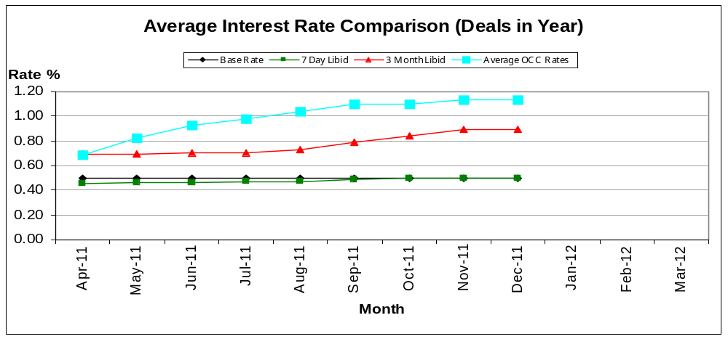

55. The average Oxford City Council rate of return on investments as at 31st December 2011 was 1.13%. This is an increase of 0.03% compared to September 2011 (A”).

56. The year end outturn remains £40k favourable as per the September 2011 (Q2) projection.

Business Rates
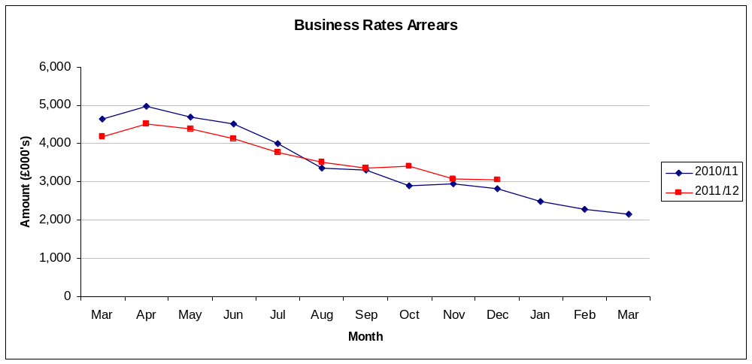

57. Arrears have decreased quarter on quarter by £318k. Arrears are £1.1m lower than the start of the year but are £236k higher than the same position last year

58.The current year collection rate is 88.22% this is up on the same period last year of 87.93%, indicating that we are more effective at collecting the outstanding debt than this time last year.

Council Tax Arrears Collection
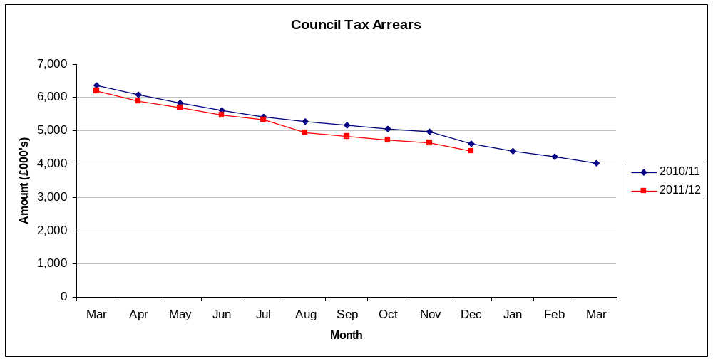

59. Arrears have reduced by £431k quarter on quarter, down 29% from the start of the year.

60. The current year collection rate is 84.19%, which is slightly down on last year's equivalent of 84.38%

Creditor Payment Times
61. During December 2011 creditor invoices paid on time stood at 89.44%. This is a 2.38% improvement on the Q2 (Sept 2011) position of 87.06%.

62. Year to date invoices paid with 30 days stands at 94.89%, 2.11% below the Council’s target of 97%

63. The table below sets out the December 2011 and Year to Date results by Service area

Service Area | Dec 11 Total Invoices | Over 30 Days | Dec 11 %Over | Dec % On time | YTD Total Invoices | YTD Over 30 Days | YTD % Over | YTD % On time
City ICT | 50 | 37 | 75.51% | 24.49% | 226 | 83 | 37.05% | 62.95%
Finance | 29 | 5 | 18.52% | 81.48% | 470 | 70 | 15.35% | 84.65%
Policy Performance & Culture | 22 | 3 | 13.64% | 86.36% | 92 | 10 | 11.11% | 88.89%
Corporate Assets | 156 | 10 | 7.09% | 92.91% | 1742 | 183 | 11.06% | 88.94%
Business Improvement | 23 | 2 | 8.70% | 91.30% | 145 | 13 | 9.15% | 90.85%
Community Housing & Development | 235 | 37 | 16.30% | 83.70% | 1910 | 161 | 8.73% | 91.27%
City Development | 23 | 6 | 27.27% | 72.73% | 1388 | 119 | 8.65% | 91.35%
Environmental Development | 32 | 2 | 6.25% | 93.75% | 501 | 40 | 8.15% | 91.85%
City Leisure | 96 | 4 | 4.35% | 95.65% | 1205 | 92 | 7.92% | 92.08%
Housing Revenues Account | 8 | 1 | 12.50% | 87.50% | 3385 | 255 | 7.73% | 92.27%
Direct Services | 1101 | 73 | 6.65% | 93.35% | 9098 | 636 | 7.09% | 92.91%
People & Equalities | 30 | 3 | 10.00% | 90.00% | 463 | 32 | 6.96% | 93.04%
Law & Governance | 18 | 5 | 27.78% | 72.22% | 229 | 15 | 6.58% | 93.42%
Customer Services | 58 | 1 | 1.79% | 98.21% | 657 | 39 | 6.06% | 93.94%
 | 1881 | 189 | 10.56% | 89.44% | 21511 | 1748 | 5.11% | 94.89%

HRA Rent Arrears (Current Tenants)

Aged Debt Analysis
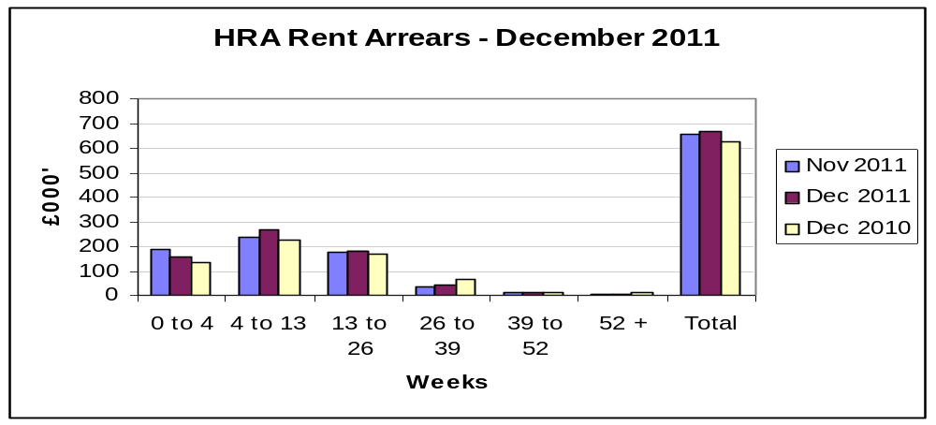

64.Overall arrears stands at £667k, this is £13k higher on than last month and £45k more than the same period last year.

65.Of the aged debt, £603k (90.4%) is less than 6 months old. £5k is aged over 52 weeks. Rents have increased by approximately 7% since 2010/11 and due to the current economic conditions arrears have been rising.

66. The Council also has arrears related to former tenants, the value of these arrears is £122k as at December 2011, and this is 4k less than the previous month (this data is not aged and has not been included above)

67.The Council holds a bad debt provision of £270k against this debt. As at 31st December 2011 the authority had written off £58k of former tenant’s debt (£2k during December 2011), this equates to 0.2% of the total collectable rent in the year.

68. Arrears Analysis 2011-12 compared to 2010-11
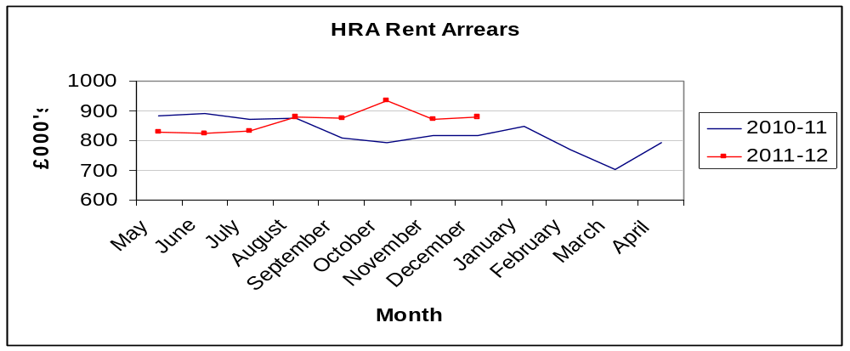

Name and contact details of author:-
Name: Nigel Kennedy
Job title: Head of Finance
Service Area / Department Finance and Efficiency
Tel: 01865 272708 e-mail: nkennedy@oxford.gov.uk

